**Bloomberg Financial Analytics Visual Dashboard**

**BUSM130 Group Project**

**School of Business and Management**

**Queen Mary University of London**

By (Group 7)

Aditya Venugopal Nair (200929374)

Apoorv Sharma (230712733)

Nava Bhargav Gedda (230270185)

Ompal Singh Bhati (230720842)

Pon Ananth Veppalodai Senthurpandi (230289833)

Date: 23/08/2024

Table of Contents

1. Executive Summary 3

1. 1. Problem Statement and Project Scope 3

1. 2. Methodology 4

1. 3. Key Findings and Discussions 6

1. 4. Conclusion, Recommendations and Future Scope 8

2. Introduction (Apoorv Sharma - 230712733) 9

2. 1. Market Concepts 10

2. 1. 1. Stock Market 10

2. 1. 2. Stocks 10

2. 1. 3. Ticker 11

2. 1. 4. Index 11

2. 1. 5. Other Assets Sold on the Stock Market 12

2. 1. 6. Stockbrokers 13

2. 2. Bloomberg L.P 14

2. 2. 1. Bloomberg Terminal 14

2. 2. 2. Competitive Edge 15

2. 2. 3. Bloomberg Terminal Commands 17

2. 2. 4. Data Extraction from Bloomberg 18

2. 3. Data Exploration 21

2. 4. Stock Price Prediction Methodology 30

2. 4. 1. Fundamental Analysis 30

2. 4. 2. Technical Analysis 33

2. 4. 3. Quantitative Analysis 33

2. 4. 4. Sentiment Analysis 33

3. Model Methodology 34

3. 1. Classification (Aditya Nair - 200929374) 34

3. 1. 1. Sentiment Analysis 34

3. 1. 2. Data Acquisition 35

3. 1. 3. Data Analysis 39

3. 1. 4. Machine Learning Classification 44

3. 1. 5. Classification Model Analysis 46

3. 1. 6. Results and Discussions 50

3. 2. Time Series (Ompal Singh Bhati - 230720842) 52

3. 2. 1. Introduction 52

3. 2. 2. Benefits of using time series 53

3. 2. 3. Data & EDA 54

3. 2. 4. Methods & Analysis 58

3. 2. 5. Results 68

3. 3. Regression and Deep Learning Models (Nava Bhargav Gedda – 230270185) 73

3. 3. 1. Machine Learning Models 73

3. 3. 2. Neural Networks 82

3. 3. 3. Feature Engineering 89

3. 3. 4. Results 90

3. 3. 5. Model comparison. 99

4. Trading Dashboards & Backtesting (Pon Ananth Veppalodai Senthurpandi - 230289833) 102

4. 1. Getting Data from Bloomberg 102

4. 2. Candlestick Plot 102

4. 2. 1. Component of Candlestick charts 103

4. 2. 2. Interpretating Candlestick Charts 104

4. 2. 3. Plotting the chart using Python libraries 105

4. 3. Backtesting using Trading Indicators 107

4. 3. 1. Trading Strategy 107

4. 3. 2. Types of Trading Strategies 107

4. 3. 3. Simple Moving Averages Crossover Strategy 108

4. 3. 4. Plotting Entry/Exit Plot Using Python Libraries 109

4. 3. 5. Portfolio Management of Stocks 110

4. 3. 6. Evaluating Stocks using Trade Indicators 111

4. 3. 7. Summary of Trade details for all stocks 112

4. 4. Backtesting using Backtesting.py library 113

4. 4. 1. Mean Reversion Strategy 113

4. 4. 2. Plots of Backtesting 114

4. 4. 3. Stats of Backtesting 115

4. 4. 4. Optimization of the strategy 116

4. 4. 5. Drawbacks of the library 118

4. 5. Trading Strategy Dashboard 119

5. Future Scope & Conclusion 120

5. 1. Future Scope 120

5. 2. Conclusion 121

6. References 122

# Executive Summary

## Problem Statement and Project Scope

The stock market is a complex and dynamic system which is influenced by numerous internal factors, such as financial and economic indicators, as well as external factors such as market sentiments. Forecasting stock prices is a challenging task due to the complexity of financial markets and the various factors that influence stock market prices. Extensive research and analysis have portrayed that stock price movement is influenced by four key factors- fundamental, technical, quantitative and sentiment. While each of these factors have an individual effect on stock price, the combined effect of these four factors is necessary to quantify so as to develop an optimal stock prediction model.

Bloomberg Terminal is a leading platform for financial professionals which offers a vast repository of real-time financial data, news and trading. It provides advanced data and analytics capabilities that is leveraged by more than 325000 subscribers worldwide. Additionally, Bloomberg leverages a news sentiment analysis tool that employs complex machine learning algorithms to compute sentiment scores from news and social media text. These sentiment scores represent the market's collective mood towards a particular stock or the broader market, providing a significant qualitative dimension to stock market analysis. Despite the availability of such rich data, the integration of sentiment analysis into stock price prediction models remains underutilized. Hence, this project aims to develop a sentiment analysis-based stock price prediction model using Bloomberg Terminal data.

This project aims to develop a machine learning (ML) based predictive model that incorporates quantitative, sentiment and technical indicators to forecast stock prices. The project is segregated into five key phases, beginning with a detailed introduction of the stock markets. Upon completion, the second phase emphasizes on the functioning of the Bloomberg Terminal and its application in a data extraction pipeline to retrieve historical stock prices, trading volumes, and sentiment scores related to specific stocks or indices. In addition to this, technical indicators are calculated and incorporated into the analysis. The third phase focuses on a comprehensive study of ML classification models so as to measure the influence of sentiment scores on stock price movement. This is followed by a time-series analysis leveraging ARIMA, SARIMA and FB Prophet modelled on the adjusted close price. In addition to this, quantitative models using ML and Deep Learning algorithms are implemented to develop a price prediction model using multiple explanatory variables including sentiment scores and technical indicators.

The final deliverable is a detailed report that conducts a comparative analysis of the stock prediction models developed. Additionally, the report incorporates a portfolio analysis supported with a financial dashboard to showcase the empirical results.  This report aims to assess the influence of sentiment in financial markets, thereby offering practical insights for investors and financial analysts.

## Methodology

The methodology used in this study contains several essential steps: data acquisition, data processing, model building, and model evaluation. These steps are crucial for creating effective and reliable stock price prediction models which combines sentiment research with traditional quantitative and technical indicators.   
   
Data for this research is gathered from the Bloomberg Terminal, a major financial platform that delivers comprehensive real-time and historical data on global financial markets. The research focusses on seven prominent companies: Apple, Amazon, Google, Meta, Microsoft, Nvidia, and Tesla. These firms are selected because of to their substantial market capitalization and considerable media attention, promising a solid sentiment dataset for study. The data collected starts from August 1, 2016, to August 1, 2024, offering eight years of daily stock data, including Open, High, Low, Close, and Volume (OHLCV) measures, and sentiment scores generated from news articles and social media postings. The sentiment ratings, which varied from -1 (negative) to 1 (positive), are determined using sophisticated Natural Language Processing (NLP) methods applied to textual data. These ratings are crucial in determining the emotional tone of the market as represented in news and social media, which were subsequently employed as input features in the prediction models.   
   
Once the data is obtained, it is pre-processed to guarantee consistency, correctness, and appropriateness for model training. The preparation methods consist of data cleansing, scaling, and feature engineering. Initially, the dataset is examined for missing values and any inconsistencies were corrected. Null values are handled effectively to avoid biased predictions, either by removal or imputation depending on the unique context of the data. Next, data scaling takes place using the Min-Max scaling approach, which normalizes the data within a given range, often between 0 and 1. This phase is critical for machine learning models, especially neural networks, since it guarantees that all characteristics contribute evenly to the model and that no one feature dominates due to its magnitude. Scaling also assists in speeding up the convergence of the optimization method during model training.   
Feature engineering includes the introduction of new variables, such as technical indicators and sentiment ratings, to boost the prediction potential of the models. Technical indicators including Moving Averages (MA), Bollinger Bands, and Relative Strength Index (RSI) are generated and incorporated as features. Additionally, the sentiment ratings are pooled daily to establish average sentiment scores, which are then integrated with the OHLCV data to build a full dataset for each organisation.   
   
The model-building process includes choosing and training multiple machine learning algorithms to forecast stock price changes. The research experiments with both classic ML models and complex neural networks. Traditional models such as Logistic Regression are used for their simplicity and interpretability. These models are mainly used to examine the influence of fundamental and technical indicators on stock prices.   
In parallel, advanced models like Long Short-Term Memory (LSTM) and Gated Recurrent Unit (GRU) neural networks are trained to capture the temporary relationships and sequential patterns in the stock data. These models are especially well-suited for time series forecasting due to their capacity to store information across extended sequences of data, making them perfect for predicting stock price changes impacted by both previous prices and sentiment patterns.   
   
The third step involves Model Evaluation and Tuning, which is to validate the model's robustness and accuracy, cross-validation techniques, especially Time Series Cross-Validation (TSCV), were applied. This approach is suited for time-dependent data and helps reduce data leakage between training and testing datasets. The models are tested using performance indicators such as Root Mean Squared Error (RMSE) and R² (Coefficient of Determination). Hyperparameter tuning is a significant component of this process, notably for the neural network models. Techniques like Random Search are utilised to improve the model parameters, such as the number of units in each layer, learning rates, and dropout rates, ensuring that the models are not only accurate but also generalized well to unknown data.   
   
In summary, this complete approach, which combines data from numerous sources and employs both classic and sophisticated machine learning methods, is aimed to produce a viable forecasting framework for stock prices that involves sentiment analysis as a fundamental component.

## Key Findings and Discussions

Various classification models are implemented to churn out a buy/sell signal to generate a feature efficient enough to capture the sentiment effect on stock price. When using Open, High, Low, Close and Volume data along with sentiment scores, counts and technical indicators, it is observed to have a higher prediction accuracy than just using OHCLV or OHCLV + Sentiment data. This confirms the initial hypothesis of the dynamic nature of stock price prediction justifying the importance of considering all the factors namely fundamental, quantitative, technical and sentiment as a combined unit while trying to perform prediction.

Since technical indicators are computed using the stock price (Adjusted close price), it is assumed to have a higher impact in forecasting methods which is evident upon performing feature importance analysis. Technical indicators have a stronger effect than sentiment variables on the forecasting ability of the machine learning models suggesting a need for complex models to better capture the effects of sentiment variables during predictions. The analysis concludes that Logistic regression is the optimal classification model to generate a buy/sell indicator which can be used as an important feature in other complex machine learning models. Hyperparameter tuning is also performed on the optimized model and the results portrayed higher accuracy during classification for all the 7 stocks.

To consider the impact of trends and patterns in stock price prediction, a time series analysis is performed using ARIMA, SARIMA and FB Prophet models which provides considerable inputs in the analysis. ARIMA model, being the simplest model, provides a higher error rate suggesting a failure in capturing the recent major trends in stock prices. FB Prophet being a more complex model provides slightly better results than ARIMA model but still had considerable error metrics specifically for stocks which were range bound for few years and random trends evident by the sudden outliers during price prediction, suggesting that the rather new model is slightly inefficient in capturing random movements. SARIMA model performs the best out of the 3 with lower error rates suggesting effective capturing of trends and seasonality in stocks. The analysis also provides an understanding of how prices behave during major events like COVID lockdowns and how effective the time series models could be while performing price prediction.

Later, implementation of more complex models like regression models and deep learning models are studied to analyze how effective they could be in capturing the fundamental, sentiment and technical effects on stock price prediction. Linear regression and MLP Regressor perform the best among a range of regression models, but the error metrics suggest the need for much more complex models. Long Short-Term Memory, Gated Recurrent Unit and Recurrent Neural Network are analyzed and GRU model is found to be the optimal model for majority of the stocks, but these complex models still have high significant error rates. Hyperparameter tuning is performed to enhance the accuracy of the models, and the results are compared with respect to technical indicators to understand the impact of fundamental and sentiment data on price and how well the technical indicators could capture these effects in historical prices. The analysis also suggests that even after using powerful neural networks, a careful consideration of tuning and validation is required which prevent the model from overfitting. The results from the model evaluation confirm the hypothesis that stock price prediction is a highly dynamic problem, and no single model can successfully predict the prices for all the stocks while capturing all factors effectively.

The final section focusses on considering another aspect of understanding the effect of trading strategies and portfolio management on price prediction. The analysis is performed by back-testing existing strategies and trying to create an optimal portfolio using these. Buy and sell signals are extracted from the strategies which is used as an important feature in considering entry and exit in portfolios. Simple moving average crossover and mean reversion strategies are implemented and backtested against the 7 stocks in the dataset. It is found that mean reversion strategy performed the best in NVIDIA. It is worth noting that NVIDIA has risen almost 3000% in the last 5 years and has been very volatile after 2021 suggesting a frenzy and sentiment effect in place. The mean reversion strategies were effective in creating a portfolio with better than market results with NVIDIA giving about 618% annual return.

## Conclusion, Recommendations and Future Scope

The accuracy of stock prediction is increased by using advanced models like LSTM and GRU. These models significantly improve the forecasting of stock prices to obtain better financial outcomes. Based on the key findings, the use of optimized mean reversion strategies on different stocks enhances the quality of trading decisions, thus resulting in maximizing profits. Creating a visually appealing and interactive dashboard showing effective trading strategies helps enhance operational efficiency. Overall, financial performance benefits from enhanced predictions and optimized trading strategies.

This study is beneficial to retail investors looking to identify the best trading strategies to use. Accurate forecasting models assist financial analysts in the analysis of market trends for investment planning. Investment firms also benefit from managing portfolios and modelling an optimized trading strategy to maximize their client returns. Additionally, hedge funds can leverage advanced machine learning models developed to gain a competitive advantage in the market.

# Introduction (Apoorv Sharma - 230712733)

Stock price prediction of a company usually depends on four factors – fundamental, technical, quantitative, and sentiment. Each factor has an individual underlying effect on the price of a stock, and it becomes essential to consider all the factors combined to get an optimal prediction rather than relying on a single factor.

This project aims to understand the effect of sentiment analysis and technical indicators on stock price prediction models. Technical indicators play a major role in price changes, but sentiment analysis on stock price prediction remains vastly unexplored. The research aims to analyse stock price prediction by collaborating three factors – quantitative, technical and sentiment analysis to understand short term price movements.

For the analysis, data has been retrieved from Bloomberg repositories via the Bloomberg Terminal. Bloomberg has been successful in leading the sentiment analysis methodology by leveraging its abundance of data repositories and market dominance in news and information, by implementing Natural Language Processing (NLP) on news and information acquired from multiple sources. It tries to capture the sentiment of the article which is later used to generate individual sentiment scores for each source (news articles, Twitter or any other sources). Capturing sentiment effect for the analysis has been performed by utilising these scores and counts available from Bloomberg.

The report starts with providing a brief introduction about stock markets. The second section emphasizes on the Bloomberg Terminal and its advantages followed by the methodology implemented for data extraction from the Bloomberg terminal. A detailed summary of all the variables utilized along with their significance is provided.

The next section focusses on classification models’ comparative analysis to understand the impact of sentiment variables on the stock price. A time series analysis is later conducted with the adjusted close price using ARIMA, SARIMA and FB Prophet models. Later, price prediction is performed using multiple explanatory variables including sentiment and technical factors using quantitative models (regression and deep learning models).

Finally, a detailed comparative analysis of the study is provided for each section and concluded with a portfolio comparison along with a financial dashboard to display the empirical results. Concluding the analysis, a detailed discussion along with future scope and recommendations to enhance the results is provided.

## Market Concepts

### Stock Market

Stock market is a place for trading stocks (equity) and other financial instruments of public listed companies, where the price of shares is termed “share” or “stock price” (Wanjawa and Muchemi 2014). The stock market is an excellent means for businesses to raise capital for expansion and operations. It also allows investors a chance to monetize from the growth of businesses by making financially sound investment decisions.

The term “stock market” and “stock exchanges” are often used interchangeably, but they’re not the same. A trader in a stock market can buy or sell shares on one or more than one stock exchanges, which are only a part of the overall stock market. Some of the major stock exchanges include the New York Stock Exchange (NYSE), Nasdaq, Tokyo Stock Exchange, Shanghai Stock Exchange and the London Stock Exchange. (Gratton, 2022)

### Stocks

The word “stocks” in western culture often relates to ownership or equity in a corporation. It is usually issued in the form of shares, and a share of ownership concisely defines what a stock is. Many securities which are not stocks may also be issued by various entities including governmental organisations, agencies, authorities as well as corporations and are usually referred to bonds or debentures. These securities usually represent debt or loan offerings by the issuing party. (Fernando, 2023)

A share of stock represents an equity interest in the company, i.e., the owner is buying an ownership stake in the company with the expectation of receiving a share of the profits in the form of dividends, or benefit from the growth of its stock price or both.

The price of a share changes based on the demand for shares from investors who want to buy or sell shares of a particular company. When the supply and demand requirements are met, the transaction results in a successful change of equity of shares referred to as a trade. Investors make a trade decision based on the company’s performance, economic conditions, the current price of the shares.

There are mainly two types of stocks which companies’ issue – “common stock” and “preferred stock”. Common stocks are traded actively, and the price of a common stock is usually referred to when quoting the price for a company share.

### Ticker

Every public listed company and security being traded is provided a unique identification code which contains essential information including transaction, trading volume, etc updated continuously throughout a trading session by the stock exchange for a particular security.

A “tick” represents any change in price of the security whether it is an upward or downward movement. A stock ticker automatically displays these ticks, along with other relevant information, like trading volume, that investors and traders use to stay informed about current market conditions and the interest in that particular security.

Usually, a ticker is a one to four letter symbol with a green “up” symbol indicating an increase in the price. A red “down” symbol indicates a decrease in the price of the security. If the price is unchanged the arrow may be absent or grey in colour.

During a public listing, companies are allotted a unique ticker symbol which they can choose pertaining it doesn’t already exist. It is usually a representative of the company’s name.

E.g. The ticker symbol for Apple is AAPL.

### Index

An index represents a basket of assets intended to replicate a certain area of the market. Index can capture the entire market like the Standard & Poor’s 500 Index, Financial Times Stock Exchange All – Share Index and Dow Jones Industrial Average (DJIA) or they could be more specialized such as indexes that track a particular industry or segment, such as the FTSE 100 comprising the 100 most highly capitalised blue chips companies listed on the London Stock Exchange.

#### Public Companies

Only public listed companies can offer their shares to investors. Any company which desires to offer its shares to investors(public) needs to initially file for an IPO (Initial Public Offering) with a stock exchange and then their stocks get listed on the exchange for trading after IPO launch.

During the duration of planning the IPO, a company must meet stringent regulations and financial disclosure laws which helps ensure the discretionary interests of the investors.

#### Over-the-Counter Market

The “OTC” – “over the counter” market are where you can buy or sell a stock directly with another investor usually without the stringent level of regulations imposed for a public market. OTC trading is used for smaller, less liquid companies that may not meet the stringent regulations for listing in a stock exchange. The trading is usually facilitated by a network of brokers and dealers who engage in negotiations and direct settlements for the investors.

### Other Assets Sold on the Stock Market

In addition to stocks many other assets are traded on a stock market. These assets namely include –

#### Derivatives

Derivatives includes options and futures, whose value is derived from the value of an underlying asset, such as stocks, bonds, commodities, currencies, interest rates, or market indices. The change in price for derivates is directly related to the change in price of the underlying asset.

#### Funds

**1. Mutual Funds** - are financial institutions which provide their services by investing the client’s money into various assets and claim to provide clients with better returns and allowing common public with less knowledge of the dynamics of financial markets to leverage the market.

**2. Index Funds** – these funds typically mirror a particular sector, index or set of stocks and are traded on an exchange like a common stock.

**3. Preferred Stocks** – these stocks usually provide a set dividend and have priority over common stock in receiving a share of the profit’s or what’s left over if the company goes bankrupt.

**4. Real estate investment trusts (REITs)** – are financial institutions that own, manage or finance real estate projects. Investors can buy shares in them, and they are obligated to provide 90% of their profits as dividends each year. These securities are also traded on exchanges like a common stock.

For the analysis of this problem, only stocks have been considered and referred to going forward.

### Stockbrokers

Stockbrokers act as a mediator between investors and the stock exchanges to facilitate a transaction. They are licensed to buy and sell stocks and other securities for the investors and institutional clients.

Large brokerage firms usually provide an online platform for investors to trade securities electronically at lower costs and more convenience. They usually charge the investors a small fee for every transaction and services.

They also provide detailed financial advice, portfolio management services and personalised services along with educational resources, analytical tools and real-time market data.

## Bloomberg L.P

Bloomberg is an American privately held financial, software, data, and media company. It provides financial software tools and enterprise applications such as analytics and an equity trading platform, data services, and news for financial companies and organisations through the Bloomberg Terminal which is its core revenue generating product.

### Bloomberg Terminal

A Bloomberg terminal usually referred to as BT, is a proprietary trading platform where you have access to one of the most valuable data sources – Bloomberg data services. The terminal provides a user with real – time global financial data, financial analytics tools, and news feed.

Bloomberg terminal is considered one of the most sophisticated trading platforms justifying its hefty annual subscription fee of $27, 660. The vast amount of financial data, a network of the world’s most influential decision makers, easy and quick access to news and extensive research analytics provide an incentive for major financial services firms to purchase the software.

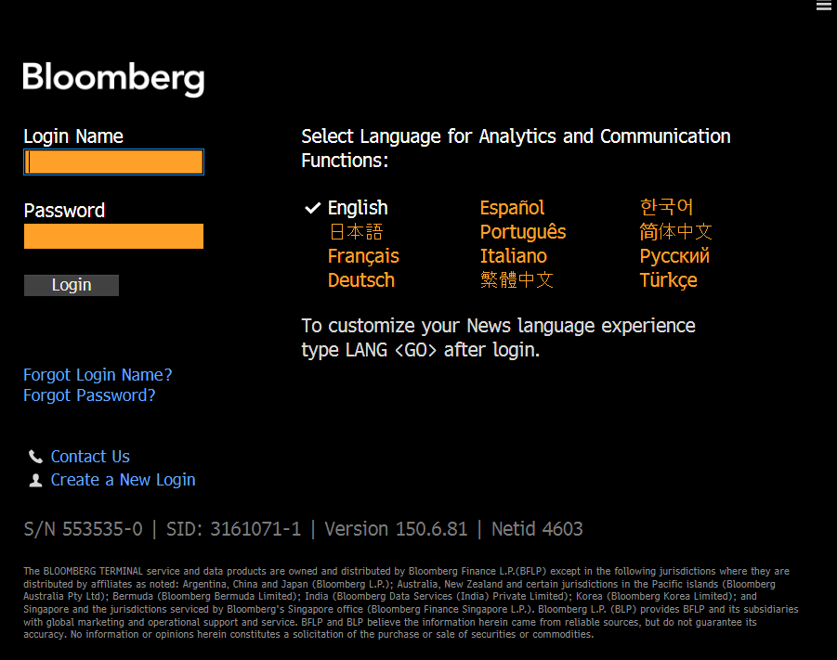

Fig 1. Bloomberg Anywhere software login page.

### Competitive Edge

1. **Ease of access** - The system operates on a PC via Windows – compatible software, a custom Bloomberg keyboard and a fingerprint scanner. The system is also compatible with Microsoft’s Excel which is an also intrinsic software used in the financial industry allowing customers with easy mobility of data. Bloomberg Anywhere software allows remote access to the software from anywhere in the world.
2. **Instant Messaging** - Bloomberg’s instant messaging service is very popular among traders allowing them to interact effectively and get updates on news about market activity.
3. **Data Abundance** - Bloomberg terminal is one of the most data extensive financial trading platform which provides information about almost every common and preferred stock traded around the world. Bloomberg effectively leverages its data repositories and provides analytical tools for its users.

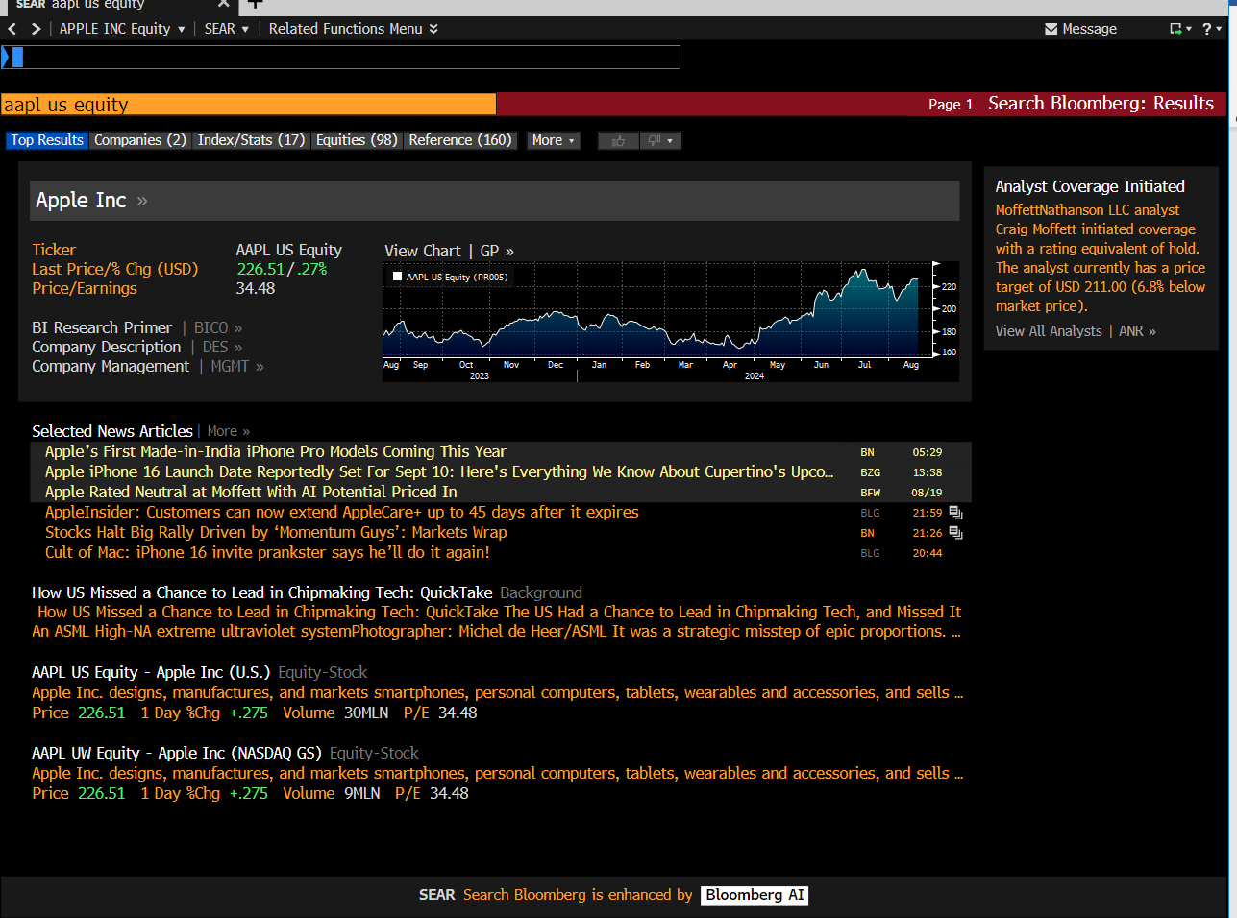

Fig 2. Common Information Page for Apple.

1. **Software Reliability and Speed** - Trading is one of the professions where it is very important to make quick decisions and execute actions. Minute delays cause huge losses for companies. Thus, they require the trades to be executed quickly and effectively. Bloomberg does a great job of understanding the market dynamics and solving such issues, enhancing the user experience and increasing reliability.
2. **Bloomberg Launchpad** – is a tool in the terminal which is used to personalize Bloomberg screens making it more effective and user centric.

### Bloomberg Terminal Commands

Few commands extensively used in Bloomberg include -

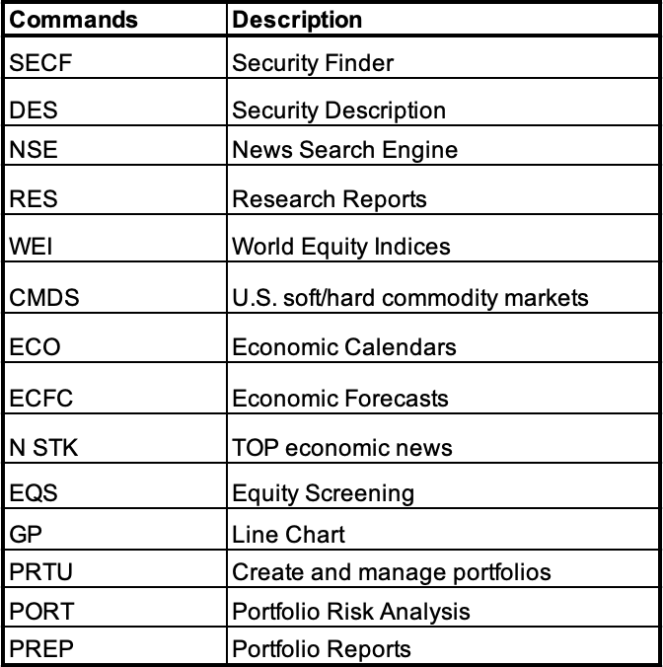

Table 1. Bloomberg Terminal essential commands

These few commands allow ease of quick access to data adding to benefits of using the terminal.

Interesting Note – Bloomberg also has many hidden commands like POSH which acts as a craigslist on Bloomberg terminal allowing users to buy/sell or rent goods from other terminal users. Another command – DINE – provides suggestions on few of the best restaurants and cafés recommended by fellow users located near you or in any desired location.

### Data Extraction from Bloomberg

Bloomberg allows multiple data extraction sources including extracting graphical data into pdfs and jpeg’s, exporting fundamental data into excel sheets and many more. These methods involve initially accessing the data in Bloomberg and exporting them accordingly.   
  
Bloomberg also now allows data extraction and access directly from third party applications and software’s making the process seamless and allowing more complex analysis to take place.

The main APIs used for the project data are –

1. **Office Add In’s** – it adds various Bloomberg functionalities into Excel, PowerPoint and Word. One of the key tools widely used in the world of finance is Excel, it allows users to handle and perform action on large datasets seamlessly. Getting customised data directly into Excel from Bloomberg helps users to perform complex computational financial analysis along with leveraging the Microsoft Office ecosystem and performing visual data analysis.

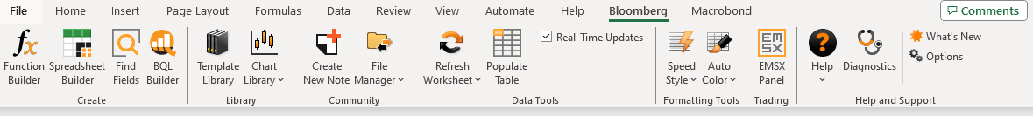

Fig 3. Bloomberg Tab functionalities in Excel.

Two of the main features which were extensively utilised for the research include –

1. **Function Builder** – this feature allows users to input different type of data and perform mathematical computation using inbuilt formula’s as well as create new user defined formula. This function allows users more control over the data and enhances data extraction and analysis.

It allows data to be imported in 3 main formats –

1. BDP (Bloomberg Data Point) - imports a single data point of current data.
2. BDH (Bloomberg Data History) – imports the historical data for a selected security.
3. BDS (Bloomberg Data Series) – imports a set of bulk data such as peers.

E.g. = BDP (“AAPL US EQUITY”, “PX_LAST”) – provides the last day close price of Apple common stock at a particular instance.

1. **Spreadsheet Builder** – this function allows user to import custom data from Bloomberg into an excel spreadsheet. A user can import time series table, real-time data, Intraday bars and ticks, bonds data, funds and technical analysis data as well.

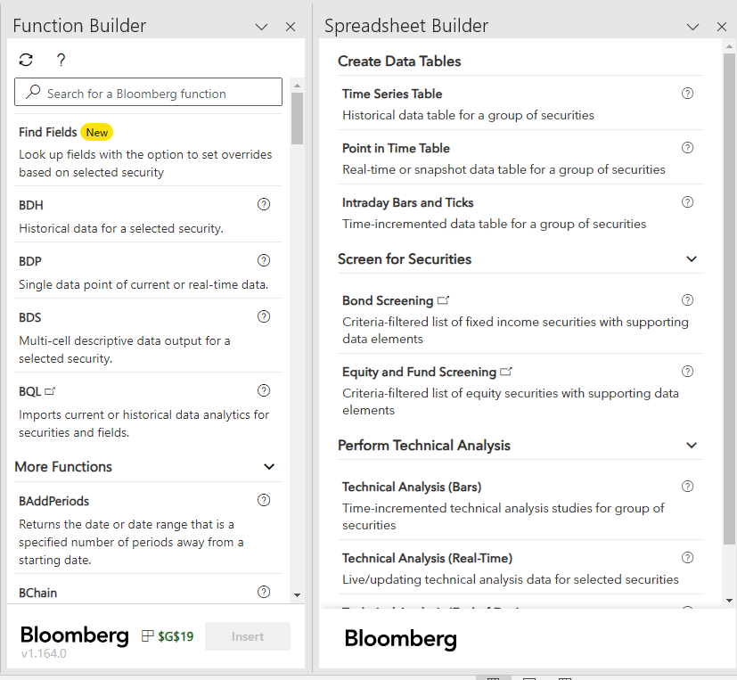

Fig 4. Bloomberg Function Builder and Spreadsheet Builder tabs

1. **Python API’s** – the api allows users to import data from Bloomberg directly into python files using the BLPAPI and XBBG API.

These can be easily installed using the below command –

1. xbbg - *!pip install xbbg*

This library provides a simple and efficient way to extract data from the Bloomberg Terminal. It allows accessing real time as well as historical market data, getting information about securities, accessing news and economic data in the form of sentiment scores and counts and executing Bloomberg commands.

1. blp - *python -m pip install --index-url=https://blpapi.bloomberg.com/repository/releases/python/simple blpapi*

The blp api is a more comprehensive and feature rich library compared to XBBG. It offers a wider range of functions and advanced analytics services.

Eg. Accessing last price of Apple from Bloomberg –

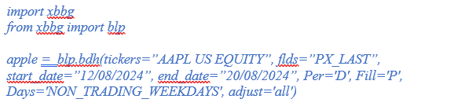

This will provide us a data frame named apple containing the last price of the Apple stock from 12/08/2024 to 20/08/2024 for all the active trading days during this period.

## Data Exploration

In this section we will elaborate on the data variables which have been implemented to perform the analysis. The data has been collected from Bloomberg terminals using the python API’s.

One of the key aspects of our comparative study involves analysing the impact of sentiment of news on the price of the stocks. Machine learning models require significant amount of training data to understand the dynamics of the price change and to increase prediction accuracy, we have selected the 7 magnificent stocks namely –

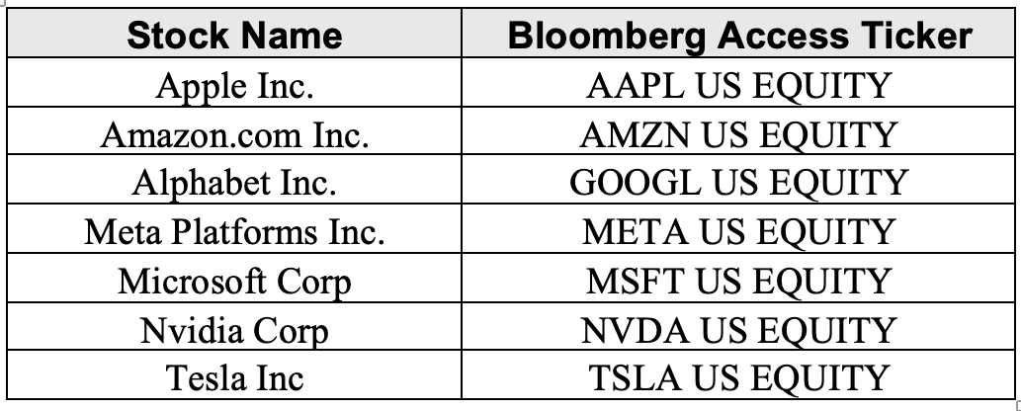

Table 2. List of Companies used for the analysis.

Since these stocks have one of the highest market capitalisations in the world and are covered by most of the analysts and news firms ensuring a sufficient sentiment bias data available for the analysis. All the above stocks have been listed on the NYSE stock exchange for more than 12 years ensuring a sufficient data set availability for our analysis.

Variables used –

1. **Fundamental Variables –**

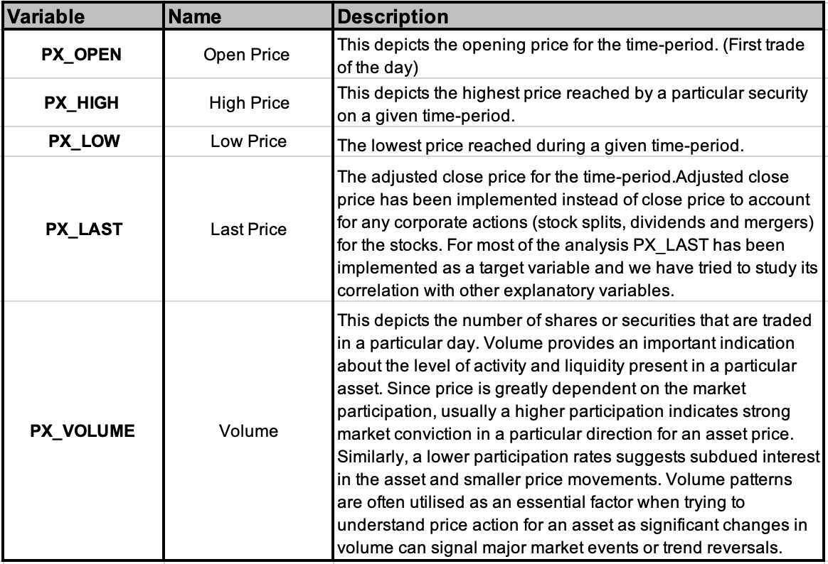

Table 3. List of fundamental variables.

1. **Sentiment Variables –**

Bloomberg performs an extensive sentiment analysis by –

* + Data Collection – Bloomberg uses a wide range of data sources including news articles, social media posts (twitter feeds), company earnings calls and various other public documents.
  + Natural Language Processing – Bloomberg uses advanced NLP techniques to analyse textual data collected from multiple sources. It identifies relevant information from sources by performing parsing on sentences and analyse the sentiment associated with the information.
  + Sentiment Lexicons – lexicons are dictionaries of words and phrases which are classified based on sentiment being either positive, negative or neutral. This extensive data is characterised by teams of financial analysts and linguists which helps ensure accuracy in categorising the sentiment classification. It makes it easier for Bloomberg to implement complex sentiment analysis models and provide an optimised categorisation medium for daily articles and posts.
  + Dynamic Analysis – Bloomberg’s sentiment analysis goes beyond simple word-level sentiment analysis, but also incorporates dynamic market factors like industry and historical conditions ensuring an optimised sentiment score.

Bloomberg’s Sentiment analysis is provided to users and industries in the form of scores and publication counts. Scores depict a number usually between 1 and -1 inferring the sentiment for the asset. A high value denotes a positive sentiment, a low value denotes a negative sentiment, and average value denotes a neutral sentiment. Count provides information for the number of sources generated and utilised for the sentiment scores. Sentiment Analysis is being performed on majority of the assets by Bloomberg almost daily and sentiment data for most stocks is available from as long as 2015.

The sentiment variables which have been utilised for our analysis include -

* **NEWS_SENTIMENT_DAILY_AVG –** is a sentiment score provided by Bloomberg that represents the daily average sentiment score for a particular asset based on the news. Bloomberg calculates the average of all the sentiment scores for the asset daily and provide the daily average sentiment score.
* **NEWS_SENTIMENT_DAILY_MIN –** represents the minimum sentiment score for an asset on a particular day.
* **NEWS_SENTIMENT_DAILY_MAX –** represents the maximum sentiment score for an asset on a particular day.
* **NEWS_POS_SENTIMENT_COUNT –** this provides information about the total number of positive sentiment news data sources categorised on a particular day.
* **NEWS_NEG_SENTIMENT_COUNT –** similar to positive count, this provides information about the total number of negative sentiment news data sources categorised on a particular day.
* **NEWS_NEUTRAL_SENTIMENT_COUNT –** provides information about the total number of news data sources categorised as neutral sentiment score on a particular day.

Similarly, Bloomberg also provides sentiment scores and counts for sentiment analysis performed on other data sources like twitter feeds and ESG news which have been utilised for our analysis.

* **TWITTER_SENTIMENT_DAILY_AVG**
* **TWITTER_SENTIMENT_DAILY_MIN**
* **TWITTER_SENTIMENT_DAILY_MAX**
* **TWITTER_POS_SENTIMENT_COUNT**
* **TWITTER_NEG_SENTIMENT_COUNT**
* **TWITTER_NEUTRAL_SENTIMENT_COUNT**
* **ESG_NEWS_SNTMNT_E5_POS**
* **ESG_NEWS_SNTMNT_E5_NEG**

1. **Technical Indicators -** technical indicators are heuristic or pattern-based signals produced by the price, volume, and/or open interest of a security or contract used by traders. Use of technical indicators to predict and forecast future price movements is known as technical analysis.

Technical indicators can be calculated for any security using historical data.

Such indicators are extensively used by active traders as these facilitate in analysing short term price changes. Support and resistance are two key concepts in technical analysis. They are basically price ranges which restrict a continuous price movement in either an uptrend (resistance) or downtrend (support). These levels are determined based on supply and demand. When demand is greater than supply, prices rise. Similarly, when supply gets higher than demand, prices fall. During an equilibrium state, prices tend to move sideways, i.e. in a range.

Technical indicators fall broadly in two categories –

* **Overlays** – are indicators that can be plotted on the same scale as price and can be plotted on top of a price chart. Moving average is one such indicator.
* **Oscillators** – these oscillate between a local minimum and maximum and are usually plotted below a price chart. Examples include Relative Strength Index (RSI) and stochastic oscillator chart.

The technical indicators used for the analysis include –

1. **Moving Average (MA) –** helps in smoothing out the price data by constantly updating average price which helps eliminates random and short-term fluctuations on the price of a stock. (Fernando, 2023b)

**Types of Moving Average –**

* **Simple Moving Average (SMA) –** is calculated by taking the arithmetic mean of a given set of values over a specified period.

The historical prices of a stock over a defined period are added together and then divided by the total number of prices in the set.

*SMA = $\frac{P_{1}+P_{2}+…+P_{n}}{n}$*

where:

P = price of a stock on period n

N = number of time periods

We have implemented the industry back-tested periods indicating an impactful support and resistance levels using –

ma (7) = 7-day moving average

ma (21) = 21-day moving average

* **Exponential Moving Average –** ponders more weight to recent prices which makes it more effective in capturing the effects of recent information in prices.

To calculate an Exponential MA, we first calculate SMA over a given period of time, then the weightage multiplier is calculated which is known as the “smoothing factor”

by the general formula: [$\frac{2}{time period+1}$]

This smoothing factor is then combined with the previous EMA to generate the current value.

${EMA}_{t}$ = [$V_{t}×(\frac{s}{1+d})$] + ${EMA}_{y} × [1-(\frac{s}{1+d})]$

where:

${EMA}_{t}$ = EMA today

$V_{t}$ = Value today

${EMA}_{y}$ = EMA yesterday

s = smoothing

d = number of days

We have implemented the industry back-tested periods indicating an impactful support and resistance levels using –

ema (12) = 12-day exponential moving average.

ema (26) = 26-day exponential moving average.

1. **Standard Deviation –** is a mathematical indicator which depicts how far an individual point is from the mean of the set. If data points are further from the mean, it indicates a higher deviation within the data set and vice versa. It also provides an indication about the historical volatility of the stock.

Standard deviation is calculated using variance.

Standard Deviation (SD) = $\sqrt{\frac{\sum_{i=1}^{n}{{(x_{i}-\overline{x})}^{2}}}{n-1}}$

where:

$x_{i}$ = Value of the $i^{th}$ point price in the dataset

$\overline{x}$ = The mean price value of the dataset

n = The number of data points in the dataset

1. **Momentum –** it provides information regarding the rate of rise and fall of stock prices. It implicates the strength and weakness in a stock’s price. Momentum is usually more useful in rising markets then during falling markets because markets tend to rise more often than they fall.

Momentum is calculated by differencing the latest closing price and the closing price “n” days ago (Segal, “Understanding Momentum Indicators and RSI”).

Momentum = ${Price}_{current}- {Price}_{n}$

One of the most widely used momentum indicator is MACD.

**Moving Average Convergence Divergence (MACD) –** is a trendline momentum indicator that shows the relationship between two exponential moving’s average of a security’s price. It is usually used by traders in identifying market entry and exit points.

It is calculated by differencing the 26-period exponential moving average (26 ema) from the 12-period exponential moving average (12 ema).

MACD = ${EMA}_{12}- {EMA}_{26}$

**Bollinger Bands –** is a combination of 3 lines which provide information about the volatility of a stock and whether the stock is overvalued or undervalued (Hayes, 2020).

* + - **Middle Band -** The centre line is the stock price’s 20-day simple moving average.
    - **Upper Band –** Middle Band + (2 * Standard Deviation of the price over the same period).
    - **Lower Band –** Middle Band - (2 * Standard Deviation of the price over the same period).

These bands are plotted over the stock price chart and when the price starts moving outside the upper or lower bands it indicates statistically high- or low-level trading as compared to its recent historical price. This can help infer overbought or oversold conditions respectively.

## Stock Price Prediction Methodology

The basic strategy for stock trading involves buying low and selling high. But the real complexity arises in knowing when to buy and sell a stock. Investors and Traders use various analysis methodologies and strategies which help them analyse the price movement.

The analysis and strategies can be broadly categorized into 4 parts –

### Fundamental Analysis

Fundamental Analysis involves evaluating the stock’s intrinsic value by analysing financial statements, broader economic factors and company’s future direction. If the current market value exceeds the fair intrinsic value, a sell rating is assigned. Similarly, a buy rating is assigned if the current market value falls below the fair intrinsic value.

While performing fundamental analysis, an analyst focuses on the company’s revenue growth, profitability, competitive advantages within its industry, and its product and services market fit (Segal et al., 2023).

The fundamental analyst also considers different financial ratios of the firm. Few of these important ratios discussed in Renu and Christie (2018) include:

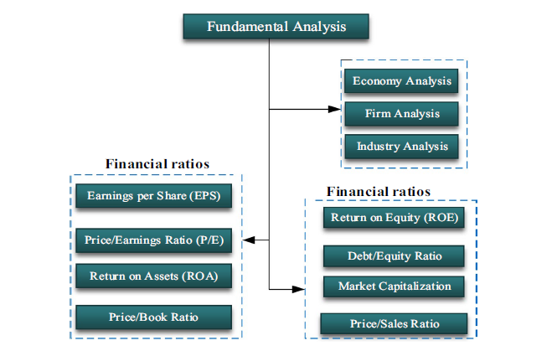

Fig 5. Flow Chart of Fundamental Variables (Segal et al., 2023).

* **Return on Equity (ROE)** – it provides an overview of how well the shareholder’s funds were used and the gains made from its investments.

ROE = $\frac{Net Income }{Shareholder^{'}s Equity}$

Net Income is the profit after tax generated by the company.

* **Debt to Equity (D/E) ratio** – provides information about the degree to which a company is financing its operations with debt rather than its own resources.

D/E = $\frac{Overall Liabilities }{Shareholder^{'}s Equity}$

* **Market Capitalisation** – represents the total valuation of a public listed company. It is used to categorise the companies into 3 – Large-cap, Mid-cap and Small-cap companies.

MC = $Number of oustanding shares ×share price$

* **Price to Sales (P/S) ratio** – is calculated by dividing the MC by the total sales or revenue generated by the company over the past 12 months.

P/S = $\frac{Market Capitalization}{Total Sales or Revenue generated over past 12 months}$

* **Price to Book (P/B) ratio** – provides a comparison between the market value of a company’s share and its fundamental value of equity.

P/B = $\frac{Share price}{Total assets-Intangible assets and liabilities}$

* **Earnings per share (EPS)** – it provides an estimate of how much money does a company makes per share. A higher EPS facilitates investments as it portrays higher profitability of a company.

EPS = $\frac{Net Income after tax -Dividends}{Total number of common outstanding shares}$

* **Price to Earnings (P/E) ratio** – is considered one of the most vital metrics for determining the stock valuation.

P/E = $\frac{Market Value Per Share}{EPS}$

* **Return on Assets (ROA)** – provides information about how profitable a company is wr.t. to its total assets.

ROA = $\frac{Net Income}{Total Assets}$

Apart from these, a few more metrics are used during fundamental analysis depending upon the valuation model and the analyst strategies. These fundamentals help analyst to enhance their investment strategies and are usually implemented for long term investments.

### Technical Analysis

Technical Analysis is a method for predicting stock price movements by evaluating historical price data. These methods assume that market movements are not random and follow certain trends and patterns. Technical analysis includes performing chart pattern analysis, observing trends in price, identifying support and resistance levels and computing technical indicators (as discussed earlier) to perform future predictions.

### Quantitative Analysis

Quantitative Analysis for stock price prediction involves implementing mathematical and statistical methods to analyse financial data and forecast future stock prices. This approach relies heavily on numerical data, complex algorithms and computational models.

### Sentiment Analysis

Sentiment Analysis involves trying to understand the market sentiment and predicting the effect of the sentiment on the price of a stock. This method generally involves trying to comprehend the sentiment from various data sources including news articles, social media posts, company’s financial reports, analyst’s recommendations and many more.

The report further delves on a comprehensive study of the combined effect of sentiment, technical and quantitative analysis on stock price predictions.

# Model Methodology

## Classification (Aditya Nair - 200929374)

### Sentiment Analysis

#### Background

In today’s rapidly evolving world of artificial intelligence (AI) and data driven decision making, companies are generating vast volumes of data to understand customer behaviour and identify target markets (Ainsworth, 2023). In addition to this, organizations are investing significant amounts of capital into data analytics and machine learning (ML) algorithms so as to optimize business operations. One of the key factors of business stability and customer expansion is the understanding of consumers’ sentiment. As a result of this, sentiment analysis has emerged as a powerful tool in gaining valuable insights into a company’s financial performance as well as identifying areas of improvement in product development and customer experience (Mohamed, 2024).

Sentiment analysis is a powerful technique that leverages natural language processing (NLP) to analyse and evaluate the emotional tone of text (AWS). Sentiment analysis uses contextual mining of text to extract as well as classify subjective information thereby allowing organizations to evaluate the social sentiment of their brand based on online conversational and textual data (Gupta, 2018). In order to develop a comprehensive sentiment analysis, numerous ML and Deep Learning (DL) classifier models have been developed to categorise data based on emotion and opinion (McMullen, 2022). Previous research has studied and concluded that ML methods showcase higher accuracies in classifying sentiments of text data. As a result of this, numerous industries such as healthcare, retail and travel have implemented complex ML sentiment analysis models to tailor marketing strategies and enhance customer experience. Similarly, sentiment analysis has effective applications in the financial sector, particularly in the prediction of market volatility and stock returns (Deveikyte et al., 2022).

Financial stock markets are an integral part of the global economy by providing investors and organizations with access to capital and liquid assets which are necessary for market growth. Since stock markets are typically dependent on the law of supply and demand, traditional prediction models focused on quantitative data such as fundamental and technical indicators for stock returns forecasting. However, market movements are also dependent on other external factors such as consumer sentiments since investors’ perceptions about the economy or individual stocks influence market trends. Major financial market events such as the financial crisis of 2008 have emphasized the important of quantifying emotional and behavioural factors in order to understand the dynamics of the market (Gric et al., 2023). As a result, sentiment analysis models are leveraged to quantify consumer’s emotion and confidence in the prediction of specific stocks as well as the overall market (Xiao & Ihnaini, 2023).

#### Aims and Outcomes

The aim of this study is to develop a sentiment analysis classification model and evaluate the effect of sentiment on stock market prediction. Additionally, the analysis aims to evaluate the impact of fundamental and technical indicators in forecasting stock price movements. Lastly, the analysis seeks to evaluate multiple ML classification models and identify the optimal model to create a buy/sell signal based on stock price movement.

### Data Acquisition

#### Data Extraction

In order to create the sentiment analysis classification model, the stock and sentiment scores data of each of the seven companies is obtained from the Bloomberg Terminal. The Bloomberg Terminal provides a comprehensive list of financial real-time and historical financial data for each equity listed in the relevant stock market (McFarlane, 2017). Furthermore, the Blomberg Terminal provides sentiment scores of each equity derived from news and social media sources (ibid). In order to extract this data from the Bloomberg Terminal, the Bloomberg API (BLPAPI) is installed and integrated into Python.

The ticker symbol for each of seven companies’ stocks is obtained so as to retrieve their data from the Bloomberg Terminal via the Bloomberg API. Additionally, the field names of the features required for the classification model are identified. Primarily, the historical data of each equity such as Open, High, Low, Close and Volume (OHLCV) is required in order to consider the fundamental factors for the classification model. Additionally, the sentiment scores of each equity are considered so as to evaluate the effect of market sentiments on stock returns. These sentiment scores are derived from relevant news as well as Twitter text data through the use of advanced ML algorithms and range between -1 and 1 where -1 is negative, 0 is neutral and 1 is positive (McFarlane, 2017).

The Bloomberg API employs two main functions, Bloomberg Data Point (BDP) and Bloomberg Data History (BDH) which is used to extract current data and historical data respectively. Since this analysis leverages the use of both historical fundamental data and sentiment scores data, the BDH function is solely utilized to retrieve the relevant data. Furthermore, an optional argument, ‘Days’, is specified and set to ‘NON_TRADING_WEEKDAYS’ so as to exclude weekend data since no trading occurs on weekends thereby resulting in no change in the stock price. Lastly, a ‘start_date’ and ‘end_date’ are specified in order to indicate a timespan for the data. For this analysis, daily data of each equity is collected between the 1st of August 2016 and 1st of August 2024, which corresponds to 8 years of historical data. Upon completion of the necessary parameters, the BDH function is executed, and data of each equity is stored as well as indexed (using the Date) into a Pandas dataframe for analysis.

#### Data Information

The extracted dataset of each equity contains 2088 rows of daily stock data and 20 features consisting of fundamental and sentiment scores data. However, previous research has highlighted the importance of leveraging technical indicators as input features in ML models for forecasting stock price movements (Shynkevich et al.,n.d). These technical indicators are mathematical calculations that use historical data and are essential in the forecasting of future price trends. Due to this, these technical indicators are calculated and included in the dataset of the classification model. As a result of this, the final dataset of each equity consisted of 30 features. Table 1 below categorizes and lists all the features used in the classification model.

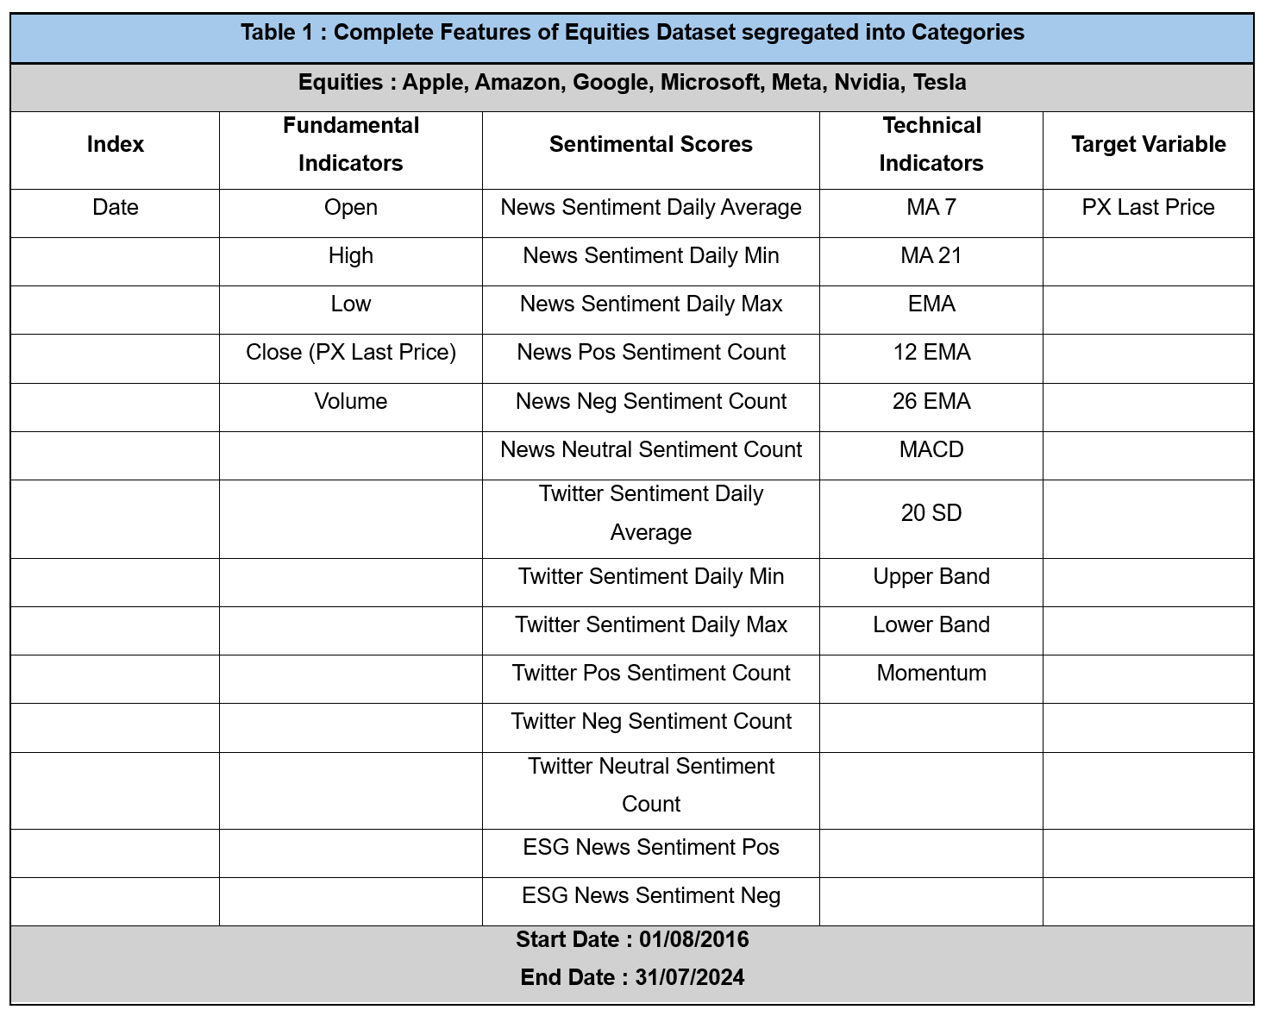

#### Data Types

Upon extracting and loading each equity’s dataset into a dataframe, the features data types are identified to gain a technical understanding of the features. Figure 1 below showcases the data type of each feature in the dataset. From the figure, it is observed that every feature is stored as a float64 data type except the Date feature, which is stored as an object. The details of these datatypes are listed below.

* Object : Data with varying formats are stored in an Object data type
* Float64 : Numbers with decimals are stored in a double precision 64-bit float data type

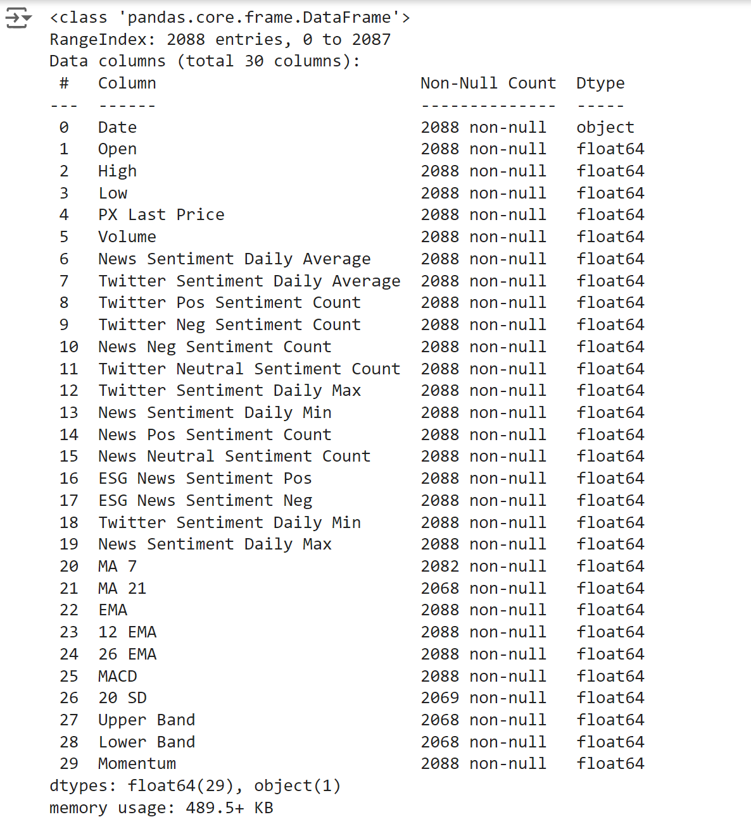  
**Figure 1 : Summary of the Data Types of every Feature in the Equities’ Datasets**

#### Data Cleaning

Data cleaning is a crucial part of the analysis so as to ensure that the data is accurate and consistent (Hillier, 2023). Hence the datasets are checked for the presence of null values in the features. It is essential to identify null values in order to build a robust and accurate classification model (Salman, 2023). The presence of a large percentage of null values in a feature is detrimental to an ML model’s performance since it causes skewed predictions thereby hampering its accuracy (ibid). Upon evaluation, it is observed that there is no presence of null values in the fundamental and sentiment scores features for all seven stocks’ datasets. On the other hand, null values are detected in five of the technical indicators features in each of the seven stocks’ data. Table 2 below showcases the percentage of null values present in the technical indicators features for each of the 7 companies’ data. However, on further analysis, these null values contribute to a small percentage of the total data and are therefore omitted from the data.

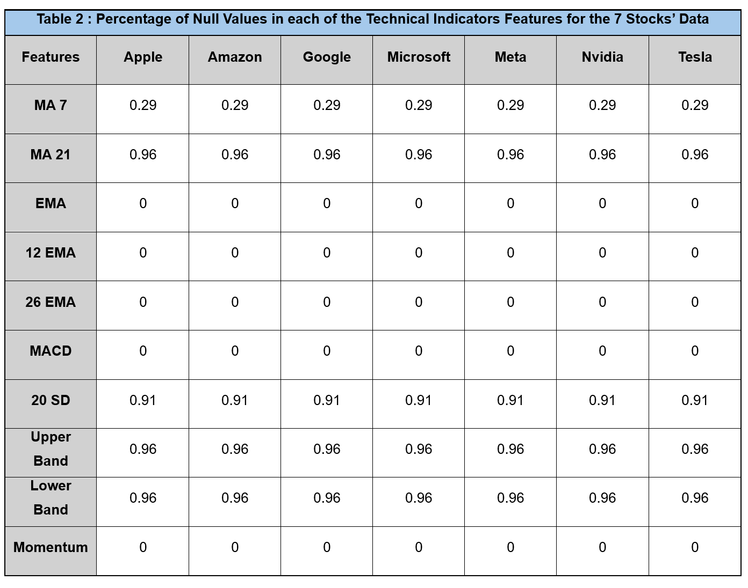

### Data Analysis

#### Descriptive Statistics/ EDA

An exploratory data analysis is conducted in order to acquire valuable insights, observe trends and understand the structure of the data (Awais, 2023). Therefore, a detailed analysis of the sentiment scores features is performed so as to evaluate and compare the sentiment scores data among the seven companies. Initially, the summary statistics of the ‘News Sentiment Daily Average’ feature is obtained and evaluated for each of the seven stocks. Table 3 displays the results of this analysis. From the table it can be inferred that the mean news sentiment daily average of Apple, Google, Meta and Tesla are minutely negative. This indicates that the average market sentiment of these companies, based on news articles, is slightly negative for the selected time period. On the other hand, the mean news sentiment daily average of Amazon, Microsoft and Nvidia is minutely positive indicating a positive market sentiment within news articles.

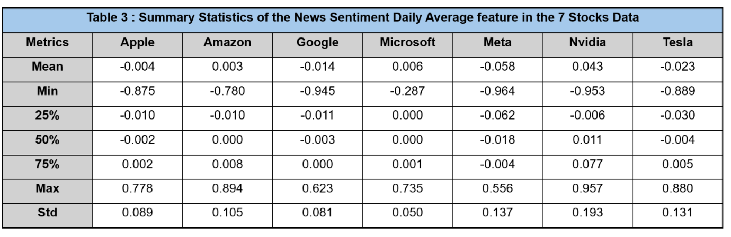

Similarly, the summary statistics of the ‘Twitter Sentiment Daily Average’ feature are calculated for all the seven stocks’ datasets and are displayed in Table 4. Based on the results, it is inferred that the mean twitter sentiment daily average of Apple, Amazon, Google, Meta and Tesla is minutely negative. This indicates a slightly negative market sentiment about these companies on Twitter for the selected time-period. Furthermore, apart from Amazon, the news sentiment and twitter sentiment daily average scores support each other for Apple, Google, Meta and Tesla. In contrast, Microsoft and Nvidia exhibit a slightly positive market sentiment based on the mean twitter sentiment daily average, which is backed by their news sentiment daily average scores.

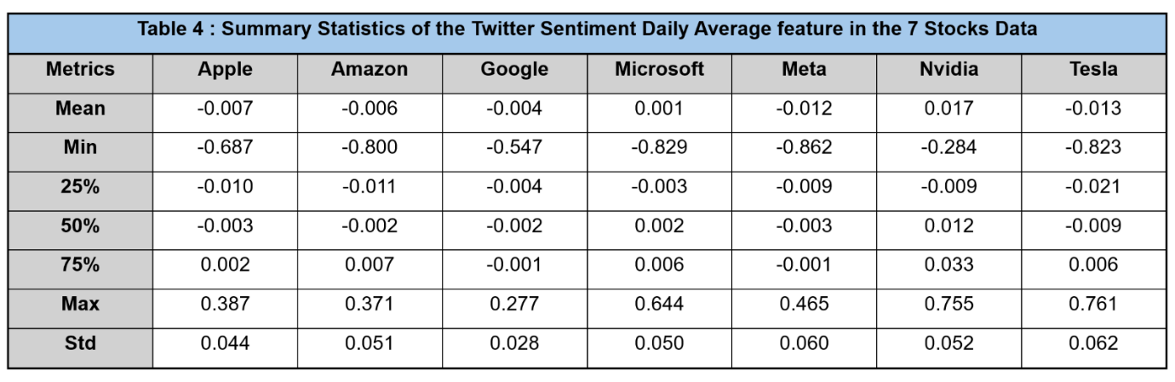

Additionally, it is beneficial to understand the relationship between market sentiment and stock price movements. Figure 1 below showcases a time series chart of News and Twitter Sentiment Daily Average vs PX Last Price for Apple. Based on the chart, it can be generalised that small changes in the market sentiment do not influence PX Last Price. However, it is observed that significant spikes and dips in the sentiment scores impact the movement of PX Last Price. Additionally, it is observed that the deviations in twitter and news sentiment scores are consistent with each other. However, the spikes and dips in market sentiment are more evident in the news sentiment compared to twitter sentiment. 

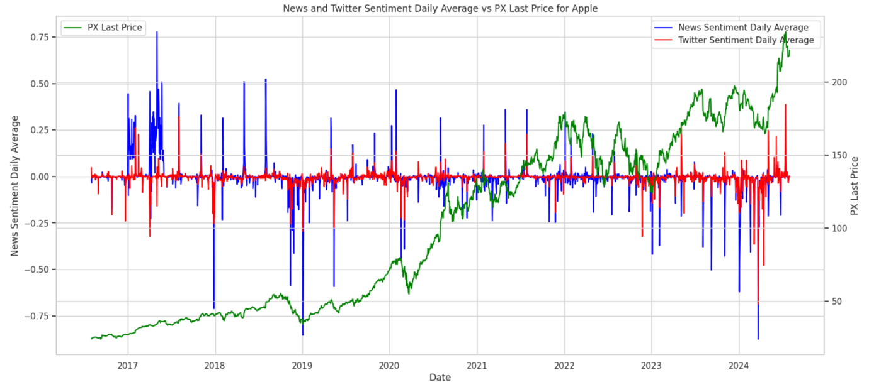   
**Figure 2: Time Series Chart of News and Twitter Sentiment Daily Average vs PX Last Price for Apple**

#### Data Preprocessing

Data preprocessing is an essential part of the analysis so as to remove inconsistencies and irrelevant noise from the data thereby validating the accuracy and reliability of the data for the classification model (Khan, 2024). A significant part of data preprocessing is data cleaning which has already been completed in the previous section of the report. As observed in the previous section, the ‘Date’ feature is stored as an object data type. Since, the ‘Date’ feature is not required for the classification model, it is set as an index in the dataframe and excluded from the analysis.

In addition to this, the stocks’ datasets are assessed for duplicate values in the features. Identifying duplicate values is critical so as to ascertain that these duplicate values do not compromise data accuracy and precision (Hammer et al., 2023). Since no duplicate values are detected in any of the features in the datasets, the data preprocessing phase is concluded.

#### Feature Engineering

**Target Variable : Daily Returns**

The feature engineering phase is an extension of the data preprocessing and includes manipulation as well as augmentation of data so as to prepare the data for the model building and training. In order to provide a comprehensive analysis of the effectiveness of the ML classifier in forecasting stock price movement, a target variable ‘Daily Returns’ is created to measure the percentage change in ‘PX Last Price’. Financial researchers have indicated that the daily returns of a stock provides more insight compared to its stock price since it allows investors to quantify the daily performance and volatility of an equity (Quantified Strategies, 2024). Hence, it is beneficial to use the ‘Daily Returns’ as a target variable in order to evaluate the predictive capabilities of the classification model in forecasting stock price change. In order to prepare the target variable for the classification prediction models, the ‘Daily Returns’ variable is converted to binary variable wherein a positive ‘Daily Returns’ value corresponds to buy (1) and a negative ‘Daily Returns’ value corresponds to sell (0).

**Target Variable Class Balance**

Upon creation of the ‘Daily Returns’ target variable, the label count is assessed to confirm that there is no class imbalance observed in the target variable of all the stocks. This is essential to evaluate since the presence of a class imbalance can result in biased predictions as well as hinder model performance and accuracy. Tables 5 showcases the proportion of each class in the target variable ‘Daily Returns ‘for each of seven stocks. The tables highlight that all the seven stocks’ data exhibited a class distribution ratio between the range of 0.54:0.46 and 0.56:0.44 which indicated that there is no significant class imbalance observed in the target variable for any of the stocks. As a result, the variables do not require any adjustment in class distribution.

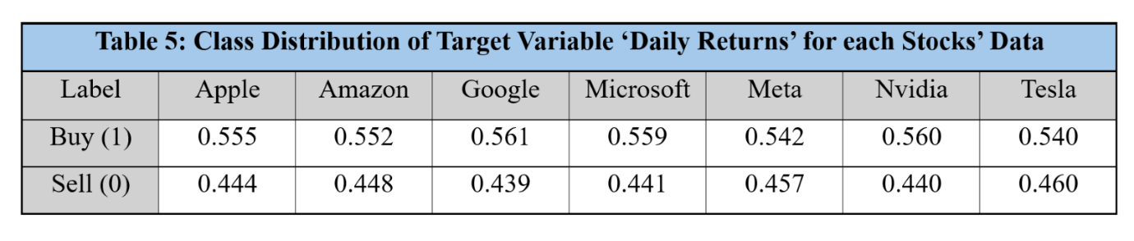

**Splitting data into Train and Test**

Upon creation of the target variables, the datasets are split into x and y variables which represent the input features and the target variable respectively. Furthermore, the datasets are categorized into a training and test set so as to guarantee that the models are trained properly without any data leakage and the models’ performance is tested on unseen data. Since the datasets contain 8 years of daily historical data, the training data is set to the initial 6 years and the test data was set to the remaining 2 years, which corresponds to a 75:25 split ratio.  The data utilized for the classification task is time series data since it contains daily recorded data points. Hence, contrary to traditional approaches, the dataset is not split randomly into a training and test set to preserve the continuity of the data.

**Data Scaling**

Data Scaling is a crucial ML technique that is used to transform the values of the features so as to maintain their values within a specific range (Khoong, 2023). Previous research has shown that data scaling is crucial to optimizing convergence and accuracy of classification models (ibid). In addition to this, data scaling balances the importance of the input features thereby ensuring that there is no bias caused by features with large values (Bhandari, 2024). Due to this, the input features of the train and test data are scaled using a Standard Scaler. This method is chosen for data scaling since studies have highlighted that the Standard Scaler is optimal for classification tasks**.**

### Machine Learning Classification

#### Model Information

To provide a thorough study of the optimal classification model for predicting stock returns movement, multiple ML classification models and algorithms are evaluated and assessed. Table 6 provides a detailed description and explanation of the classifier models used.

|  |  |  |
| --- | --- | --- |
| **Table 6: Classifier Models used for Stock Price Prediction** | | |
| **Name of Classifier Model** | **Model Characteristics** | **Model Selection Criteria** |
| **Logistic Regression** | A supervised learning model that is used in classification problems. The algorithm leverages a sigmoid or logistic function to generate the probabilities of an instance belonging to a particular class (Agrawal, 2017). | Logistic regression is a powerful model that can be leveraged for stock market prediction by creating a buy or sell indication based on modelling the probability of binary outcomes. |
| **Support Vector Machine (SVM)** | SVM is a supervised learning algorithm that is used for both classification and regression tasks. The SVM model calculates the optimal hyperplane in an N-dimensional space thereby categorizing data points into classes (Sasidharan, 2021). | SVM is beneficial for stock market prediction due to its ability to handle small datasets and scale effectively in high dimensional spaces. Additionally, SVM is less prone to overfitting compared to other classifiers (Ngui, 2023). |
| **Stochastic Gradient Descent (SGD)** | The SGD is a supervised linear algorithm that is used for classification. The model aims to locate the optimal decision boundary in order to separate data points into different classes in a feature space. It uses the SGD optimization technique to minimize a loss function (Shi, 2023) | SGD classifier is optimal for stock market prediction in cases where there are large amounts of data available. Additionally, its ability to minimize loss functions allows the algorithm to capture and adapt to dynamic market movements (GeeksforGeeks, 2023) |
| **K Nearest Neighbors (KNN)** | The KNN is a supervised non-parametric algorithm that is used to tackle classification problems. It uses proximity to create groupings of individual data points | KNN is suitable for stock market prediction due to its ability to map complex and non-linear relationships present in financial markets. Previous research has suggested that the KNN model is robust with small error ratio (Alkhatib et al., 2013) |
| **Gaussian Process (GP)** | The GP classifier is a supervised non-parametric algorithm that is used for classification and regression problems It uses Gaussian Processes to obtain probabilistic classification through a link function. | Similar to KNN, the non-parametric capabilities of GP allow it to model non-linear relationships between input variables. Furthermore, previous studies have concluded that the GP classifier is effective in stock index prediction (Wang et al., 2021). |
| **Random Forest** | Random Forest is a supervised learning algorithm that is used in classification problems. It leverages the bagging method to create an ensemble of decision trees to predict an outcome (Donges, 2024) | Random Forest is optimal for stock market prediction when handling large datasets. Furthermore, research  has concluded that Random Forest is powerful in forecasting stock price movement with its ensemble learning capabilities (Zheng et al., 2024). |
| **Extreme Gradient Boost (XGBoost)** | XGBoost is a supervised learning algorithm used for classification tasks. It creates  a predictive model with an ensemble of multiple individual decision trees. (Sonawane, 2023) | XGBoost is beneficial for stock market prediction due to its ensemble learning method that reduces overfitting. In addition, research highlights that the XGBoost model is superior in forecasting stock market movements (Deng et al., 2023) |

#### Model Building

In order to conduct a thorough and detailed study of the optimal classification model for stock market prediction, three iterations of different features are selected and implemented to create the training and testing data. Consequently, the training and testing data are inputted into all the ML classifiers (discussed in the above section) and evaluated on their forecasting accuracy metrics for each stock’s data.

For the first iteration, each ML classifier is trained solely on the fundamental indicators as the input features and the ‘Daily Returns’ as the target variable so as to assess the individual effect of the fundamental indicators in prediction stock market movements. In the second iteration, the fundamental indicators and sentiment scores are combined as the input features along with the target variable in order to train the ML classifiers. This is done so as to measure the impact of the sentiment scores features in improving the predictive capabilities of the ML models in forecasting daily returns. In the final iteration, the ML classifiers are trained on all the input features which include fundamental indicators, sentiment scores and technical indicators. This is completed so as to evaluate the weightage of technical indicators in forecasting daily returns. Additionally, it measures the combined effect of all the input features in modelling and predicting daily returns of all the stocks. Table 7 below details the different permutations of features used to create the ML classifiers for all seven companies.

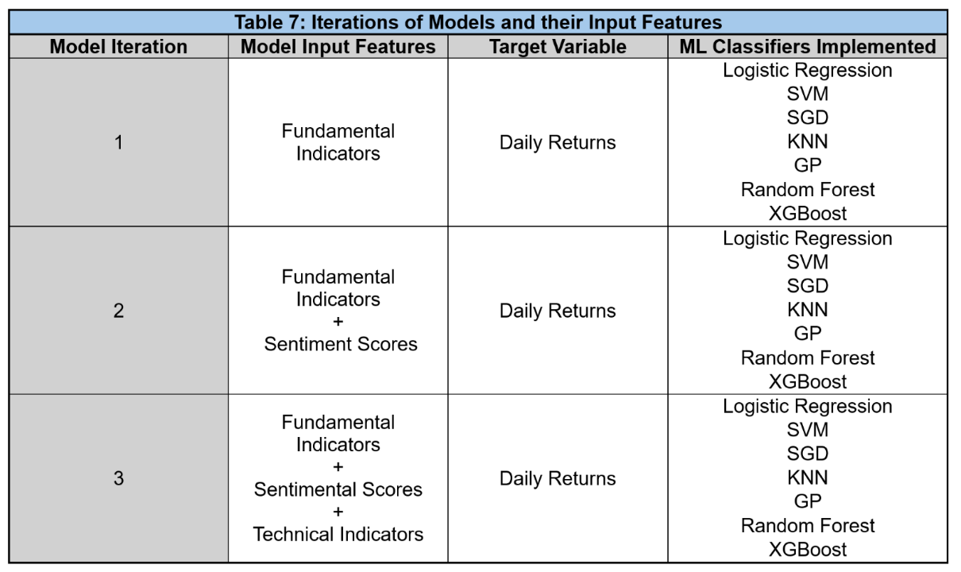

#### ML Packages and Libraries

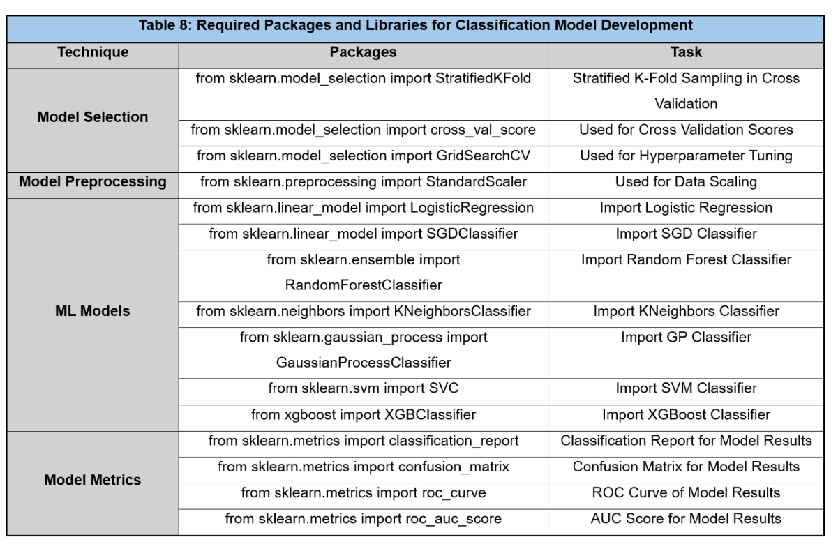

#### Data Preprocessing

### Classification Model Analysis

#### Analysis of ML Model Iterations

As discussed in the Model Building section, three different iterations of model input features are tested on numerous ML classifier algorithms in order to evaluate the effect of the different input features on model forecasting accuracy. The 3 different model iterations were trained using their appropriate input features and then validated on unseen test data for every stock. Table 9 below shows the weighted F1 score of the ML classifiers in the 3 model iterations for Google’s historical data.

Upon comparison of the results of Model 1 with Model 2, it is observed that weighted F1 score increased in Model 2 for the SGD, KNN and GP classifiers. This indicates that the addition of the sentiment score features had a positive effect on its forecasting of daily returns. On the other hand, the SVM and Random Forest classifier showed no change in the weighted F1 score between Models 1 and Model 2. Furthermore, the Logistic Regression and XGBoost classifiers showcased a decrease in the weighted F1 score for Model 2 which indicates that the sentiment score features actually hindered their forecasting capabilities.

On further comparison of the results of Model 3 with Model 1 and 2, it is observed that the weighted F1 scores showed an increase in Model 3 for Logistic Regression, SGD, KNN and GP which suggests that the addition of the technical indicators features increased their forecasting accuracies. In contrast, the technical indicators did not exhibit a positive effect on the prediction results of SVM, Random Forest and XGBoost. Additionally, the results of these classifiers did not exhibit any positive change in the weighted F1 score from Model 1 to 3 which suggests that the sentiment scores and technical indicators features are not valuable variables in predicting stock price movement.

While the sentiment scores feature failed to improve forecasting accuracies in most of the classifiers, the technical indicators enhanced the forecasting metrics in most of the classifiers, particularly Logistic Regression which exhibited the highest weighted F1 score of all the classifier. This implies that the Logistic Regression classifier with the complete input features is the optimal model for predicting stock price change. Similar results and insights are obtained when applied to all the stocks’ datasets.

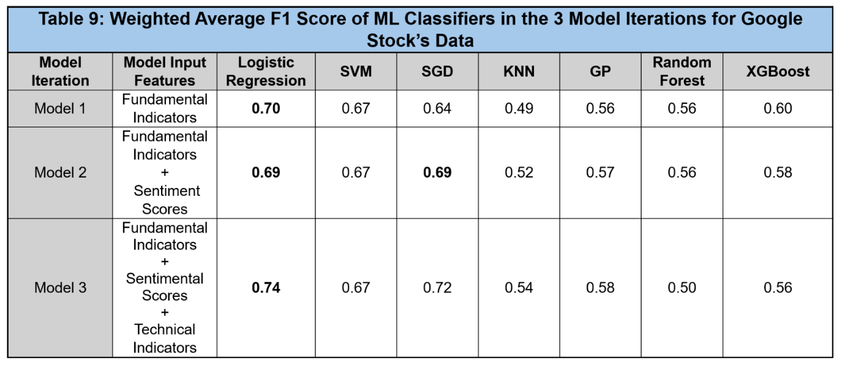

#### Analysis of ML Classifiers using Cross Validation

To provide a comprehensive study of the predictive capabilities of the ML algorithms, a cross validation is performed for each ML algorithm using the training data containing all the input features and the target variable for the entire stocks’ datasets. The cross validation is completed in order to compare and identify the best ML classifiers based on their daily returns forecasting capabilities. Stratified K-Fold sampling is implemented with the number of splits set to 5, where each fold maintains the same proportion of target class distribution observed in the original datasets. Furthermore, the mean F1 score is calculated for each model’s cross validation in order to identify the ML classifier with the optimal mean F1 score. Table 10 below showcases the mean F1 score of ML models for each stock’s data. As can be seen from Table 10, the logistic regression algorithm achieves the highest cross validation mean F1 score for every company. These results suggest that the logistic regression model is the optimal model for forecasting daily returns of stocks. These results are consistent with the findings in Table 9 which also conclude that the Logistic Regression trained on the complete set of input features is the most effective predictive model.

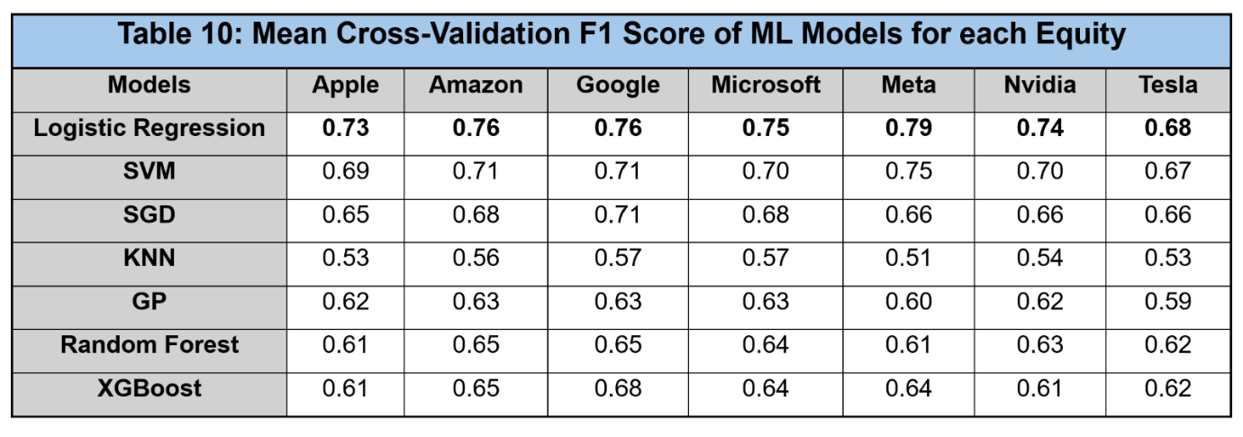

#### Feature Importance

Upon conclusion that the Logistic Regression classifier are the optimal forecasting models for daily returns, it is vital to assess the importance of the features towards the model’s predictive capabilities. Feature importance computes a score for all input features in order to measure the significance of each input variable. Figure 2 below showcases a visual representation of the Logistic Regression  classifier’s feature importance scores for all 3 model iterations using Apple’s financial data.

Based on Figure 2, it can be inferred that the ‘Open’ and ‘PX Last Price’ are the most valuable input features among the fundamental indicators. This is expected since these input variables exhibit a significant correlation with the ‘Daily Returns’ target variable. Furthermore, the figure highlights that technical indicators also showcase a significant score in the feature importance calculation, particularly the ‘Momentum’ feature. This is supported by research conducted by Lansing and Tubbs (2018) who investigated the use of market sentiment and momentum in stock returns prediction. Their research concluded that momentum is a key factor in forecasting stock price movements

 However, contrary to the findings of Lansing and Tubbs (2018), Figure 2 showcases that the feature importance scores of the sentiment scores features are negligible thereby concluding that the sentiment scores are not important features for the Logistic Regression in predicting stock price change. These findings are consistent throughout the seven stocks’ data.

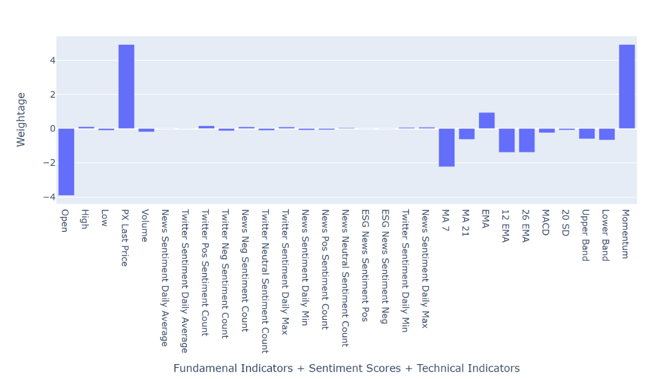   
**Figure 3: Feature Importance Scores of all Input Features for Apple Stock Data** 

#### Hyperparameter Tuning

Once it is ascertained that the Logistic Regression classifier with all input features is the optimal model for forecasting stock price change, it is essential to perform hyperparameter tuning. Hyperparameter tuning is a critical step of ML model development and is used to obtain the optimal parameters so as to fine tune the model (Navas, 2022). This process enables the model to improve its forecasting accuracies. Table 11 below shows the multiple parameters used in the hyperparameter tuning process. On completion of hyperparameter tuning, the ideal parameters of the model are identified and executed to create the fine-tuned Logistic Regression classifier. The final metrics of the fine-tuned prediction model for each equity is displayed in the Results and Discussion section.

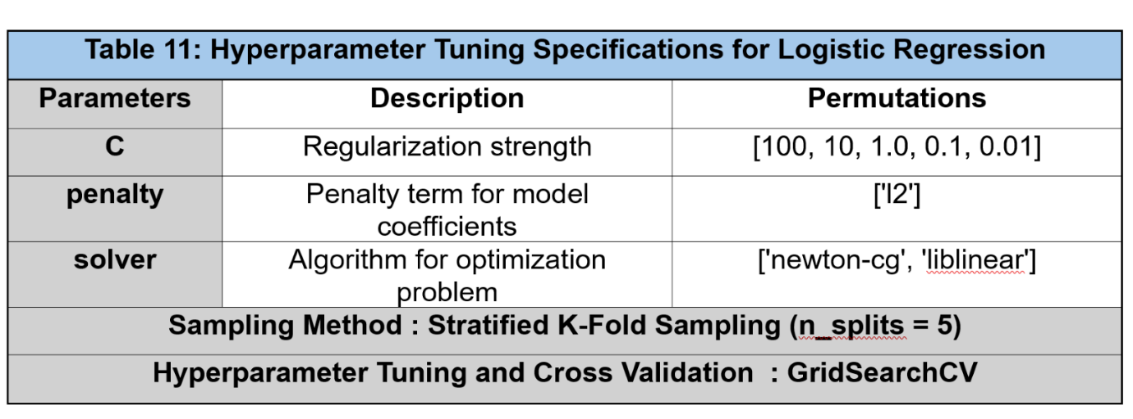

### Results and Discussions

#### Final Results

Table 12 compares the weighted F1 score of the final Logistic Regression model before and after hyperparameter tuning for the seven datasets. The table emphasizes that hyperparameter tuning is significantly effective in improving model performance.

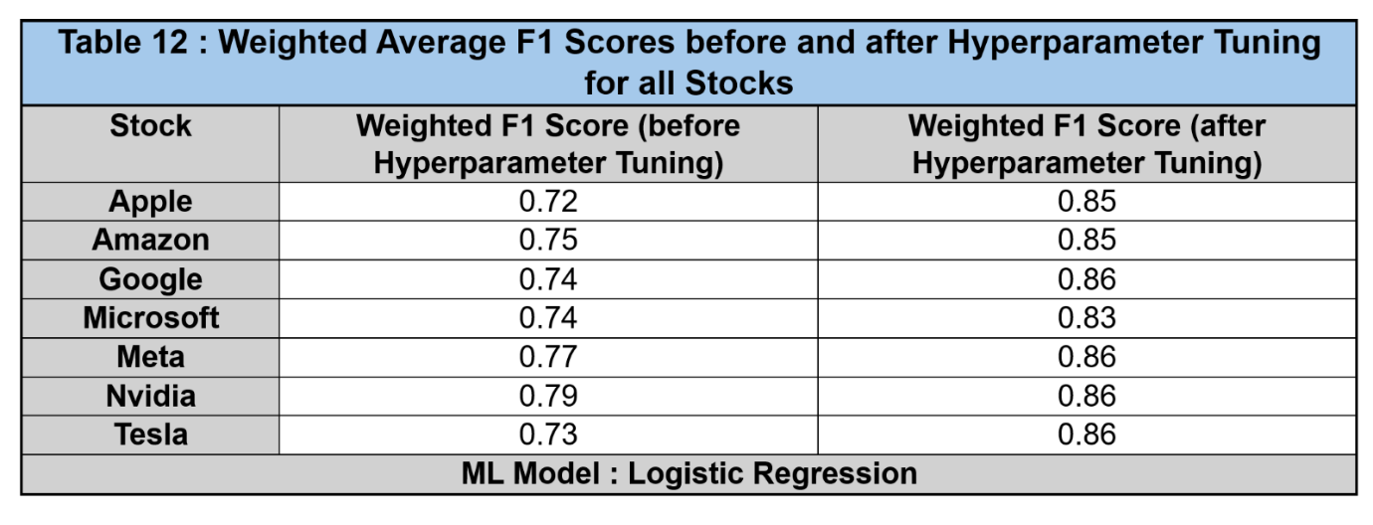

ROC curves are used to visualize the performance metrics of the models. Figure 4 showcases the ROC curves and AUC scores for each of the stock’s models. The figure highlights that all models exhibit similar accuracy metrics. Based on the AUC score, it is concluded that Meta’s Logistic Regression classifier is the best model for forecasting stock price movement. The confusion matrix for this model is displayed in Figure 5

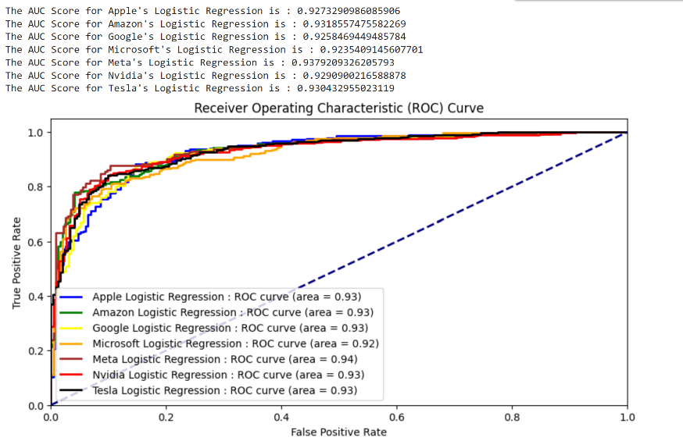

**Figure 4 : ROC Curves and AUC Scores for each stock’s fine-tuned Logistic Regression Model**

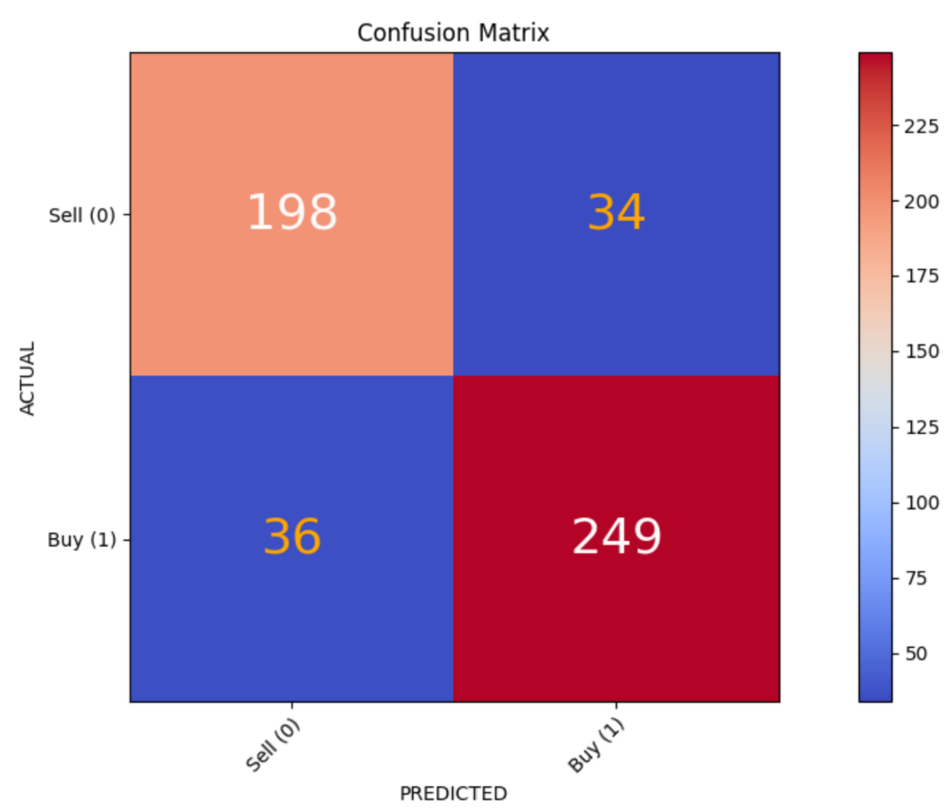   
**Figure 5 : Confusion Matrix of Meta’s Logistic Regression Model**

#### Technical Summary

The objective of developing a classification model is to evaluate the impact of sentiment scores in forecasting stock price movement and generating a buy/sell signal based on the change in stock price. The analysis concludes that fundamental indicators and technical indicators are valuable input features that are necessary for predicting change in stock price. In contrast, the sentiment scores features did not have a significant impact on the forecasting capabilities of the ML classifiers for any of the seven stocks. In addition to this, the analysis concluded that the Logistic Regression is the optimal ML classification model for creating a buy/sell indicator based on change in stock price. These results are consistent throughout the seven stocks dataset.

## Time Series (Ompal Singh Bhati - 230720842)

### Introduction

Time series analysis is a statistical method that uses data that is collected or recorded in specific intervals of time, like daily monthly or weekly. The main core of time series is that data points are not independent of each other but are ordered chronologically in a time sequence, meaning that each data point is dependent or related to the previous one in a series of time.

Time series generally works on 3 components, which are trend, seasonal and noise component. The below graphs show observed time series which contains all the components.

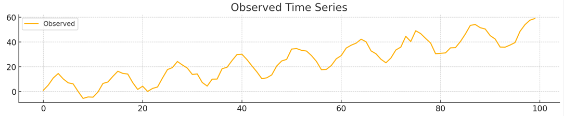

When each component is broken into its separate graph, the charts below would represents its standalone identity of the component and together they make the observed chart in a very easily recognizable pattern.

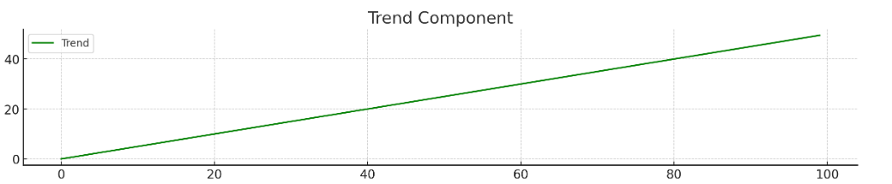 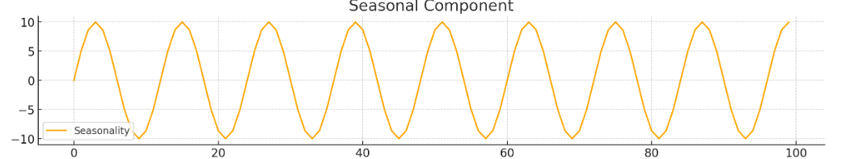

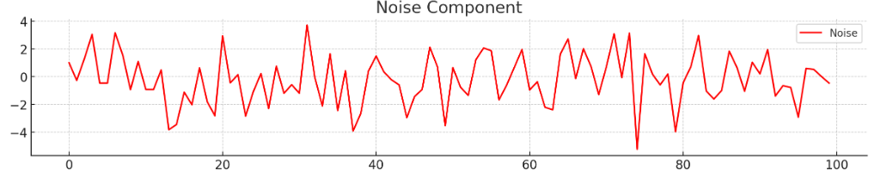

The trend component is in a much larger timeframe suggesting an upward or downward trend, whereas season component highlights the repeating pattern at regular intervals and the noise is made up by random fluctuations which cannot be explained by the trend or seasonality. Another important factor to time series analysis is autocorrelation, it measures how data points in a time series are related to each other; in this context, higher correlation indicates that the price today is highly correlated to the price from previous days.

Time series models like ARIMA, SARIMA, and FBPROPHET have been extensively studied for stock market prediction. ARIMA performs well with the stable and linear data, it performs well to capture relationships between linear and seasonality in time series data (Sunki et al., 2024). While on the other hand, SARIMA performs better than FBPROPHET for Indonesian stocks according to a study conducted by (Ferdinand et al., 2024). While Prophet surpassed ARIMA for Myanmar stocks, meanwhile ARIMA and PROPHET are suitable for short term predictions (Chan, 2020). These models have been consistently used to study trends and patterns, also predicting change in prices in stock markets. Therefore, these models have been selected the analysis on stock market using time series.

### Benefits of using time series

Time series models offer several benefits when applied to the stock market for analysis, some of them are listed below:

* *Capturing past dependencies-* Unlike other forms of data analysis and machine learning models, time series models explicitly consider the factor that the price of the stocks will be influenced by the previous prices of the stocks. This dependency is very crucial for the financial markets, where the past price movements and market trends heavily influence the future prices.
* *Tailored Forecasts-* Each stock exhibit different trends and patterns in seasonality, like TSLA have high volatility with strong seasonal patterns, where as AAPL have a steady upward trend. Time series models allows to tailor forecasts to each stock’s unique characteristics.
* *Modelling Complex Relationships –* Time series models like ARIMA and SARIMA both incorporate autoregressive and moving average components, which helps them build complex relationships between past and future values. In autoregressive component, lag variables are used for time series models to understand temporary dependencies.

### Data & EDA

#### Variables

Time series models only require one variable: the target variable which must be predicted over the period. The variable used for the time series is PX_LAST, as it is the target variable intended for prediction and further study. PX_LAST is also termed as last traded price of the stock, is more standardised as compared to other price points such as open, high and low as it provides consistency. This is because PX_LAST represents last price of the period and can be considered the price for the day on a larger time frame.

#### Data Preparation

Data preparation is a very crucial part of any model analysis, ensuring that the data is consistent, clean and ready for modelling. The following process outlines steps involved in data preparation and processing:

The data preparation process follows a flowchart that explains the flow in which the data is fetched and processed before they are used for the models for time series. The focus here is on the first 3 steps-

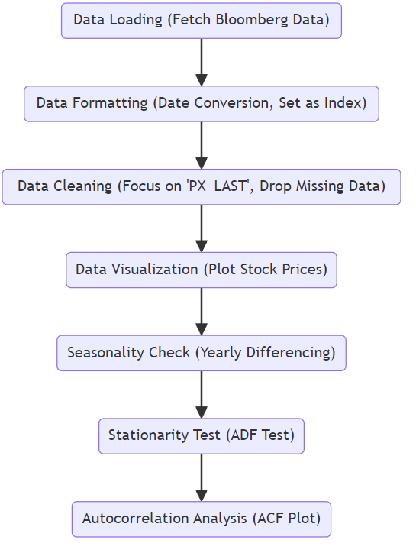

Data loading is done by fetching data from the Bloomberg using BLPAPI. The following code is responsible for creating a session for the API and fetch data from it:  
def fetch_bloomberg_data(tickers, start_date, end_date):

    from blpapi import SessionOptions, Session

    from blpapi import Request

    sessionOptions = SessionOptions()

    session = Session(sessionOptions)

After the session is created, an empty list of data is initialized and the data is to be fetched into this variable using a while loop, as shown below:

data = {}

    while True:

        ev = session.nextEvent()

        for msg in ev:

            if msg.hasElement("securityData"):

                securityData = msg.getElement("securityData")

                security = securityData.getElementAsString("security")

                fieldDataArray = securityData.getElement("fieldData")

                prices = []

                dates = []

                for fieldData in fieldDataArray.values():

                    date = fieldData.getElementAsDatetime("date").strftime("%Y-%m-%d")

                    price = fieldData.getElementAsFloat("PX_LAST")

                    dates.append(date)

                    prices.append(price)

                data[security] = pd.Series(prices, index=pd.to_datetime(dates))

        if ev.eventType() == blpapi.Event.RESPONSE:

            break

The function is then called with a list of stocks for which data is to be fetched, including the start and end dates for data retrieval:  
# Define the stocks (Bloomberg tickers)

stocks = ['NVDA US Equity', 'AAPL US Equity', 'TSLA US Equity', 'META US Equity', 'GOOGL US Equity', 'MSFT US Equity']

# Download historical stock price data from Bloomberg

data = fetch_bloomberg_data(stocks, '20200101', '20240601')

In the next stage of data formatting, for ARIMA and SARIMA, only the Date as index and PX_LAST as the variable are needed. Therefore, in ARIMA and SARIMA models, the Dates column is converted to datetime and set as the index of the data frame for straightforward indexing and time-based analysis. is the last price therefore the data frame is filtered and PX_LAST is the only column included in the analysis.

For FBPROPHET, the variables should be named specific way using ‘ds’ and ‘y’ because this is how the model prefers data for input, hence Date is stored in the ‘ds’ column of the data frame and ‘y’ contains the PX_LAST price of the stocks. The following code snippet shows a method which converts the data:

def prepare_prophet_data(df, stock_name):

    df_prophet = df.reset_index().rename(columns={'index': 'ds', stock_name: 'y'})

    return df_prophet

Data cleaning is a very crucial part of preprocessing, as it prevents the models from running into errors and make it ready for execution. For these models, the dataframe.dropna() function of pandas to drop the columns with null values. Since there is just one variable, PX_LAST, any null values for any date, the row will be dropped.

    df = data[[stock]].dropna()

    df_prophet = prepare_prophet_data(df, stock)

This ensures that the values have been dropped before the data is formatted for the FBPROPHET model.

#### Analysing Patterns in Data

The analysis of the stocks selected aims to identify any trends and patterns that could be helpful for the time series models; which depends on underlying patterns (as discussed in the methods section of time series analysis). This analysis is aimed to evaluate how and to what measure the data is fit for the time series analysis. The study focuses on three major patterns and trends in the data weekly, monthly and yearly timeframe:

Long term patterns are useful while understanding the stock performance and can be useful for the time series model. The below graphs exhibit that most companies have a growing trend, except TSLA. Along with that in the Yearly Returns chart, all the stocks have an evident dip in 2019, 2020 and 2023, and the returns are increasing till 2024. These patterns will set the base for the time series models for longer terms of predictions and analysis.

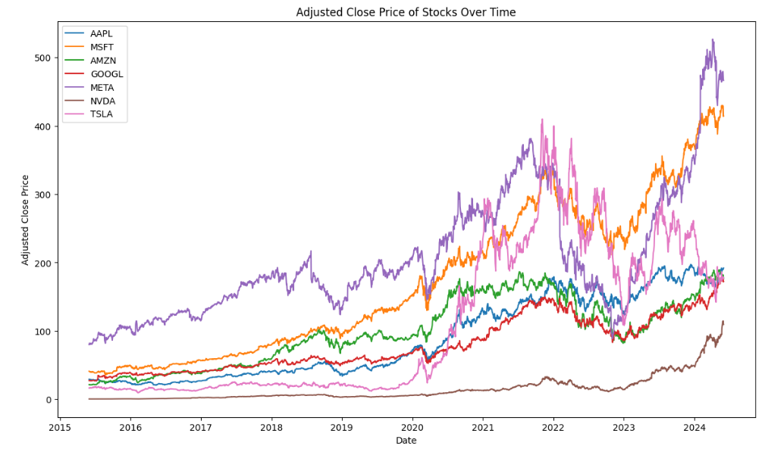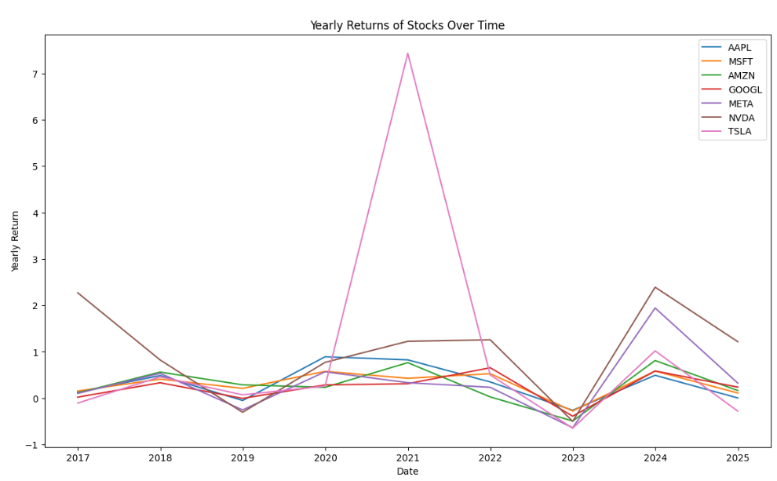

Volatility and Volume have huge implications on stock prices and realising patterns in these fields will help understand if time series models will be better suited for stock price prediction. Starting with the volatility, below graphs show how volatile the stocks are on certain days of the week and certain months of a year.

Here volatility is calculated with the standard deviation of the returns over a week and a year.

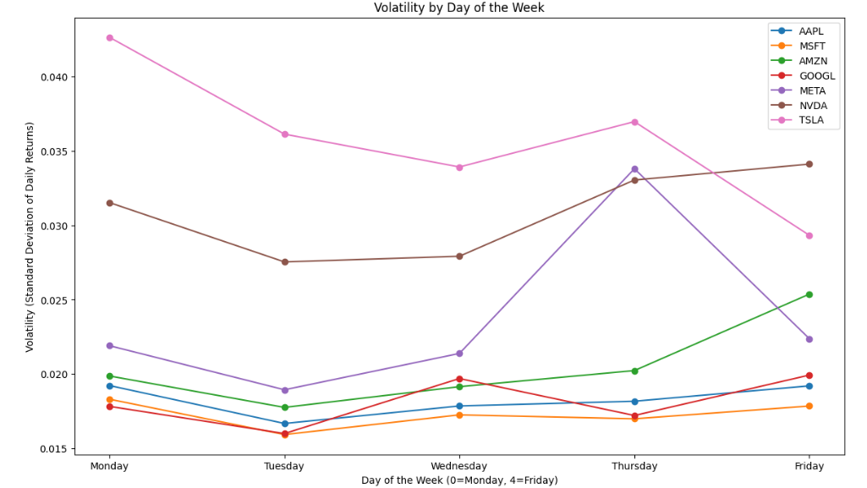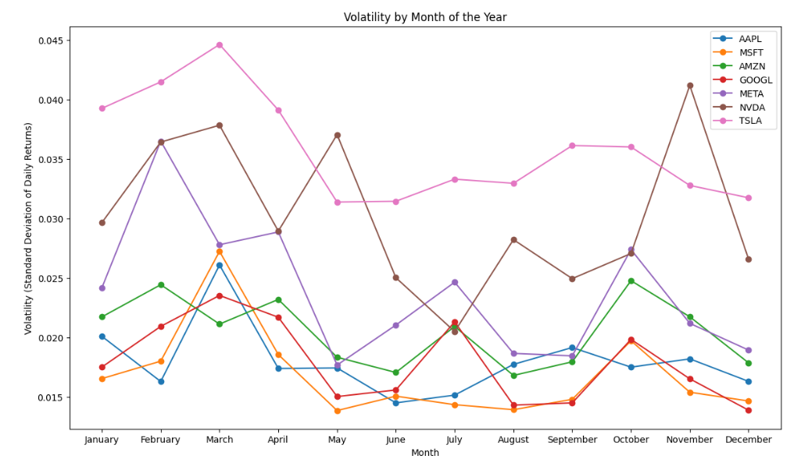

A general pattern observed is that the prices are more volatile on Mondays for TSLA, MSFT and AAPL; while GOOGL and META have more volatility on Wednesday and Thursday respectively. But for all the stocks, volatility is high on Monday and then decreases on Tuesday, this could be due to news releases on the weekends. Similarly, market is very volatile for most stocks around March due to end of financial year season. This suggests that a seasonal component to these stocks can be modelled in time series forecasts.

Regarding volume, the analysis of volume is based on average trading volume over a week and a year; therefore charts below depict that Fridays have more volume for all the stocks, higher volume often indicates higher price changes, making these days more predictable to future price changes. Similarly, over the span of a year, months like February and March have high volume as compared to other months.

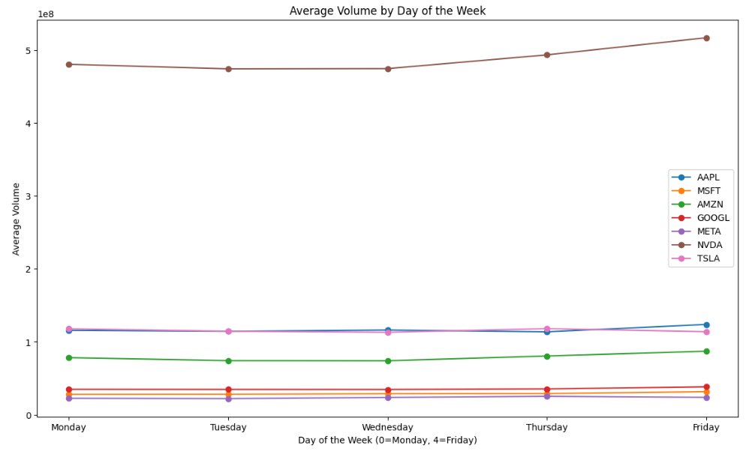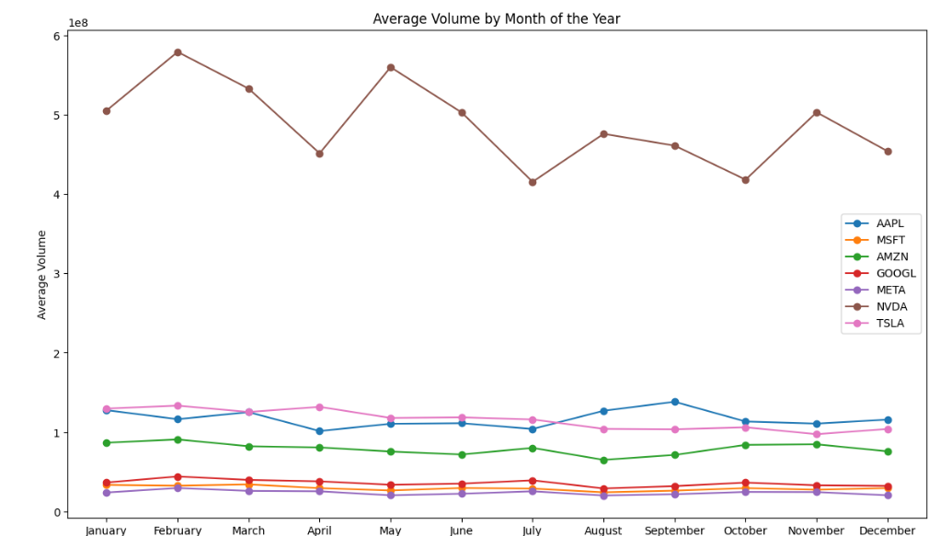

The identified weekly and monthly patterns in volatility and volume provide clear evidence of seasonality in the data. Using time series models like SARIMA or FBPROPHET (which uses Fourier Transforms) can incorporate these seasonal effects to improve forecast accuracy. The yearly price and return patterns help identify the long-term growing or declining patterns; these patterns can be very well used by ARIMA model which has ability to predict long-term movement rather than short-term fluctuations. Therefore, analysis of these patterns indicates that various time-series models can be used for further predictions and analysis.

### Methods & Analysis

#### Seasonality, Stationarity & Autocorrelation

Before dealing with time series models, it is important to understand key concepts for time series modelling, these terms and processes will be used in time series analysis. The methods and tests associated with each concept is explained as well:

Seasonality is defined as patterns or cycles in time series data, which are repeated after regular intervals of time. In financial markets, these patterns or trends can appear during certain periods in a year. Seasonality is important in time series because:   
a) seasonal effects can mask underlying patterns, b) if seasonality is not considered, the models might become systematically biased and fail to predict short term patterns and c) certain seasons have high volatility and investors should proceed with caution in these trends.

These seasonal influences can be removed from the time series data by performing differencing, making it stationary. The following is a differencing technique in general terms:

$$Y_{t}^{,}=Y_{t}- Y_{t-m}$$ where:

- is the differenced data,

- is the original data and

- is the season impact you wish to eliminate.

The differencing described is ***first order differencing***, if a pattern is continuing, second order differencing may be applied, which involves performing first order differencing twice to remove additional patterns from the data.

Stock prices typically describe seasonality with the rise at the beginning of the year and falls during August and September. This seasonal behaviour can occur due to various factors, such as fund managers trying to improve their portfolios at the end of the year, year-end bond coupon payments flowing into the stock market, and the positive investment sentiment during the holiday season (Jagwani et al., 2018). This paper also mentions that non-seasonal factors, such as significant market events like the crash of 1987, can alter these seasonal trends​ ([in Section 3](https://ieeexplore.ieee.org/stamp/stamp.jsp?tp=&arnumber=8663035) – Variation in Trends). Similar, a study done by Desai et al., (2011) talks about a seasonality effect mentioned as “monthly effect”, where the returns on equities are higher in the first half of the month as compared to the second half of the month. The study later discusses “turn of the month effect”, where the returns are abnormally higher towards the end and the start of the month; this study accounts several Indian stocks from year 2000 to 2010.

Stationarity is one the important concepts of time series, if a time series data is stationary that means the statistical properties of mean, variance and autocorrelation are constant over time. This concept is important because models like ARIMA consider the series to be stationary and non-stationary data can lead to poor model performance. The time series becomes easier to predict as the statistical values does not change across time. To ensure a series is stationary ***ADF test (Augmented Dickey-Fuller test)*** is used. The null hypothesis in ADF test is that the series is non-stationary, after the test, if the p-value in the ADF test is less than 0.05, then the null hypothesis is rejected and the series is concluded to be stationary.

Autocorrelation is used to measure correlation between a time series with its own past values. It is used to understand how persistent the series is and whether it is leading to trend or a seasonal effect. Autocorrelation is used to determine appropriate lag for ARIMA. The autocorrelation of residual can show that the model is missing some important factor; as the residuals are correlating and have a dependency between them. The test widely used to check the randomness of residual from a model is ***Ljung-Box test***. The residuals are obtained from the fitted model and perform a Ljung-Box test to check for autocorrelation. If the p-value is greater than 0.05, the residuals are random and are not autocorrelated.

#### Introduction to Time Series Models.

There are 3 time series models, which are going to be used in the analysis. These models are ARIMA, SARIMA and FBPROPHET. The components and flow of these models will be discussed respectively and how these models work.

##### ARIMA

The first model is ARIMA, it is also termed as AutoRegressive Integrated Moving Average. ARIMA is effective in non-stationary time series data with trends for forecasting. This model consists of 3 main components: a) Autoregression component, b) Integrated component and c) moving average component (Luceño and Peña, 2008). The autoregression component captures the relationship between an observation and certain number of past observations; this component is denoted by parameter p, which represents the number of lagged observations used. The Integrated component is responsible for making time series stationary; the parameter for integrated component is defined by d and represents the number of differences taken. The final component moving average, this indicates the number of errors in lagged forecast, this component is denoted by q and denotes the period for which moving average is considered.

The ARIMA model is then expressed as **ARIMA (p,d,q)**;

|  |  |
| --- | --- |
| p= | order of the autoregressive part; |
| d= | degree of first differencing involved; |
| q= | order of the moving average part. |

(Hyndman and Athanasopoulos, 2018)

For instance, ARIMA (4,2,5) means the series is differenced twice, last 4 values are differenced in the autoregressive component and includes 5 lagged forecast errors. The values of p and q are determined by ACF/PACF (Autocorrelation function/Partial ACF).

**Autocorrelation Function** - The ACF plot shows the lagged values of the time series at different delays (). It facilitates the measurement of the series's present value's degree of correlation with its past values. Should the data come from an ARIMA (0, d, q) model, the ACF plot will often show a long decrease following a significant spike at lag q. This sequence helps determine the value of q.

**Partial Autocorrelation Function** - After removing the effect of intervening delays, the PACF plot displays the time series' correlation with its lagged values. It reduces the effects of other intermediate delays eliminates the direct impact of a delayed value on the current value. The PACF plot will often show a significant spike at lag p if the data follows an ARIMA(p, d, 0) model and no noticeable spikes following this period. This pattern helps one find the value of p.

The components and processes for ARIMA can be seen in the graph beneath:

The process starts with the data collection and preprocessing, after that the stationarity check is done using ADF test and differencing is done if the data is not stationary. Then the values of p, d and q are determined for the series.

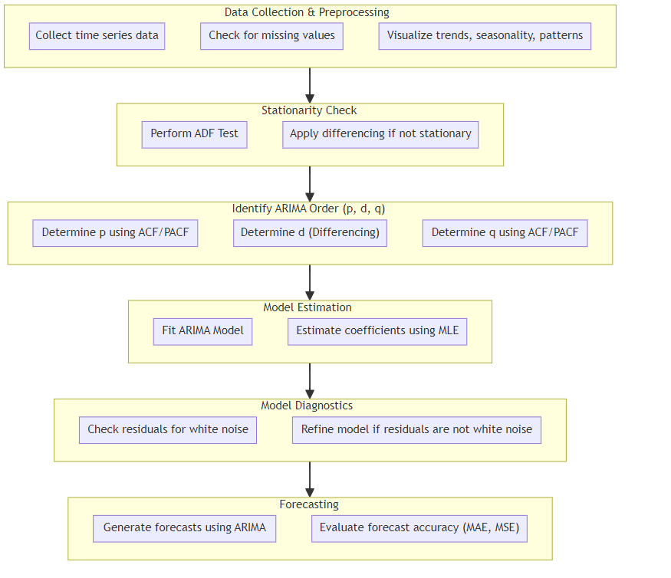

After determining the values of p,d and q, the ARIMA model is now fitted to the series dataset. Once, the model is fitted, the residuals from the model are retrieved and tested that if the residuals have autocorrelation between them; this is done by Ljung-Box test and if the p-value>0.05, the residuals are considered white noise and if the p-value is<0.05, then they have autocorrelation between them (Box et al., 2016).

If the residuals are white noise, the next and final step is forecasting. These forecasts are tested against the actual data and to calculate MAE (Mean Absolute Error) and MSE (Mean Square Error) (Hyndman and Athanasopoulos, 2018).

##### SARIMA

The next time series model is SARIMA, often called as Seasonal ARIMA. Seasonal ARIMA is an extension of ARIMA model which supports time series data with a seasonal component. SARIMA is commonly used to forecast time series data with seasonal trends (Hyndman and Athanasopoulos, 2018).

The ARIMA model is then expressed as **SARIMA (p,d,q)(P,D,Q,m)**;

|  |  |
| --- | --- |
| p,d,q= | These components are same as ARIMA components |
| P= | The number of seasonal autoregressive terms; |
| D= | The number of seasonal differences applied; |
| Q= | The number of seasonal moving average terms; |
| m= | The number of time steps for a single seasonal cycle. |

(Hyndman and Athanasopoulos, 2018)

The components and process for SARIMA model is explained below:

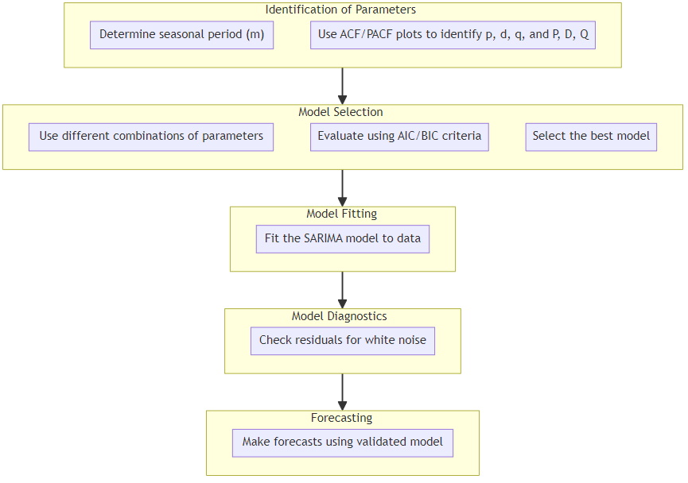

The first step is to identify seasonal period (m) which is the number of time steps per seasonal cycle. For monthly data with yearly seasonality, m equals 12. This phase is important, since it specifies the length of seasonality that the model will record (Box et al., 2016). Non-seasonal components(p,d,q) and Seasonal Components(P,D,Q,m) will be identified using ACF/PACF plots (Hyndman and Athanasopoulos, 2018). To choose the best-fitting model, experiment with different combinations of p, d, q and P, D, Q. This involves trying out many models and determining which one gives the greatest fit to the data; The two criteria used to evaluate many models are the Akaike Information Criteria (AIC) and Bayesian Information Criteria (BIC) (Akaike, 1974). The model is selected whose AIC and BIC score is the lowest (Hyndman & Athanasopoulos, 2018). With the identified non-seasonal and seasonal components, the SARIMA model is used to fit the data. Similarly, as ARIMA, the residuals are checked using Ljung’s Box test, with a mean of zero, constant variance, and no autocorrelation, the residuals should depict the qualities of white noise. Finally, the time series is forecasted using the validated model (Hyndman and Athanasopoulos, 2018).

##### FBPROPHET

Designed by Facebook, Facebook Prophet, often known as FBProphet or Prophet, is an open-source forecasting tool for time series data—especially those with daily observations showing seasonality and holidays. This is a relatively new model, it is developed by Facebook’s Core Data Science team and launched in 2019. It is especially helpful for business forecasting as the time series data typically shows complicated but predictable trends.

The following table shows the components of the FBProphet table with its description:

|  |  |  |  |  |  |  |  |  |  |  |  |
| --- | --- | --- | --- | --- | --- | --- | --- | --- | --- | --- | --- |
| | **Component** |  | | --- | --- |  |  |  | | --- | --- | |  |  |  |  |  | | --- | --- | |  |  |  |  |  | | --- | --- | |  |  |  |  |  | | --- | --- | |  |  | | Description |
| Trend Component | Piecewise linear and logistic growth models. |
| Seasonality Component | Yearly, weekly, and daily seasonality using Fourier series. |
| Holiday Component | Impact of holidays on the time series. |
| Additive vs. Multiplicative Models | Difference between additive and multiplicative combinations of components. |

FBProphet's trend component captures the long-term direction of data using either a piecewise linear model, which is appropriate for linear growth with possible alterations, or a logistic growth model for data with capped growth. The seasonality component simulates recurrent patterns on a monthly, weekly, or daily basis, employing Fourier series to capture complicated effects. The holiday component enables the explicit integration of holidays by generating dummy variables that evaluate their influence on time series. Finally, depending on the properties of the data, FBProphet combines these components additively (summed) or multiplicatively (seasonal and holiday impacts scaled by the trend) (Taylor & Letham, 2017).

The following illustration gives an idea how the model can use additive and multiplicative combinations of the components:

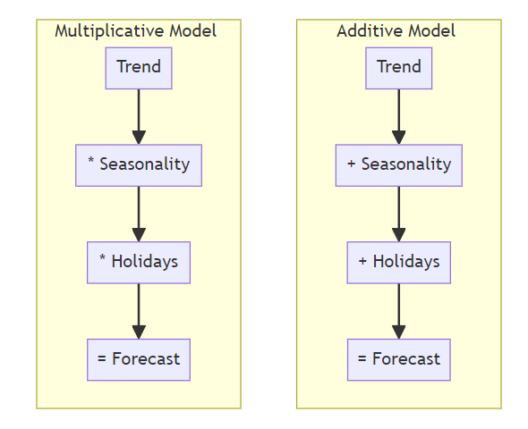

The multiplicative combinations combine the effects of seasonality and holidays by multiplying them for the development of forecast, while the additive model sums them for the result effect.

The process through which FBProphet model executes the forecasting and implementation is as follows:

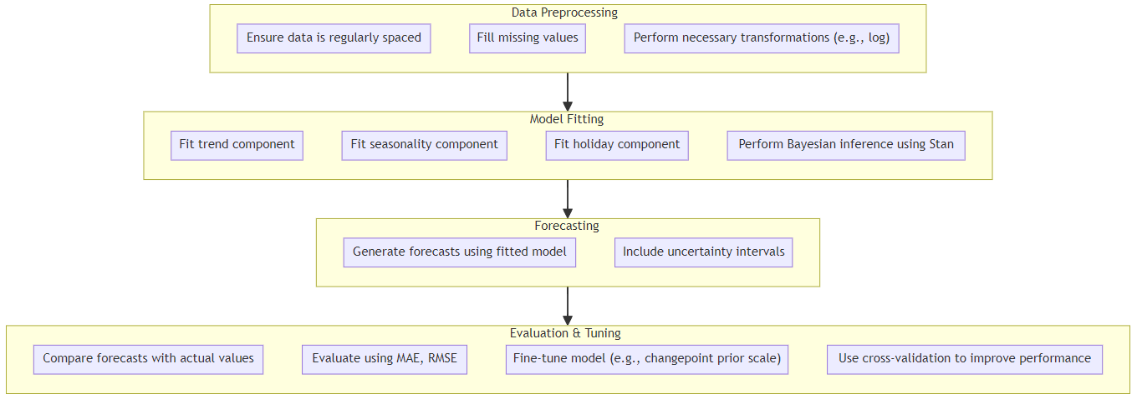

Data preparation starts the FB Prophet process; time series data is generated by ensuring consistent spacing, filling in missing values, and performing required transformations. After that, the data—which consists of a date column (ds) and a metric to predict (y)—is utilised in model fitting where in FB Prophet estimates the optimal parameters for trend, seasonality, and holiday components using Bayesian inference applied via the Stan programming language. The model creates predictions with both expected values and uncertainty ranges after it is fitted. Lastly, the accuracy of the model is assessed by means of MAE(Mean Absolute Error) or RMSE(Residual Mean Square Error); so, users may manually designate changepoints, modify hyperparameters, or use cross-valuation to improve performance (Taylor & Letham, 2017).

FBProphet has a built-in interesting way of handling outliers, it manages outliers by using a specialised loss function. Instead of the typical mean squared error, FBProphet uses the Huber loss function, which is less sensitive to big deviations (outliers) than the traditional quadratic loss. This enables the model to fit a large portion of the data well without being excessively impacted by extreme values, decreasing the effect of outliers on trend and seasonality components (Taylor & Letham, 2017).

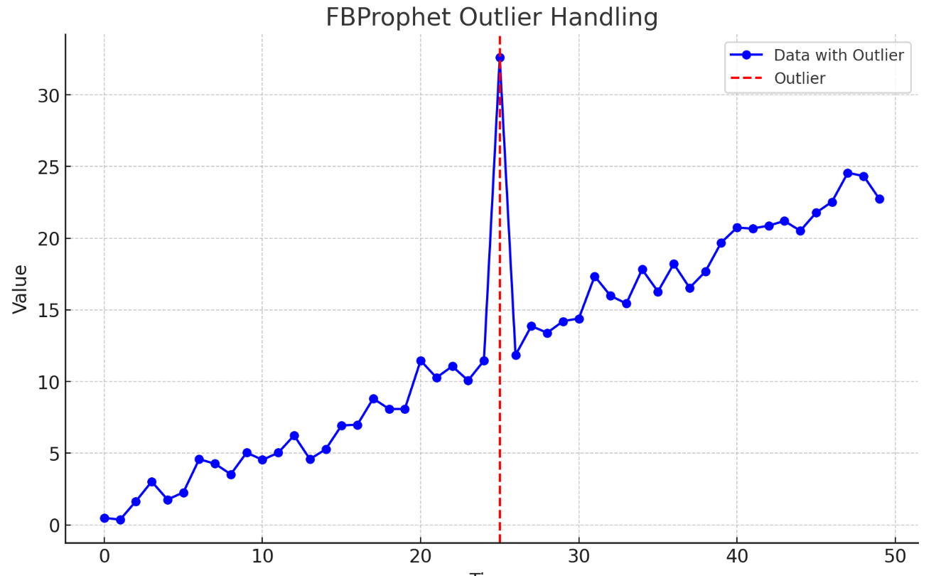

The above visualisation shows how FBProphet manages outliers. The red dashed line indicates the location of an outlier in the data, which FBProphet would reduce using its robust loss function, minimising the outlier's influence on the model's predictions.

#### Model Implementation

The ARIMA model has three parameters: 𝑝 (number of lag observations), 𝑑 (degree of differencing), and 𝑞 (size of the moving average window). In this implementation, the Meta stock data's closing prices were differenced to establish stationarity, which is critical for the model's precision. The ARIMA model was fitted with p = 4, d = 1, q = 5. The differencing was calculated using ACF/PACF plots in which after differencing lower correlation is showed. The left graph shows autocorrelation before and right one shows after differencing has been done.

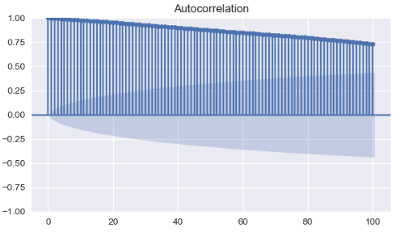 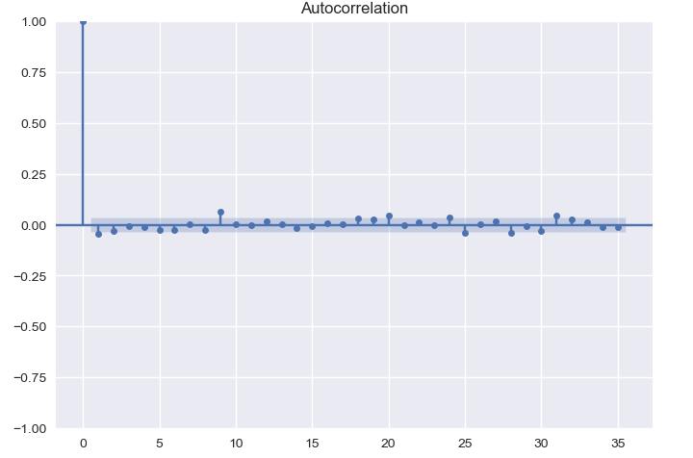

The parameters are then optimised using optimise_ARIMA() that was created. The resulting dataframe contains the parameters with their corresponding AIC score (as shown below). The p and d values are selected where the AIC score is lowest and ARIMA (4,1,5) comes to be the lowest with the AIC score.

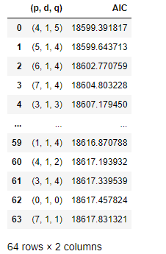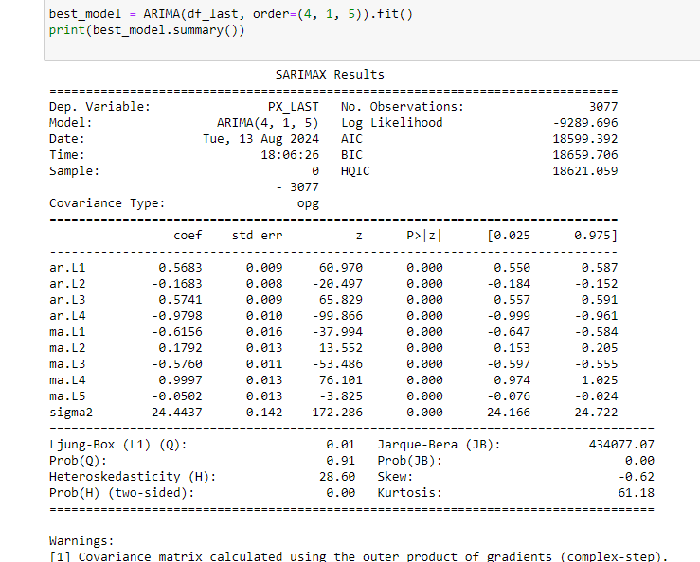

The best model is then used to forecast the test dataset, using the following command:

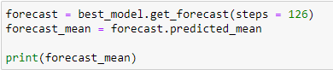  
  
Implementing the SARIMA model, which adds seasonal components to ARIMA, is better suited for datasets with seasonality. The SARIMA model for Nvidia stock was constructed using parameters p=3, d=1, q=4, coupled with seasonal parameters P=1, D=1, Q=4, and s(or m)=12 to represent yearly seasonality. Forecasts for the next 30 days were created, with confidence intervals set to account for uncertainty. Like ARIMA the differencing is decided using the ACF plot as shown below in before(left) and after(right) plots:  
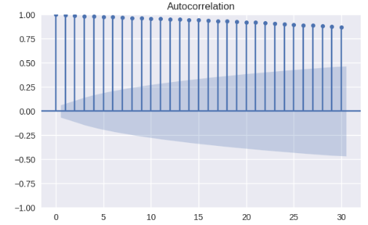 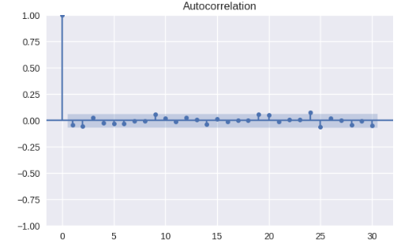

After determining the differencing parameter, the best_param() method defines the best parameter for the models, the result of the function is shown below:

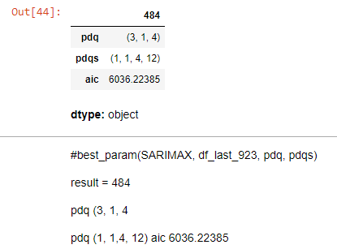

For FBProphet, the process to fit the model and implement is fairly simple, FBProphet has make_future_dataframe() method to create a dataframe with future dates for prediction. Once the initialization is done to model() from Prophet(), then model.predict(future) can be used to fill in the forecast values in the future dataframe that was created.

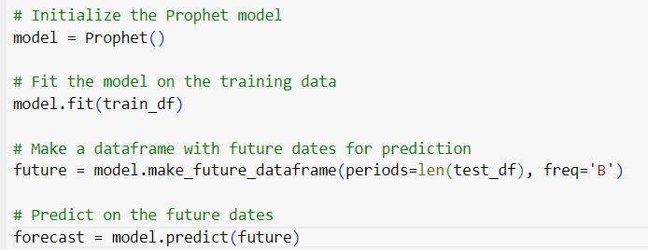

### Results

#### Comparison and Interpretation of Results

This The comparison of multiple time series models (ARIMA, FB Prophet, and SARIMA) applied to the chosen stocks—META, Microsoft, Google, Nvidia, Tesla, Apple, and Amazon—highlights considerable disparities in the predicted accuracy among models and companies. The measures evaluated include Mean Absolute Error (MAE), Mean Squared Error (MSE), Root Mean Squared Error (RMSE), Relative Squared Error (RSE), and R-squared (R2), which give insights into the efficiency of each model in projecting stock prices.

#### ARIMA Results

The ARIMA model often displayed substantial error rates, notably for Microsoft, Amazon, and Nvidia, as indicated in their very high MSE and RMSE values. Moreover, the negative R2 values across all stocks imply that the ARIMA model failed to explain the variation in stock prices well, indicating that this model may not be well-suited for this specific time series data.

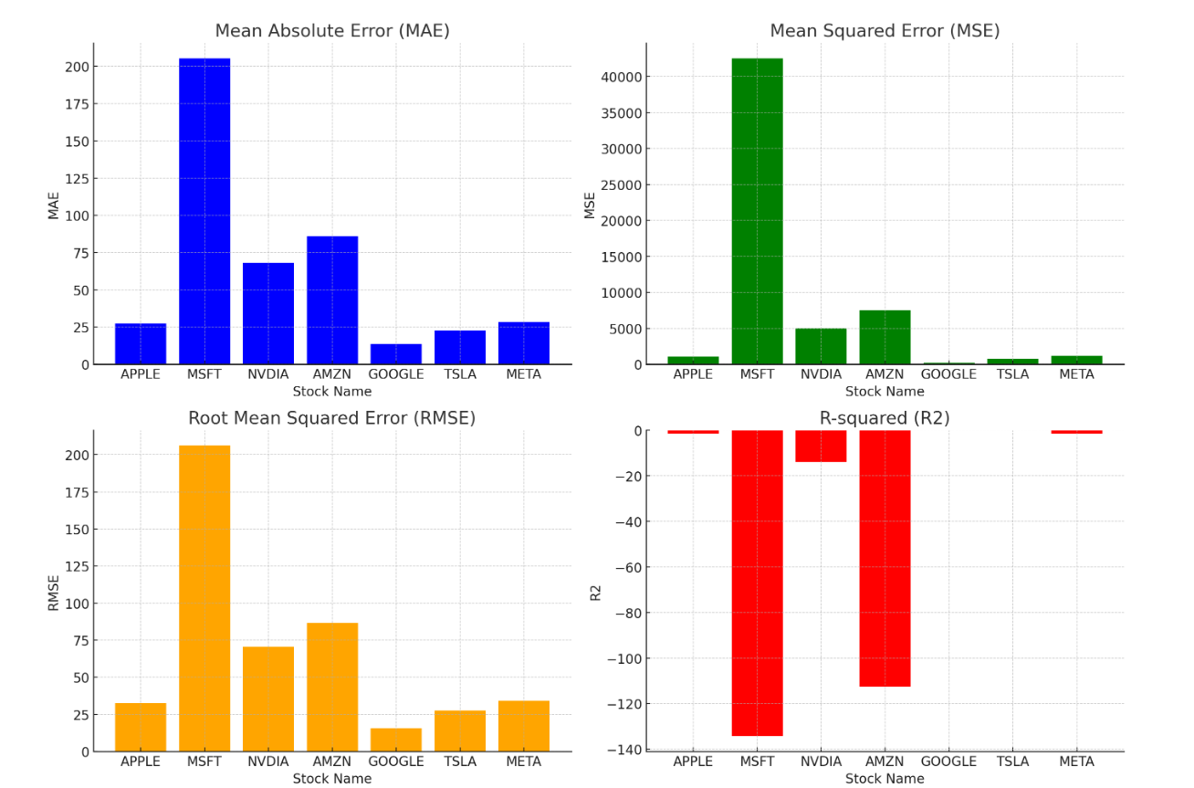  
**Figure**: ARIMA Results

The RSME values for the GOOGL is best as compared to other stocks for results. Refer the following table for more precise information:

|  |  |  |  |  |
| --- | --- | --- | --- | --- |
| STOCK NAME | MAE | MSE | RMSE | R2 |
| APPLE | 27.60428519 | 1058.029354 | 32.52736315 | -1.443953892 |
| MSFT | 205.5059505 | 42547.24058 | 206.2698247 | -134.2739225 |
| NVDIA | 68.2626647 | 4977.860604 | 70.55395527 | -13.97716001 |
| AMZN | 86.07334126 | 7516.488643 | 86.69768534 | -112.5885785 |
| GOOGLE | 13.77390632 | 248.5095284 | 15.76418499 | -0.004621527 |
| TSLA | 22.75753744 | 760.641516 | 27.57973017 | -0.04970332 |
| META | 28.34257077 | 1171.086503 | 34.22114117 | -1.550515672 |

**Table**: ARIMA Results

#### FB Prophet Results

In comparison, the FB Prophet model produced more complex outcomes. Microsoft and Nvidia have relatively low RMSE and good R2 values, suggesting a superior match for these equities. However, the model failed with other equities like Tesla and Amazon, where the R2 values were notably negative, showing poor prediction ability. This shows that although FB Prophet may catch some trends efficiently, it may struggle with more volatile or less predictable equities.

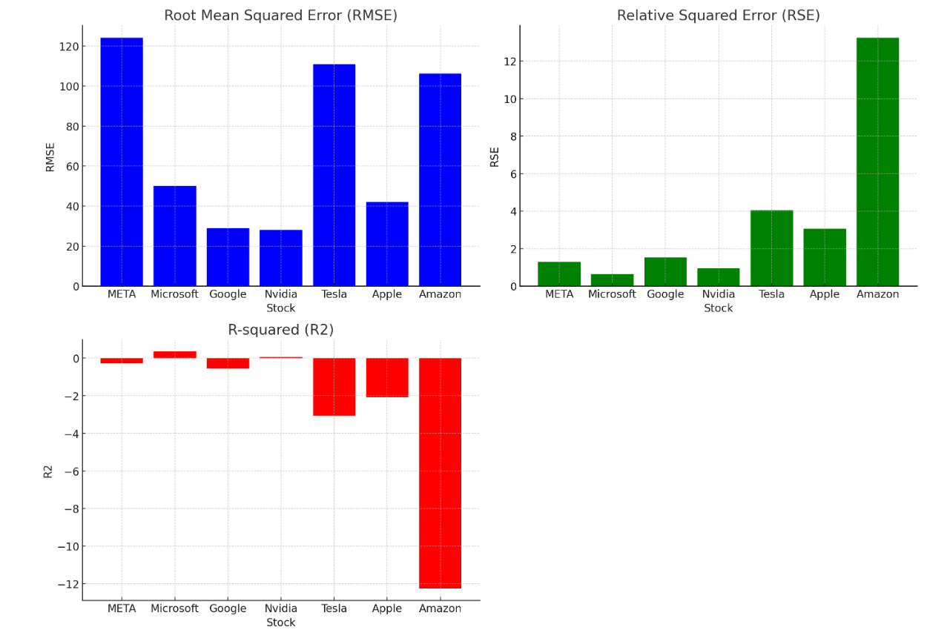  
**Figure**: FBProphet Results

For FBProphet, RMSE scores are extensively high, but does not give a high as accurate results for the models it is good for as compared to ARIMA, like GOOGL and NVDA. Following table discusses more indetail about the accuracy scores of the model with the stocks:

|  |  |  |  |
| --- | --- | --- | --- |
| STOCK | RMSE | RSE | R2 |
| META | 124.2149703 | 1.292919258 | -0.292919258 |
| Microsoft | 50.11198469 | 0.6390949 | 0.3609051 |
| Google | 28.93035634 | 1.541483663 | -0.541483663 |
| Nvidia | 28.04308005 | 0.934339229 | 0.065660771 |
| Tesla | 110.950328 | 4.053810572 | -3.053810572 |
| Apple | 42.02428552 | 3.067466153 | -2.067466153 |
| Amazon | 106.2903183 | 13.25295782 | -12.25295782 |

**Table**: FBProphet Results

#### SARIMA Results

The SARIMA model, which is a seasonal extension of ARIMA, exhibited improved performance in terms of RMSE for most equities. Nvidia, in particular, has an unusually low RMSE, suggesting a highly precise model fit. Stocks like Microsoft and Google also demonstrated appropriate RMSE values, demonstrating that SARIMA captures the seasonality and trend components more well than ARIMA. However, Tesla's high RMSE under SARIMA demonstrates that even this model suffers with extremely volatile equities.

Below is the graphics representation of RMSE scores followed by the actual values:

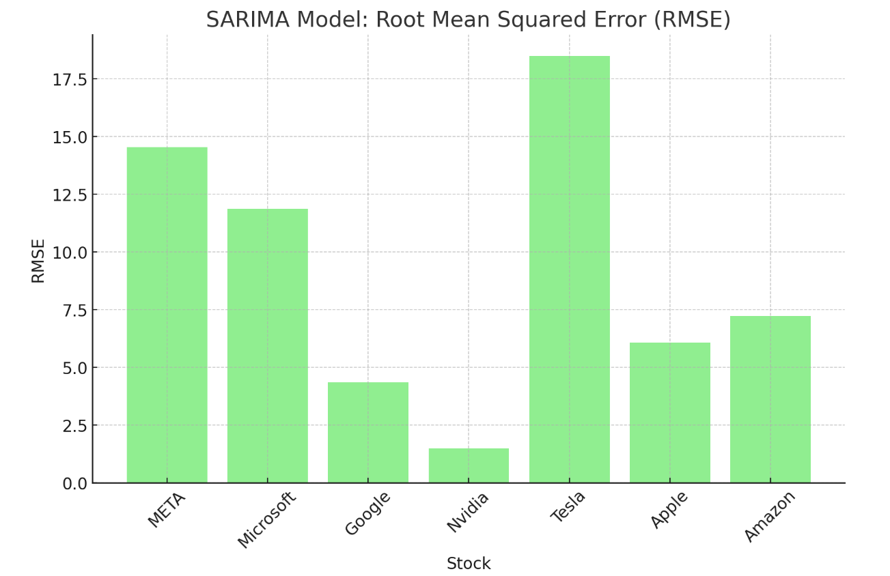  
**Figure:** SARIMA RMSE Plot

|  |  |
| --- | --- |
| STOCK | RMSE |
| META | 14.54779102 |
| Microsoft | 11.88887788 |
| Google | 4.356281537 |
| Nvidia | 1.507851699 |
| Tesla | 18.48869284 |
| Apple | 6.085713578 |
| Amazon | 7.24284758 |

**Table:** SARIMA Results

#### Overall Conclusion

In conclusion, the SARIMA model often beat the others in prediction accuracy, particularly for equities with strong seasonal trends. However, the choice of model may need to be adapted to the individual features of each company, with more complicated models likely necessary for highly volatile assets like Tesla and Amazon. The below line plot shows a comparison of the RMSE values of all the models and stocks together:

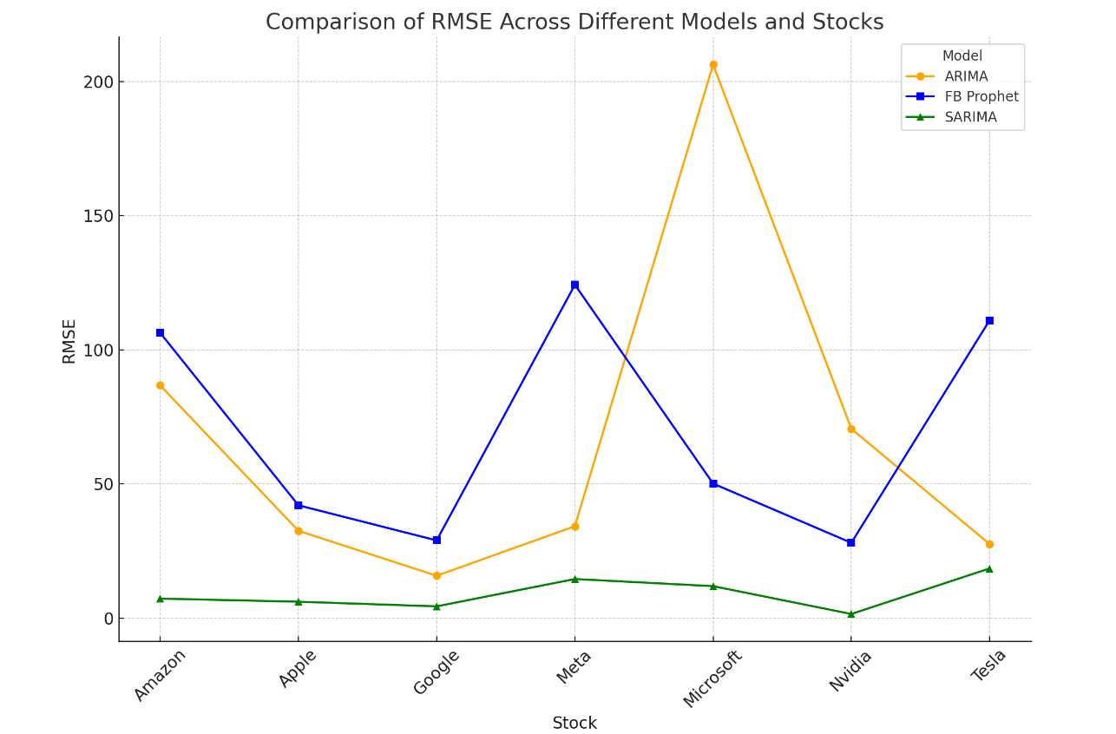

## Regression and Deep Learning Models (Nava Bhargav Gedda – 230270185)

### Machine Learning Models

Traditional time series forecasting methods, like ARIMA or SARIMA, often come with some strict assumptions about things like linearity, stationarity, and seasonality. These assumptions can be quite limiting when you’re dealing with complex real-world data. Such methods might struggle to capture intricate patterns, non-linear relationships, or long-term dependencies in the data (Nikou,2019).

This is where Machine Learning (ML) and neural network models really shine. Unlike traditional methods, ML models like linear models, tree-based models or neural network models don’t have to follow the same rules. They can potentially offer more accurate predictions because they can learn from huge amounts of data, recognize patterns, and generalize better on unseen data. This report suggests that predictions are done better using the neural network models when compared to traditional ML and timeseries forecasting methods.

#### Overview

This project explores several ML and neural network models to predict the target variable based on multiple explanatory variables. The main goal was to find the most suitable model that could capture the significant patterns in the data, providing robust and accurate predictions.

The following set of tables shows the different models with their respective model type considered for predictions (Ampomah, 2020).

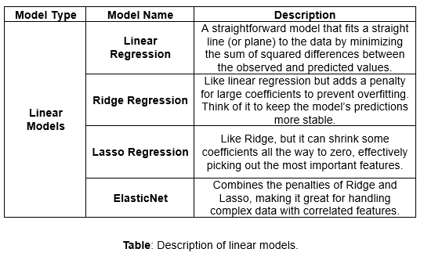

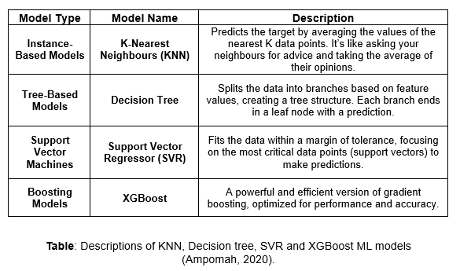  
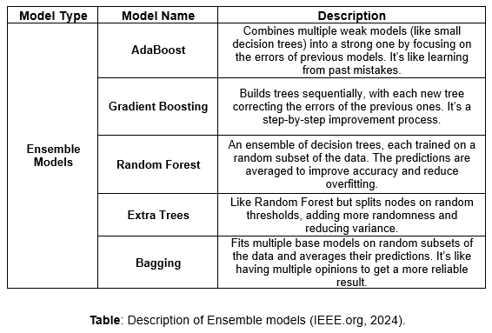

This project focusses mostly on Neural networks and will be compared on a few stocks (Apple, Tesla, Meta, Amazon, Nvidia, Google and Microsoft) with combination of different values. It then compares the scores obtained from their individual analysis and therefore recommends managers, traders, investors, companies, regulators and market analysers on which method to use. Better predictions have a notable effect on profitability and help to make valuable decisions on portfolio of stakeholders and investors.

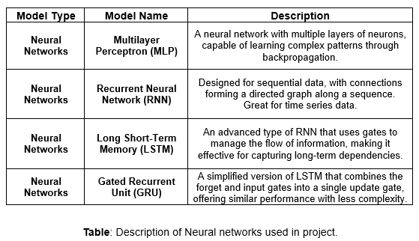

#### Data & Variables

This project utilizes a dataset spanning from January 1, 2015, to May 1, 2024, packed with various features related to financial markets. It includes the usual OHLCV data (Open, High, Low, Close, Volume), a range of technical indicators, and sentiment data from news and Twitter, all imported from the Bloomberg terminal. The main goal was to predict the closing price or returns. To achieve this, a mix of raw OHLCV data and engineered features from technical indicators was used, providing the models with a rich set of inputs to learn from, which were then applied to several machine learning models.

The report primarily uses Amazon’s company results to explain the models’ performance. However, the analysis was conducted on a total of seven company stocks, including Apple, Meta, Tesla, Microsoft, Nvidia, and Google.

Listing the target and explanatory variables:

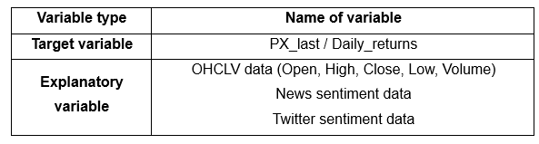

To get a better understanding of the relationships between the variables, a correlation heat map was plotted. This heat map visually shows the strength and direction of the relationships between different features, such as OHLCV data, technical indicators, and sentiment data. By looking at the heat map, it’s easier to see which variables are most strongly correlated with the target variable (closing price or returns) and with each other. This insight is crucial for feature selection and model tuning, as it helps identify the most influential predictors and potential multicollinearity issues.

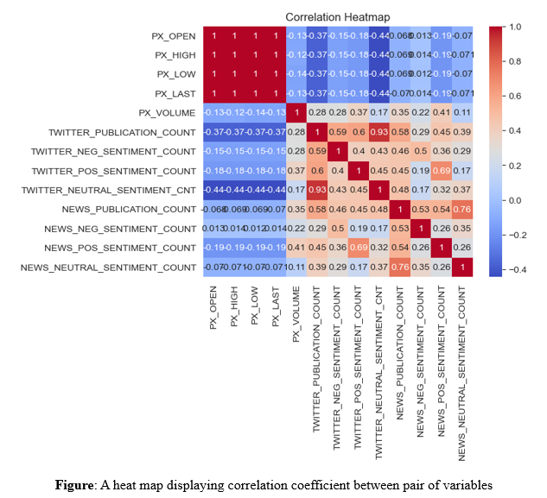  
To compare the results, several error metrics, including MAE (Mean Absolute Error), MSE (Mean Squared Error), RMSE (Root Mean Squared Error), and R² (Coefficient of Determination). These metrics help to evaluate the accuracy and robustness of the models in predicting both the closing prices and daily returns.

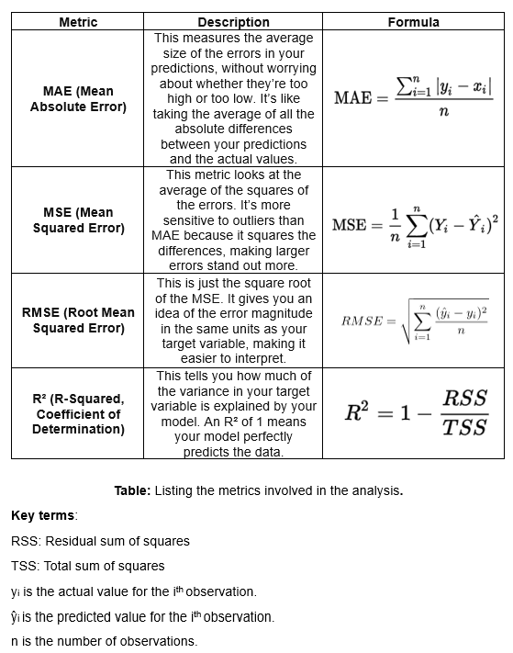

#### ML Libraries Used

The main libraries used are scikit-learn and tensorflow. Scikit-learn offers robust tools for data preprocessing, model selection, and evaluation. TensorFlow, specializes in deep learning tasks, providing a high-level neural network for building and deploying deep learning models (Scikit-learn: Machine Learning in Python).

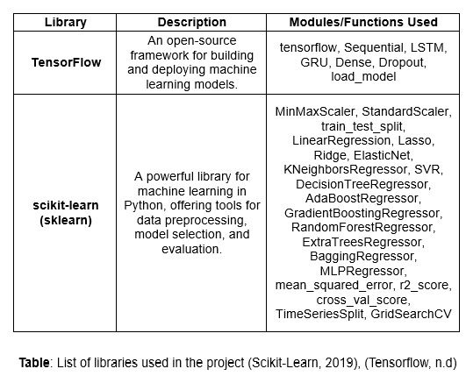

#### Model Comparisons

From the analysis, the Multilayer Perceptron (MLP) model performed better than other machine learning models which includes Linear Regression, Ridge, Lasso, ElasticNet, KNeighbors Regressor, Decision Tree Regressor, SVR, AdaBoost, Gradient Boosting, Random Forest, Extra Trees, Bagging, and XGBoost. The MLP model had better RMSE and R² values, showing it could capture complex patterns in the data more effectively. Because of these results, this report goes with MLP and other neural network models for predictions.

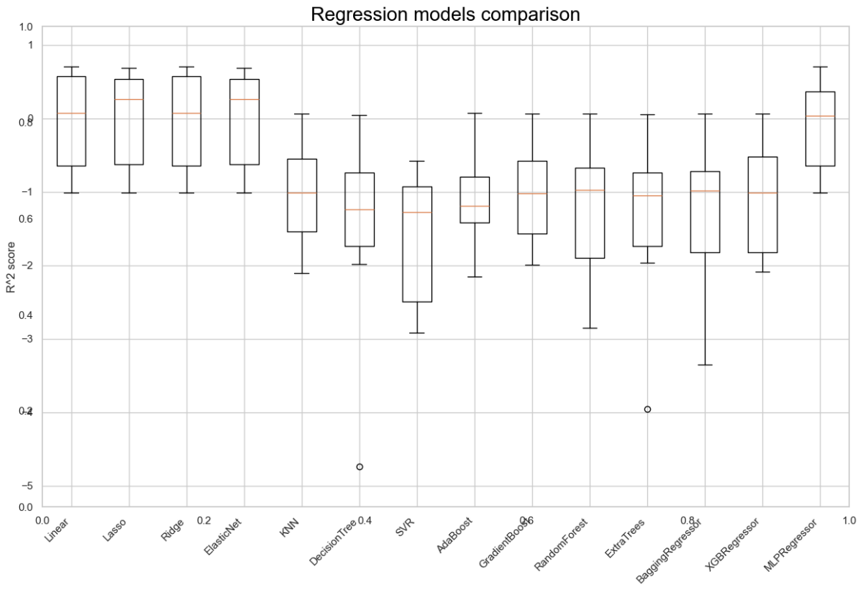

**Table:** A box plot showing regression model comparison.

While traditional machine learning models are great at capturing patterns, they often struggle with sequential data where the order of observations matters, like in time series data. To tackle this, use of Recurrent Neural Networks (RNNs), specifically Long Short-Term Memory (LSTM) and Gated Recurrent Unit (GRU) models. These neural networks are designed to handle sequential data by using the previous inputs, which helps them model dependencies over time. This makes LSTM and GRU especially good for time series predictions, where capturing temporal patterns is key for accurate forecasting (Ampomah, 2020).

The R2 and RMSE values in MLP for the regular OHCLV values are as follows:

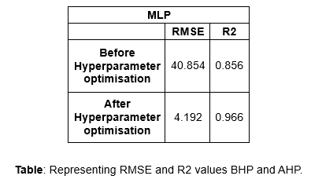

The following are the series of plots plotted against actual adjusted close price (MLP Regressor):

1. Scatterplot with Linear Regression Line: plotted against actual price and predicted price before hyperparameter optimisation

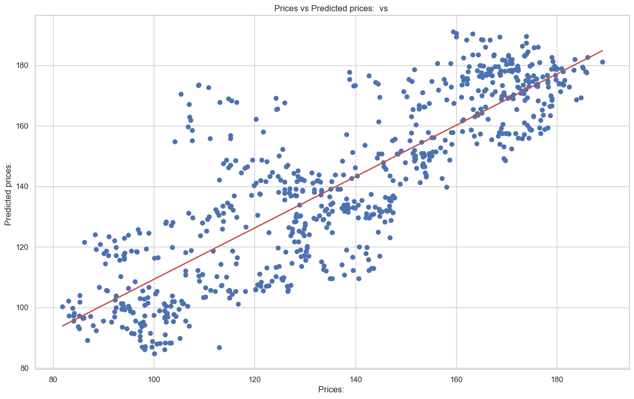

1. MLP regressor – Predictions vs actual price after hyperparameter optimisation.

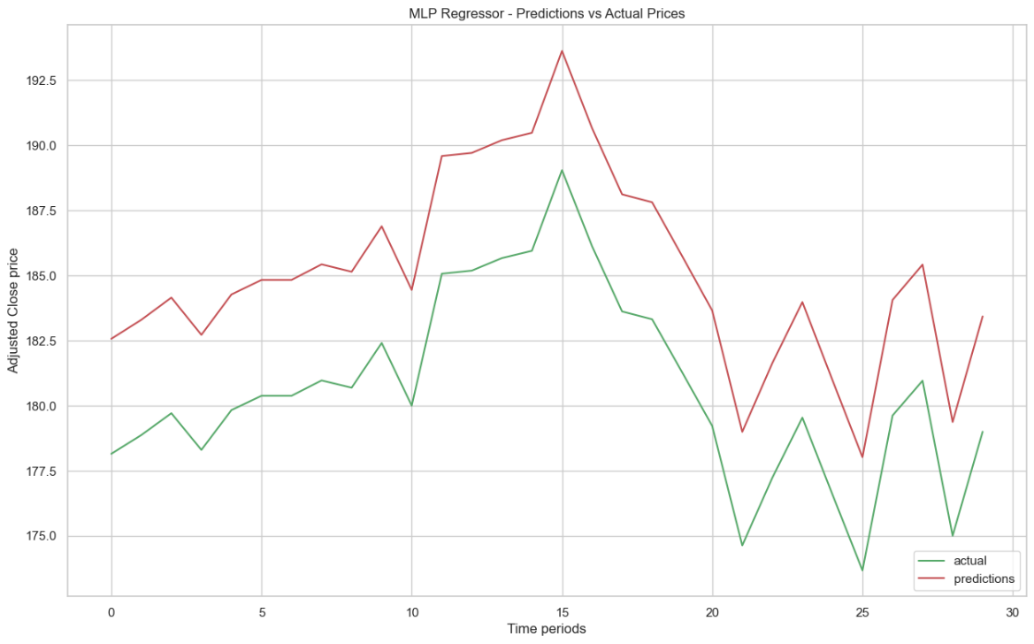

### Neural Networks

A neural network is a type of AI that mimics the way the human brain works. It consists of layers of interconnected nodes, or “neurons,” which process information and then learn to recognize patterns. By adjusting the connections between these neurons, a neural network can learn from data and make decisions based on that learning.

This report involves three neural network models used for time series forecasting: RNN (Recurrent Neural Network), LSTM (Long Short-Term Memory), and GRU (Gated Recurrent Unit). RNNs are designed to handle sequential data by maintaining a memory of previous inputs, which helps in modelling dependencies over time. However, traditional RNNs often struggle with the vanishing gradient problem, making it difficult to learn long-term dependencies.

LSTM and GRU are advanced types of RNNs chosen for their ability to manage this issue effectively. LSTM uses a complex system to control the flow of information, while GRU achieves similar results with a simpler structure. These models are ideal for time series forecasting because they excel at capturing important patterns over time.

#### RNN

##### Introduction to RNN

Recurrent Neural Networks (RNNs) are a class of artificial neural networks designed to recognize patterns in sequences of data. They maintain a “memory” of previous inputs through connections that forms directed cycles sets them apart. Thus, makes them useful for time-series prediction tasks. RNNs excel at modelling temporal dependencies in data, enabling them to capture long-term relationships in sequences, which is vital for accurately forecasting future values in time series data.

##### Architecture

The architecture of the RNN model used in this project consists of multiple layers with varying units (neurons) and dropout layers to prevent overfitting. The model begins with an input layer that reshapes the data into a suitable format for RNN processing, followed by three SimpleRNN layers with the following structure:

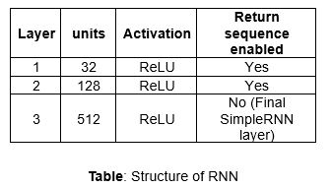

Each SimpleRNN layer is followed by a dropout layer with a 20% dropout rate to reduce overfitting. The last layer is a Dense layer with only one neuron, which outputs the prediction. This architecture is designed to capture complex temporal dependencies in the data while maintaining a balance between model complexity and generalization ability.

#### LSTM

##### Introduction to LSTM

Long Short-Term Memory networks, a type of neural network designed to tackle the limitations of standard RNNs, particularly when it comes to capturing long-term dependencies in sequential data. LSTM networks have more complex architecture that includes cell state, memory cells, input gates, output gates, and forget gates.

These components allow LSTMs to maintain and update information, making them highly effective for time series predictions where the order and duration of past events are crucial for forecasting future outcomes (Office.net, 2021).

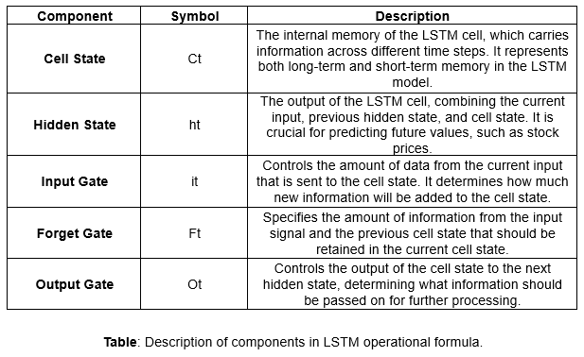

The **LSTM operational formula** (A. Bhavani, 2022) is given as follows:

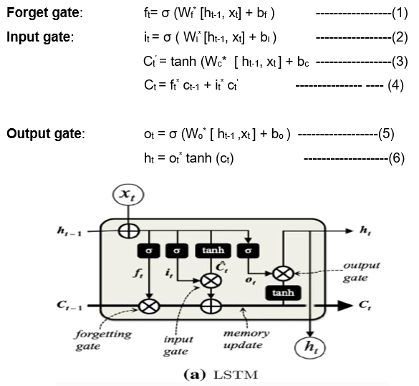

**Figure**: Structure of LSTM blocks and their gates (Lawi, 2022)

##### Advantages of LSTM

1. **Memory Retention**: LSTMs can retain information for long periods, making them well-suited for datasets where historical data significantly influences future predictions.
2. **Handling of Complex Temporal Patterns**: LSTMs are capable of learning complex temporal dynamics that are crucial in time series forecasting.
3. **Robustness to Vanishing Gradient Problem**: The architecture of LSTM networks mitigates the vanishing gradient problem, allowing them to learn from data sequences over extended periods more effectively than standard RNNs.

##### Architecture

The LSTM model used in this project is structured with multiple layers, each designed to capture the intricacies of the time series data. Here's how the architecture looks:

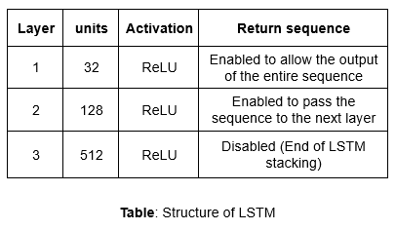

After each LSTM layer, a dropout layer with a rate of 20% is applied to prevent overfitting. This works by randomly setting a fraction of the input units to zero during training, which helps the model generalize better. The final layer, or output layer, is a dense layer with a single neuron that produces the prediction. This architecture is designed to capture both short-term and long-term dependencies in the time series data, making the model robust and capable of delivering accurate predictions.

#### GRU

##### Introduction to GRU

Gated Recurrent Unit (GRU) networks are a simpler version of LSTM. GRUs were created to tackle some of the computational complexity and training challenges posed by LSTMs, while still being able to capture long-term dependencies in sequential data. Unlike LSTMs, which have three gates (input, output, and forget gates), GRUs combine these into two gates: a reset gate and a update gate. This streamlined structure often makes GRUs faster to train and easier to implement, while still being effective in modelling time series data where the order and temporal context are critical (Song, H, 2023).

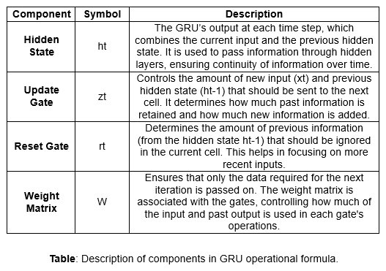

The **GRU’s operational formula** (A. Bhavani, 2022) is given as follows:

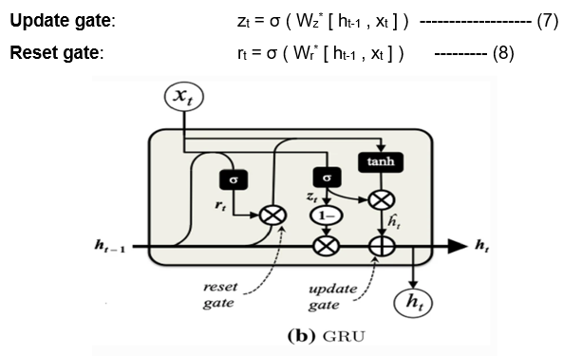

**Figure**: Structure of GRU blocks and their gates (Lawi, 2022)

##### Advantages of GRU

1. **Simplified Architecture**: GRUs have less parameters when compared to LSTM which makes the model faster to train.
2. **Capability to Capture Temporal Dependencies**: GRU’s also capture temporal dependencies in time series data just like LSTM’s.
3. **Efficiency in training**: The reduced complexity of GRUs can lead to faster convergence during training, which is advantageous when working with large datasets or when computational resources are limited.

##### Architecture

The GRU model used in this project is composed of several layers, each contributing to the model's ability to learn from the sequential data. Here's the architecture:

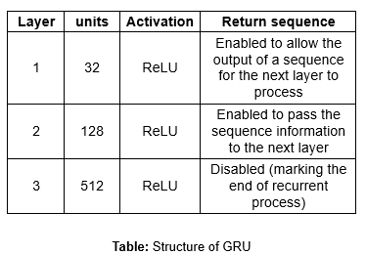

After each GRU layer, a dropout layer with a rate of 20% is added to help prevent overfitting by randomly dropping some units during training. And a Dense layer with one neuron is used to output the final prediction. This architecture ensures that the model is both deep enough to capture complex patterns in the data and regularized enough to generalize well to unseen data.

##### Hyperparameter optimisation

Hyperparameter optimization is crucial for enhancing the performance RNN, LSTM and GRU, especially in time series forecasting tasks. For all the three models MAE (mean absolute error) is considered as the loss function because it is well-suited for regression tasks and due to its robustness in predicting accuracy (Roy et al.,2023).

For RNNs, models’ complexity is tuned by the number of units in each layer and its ability to generalize to new data. Dropout rates are applied to prevent overfitting, and the Adam optimizer is chosen for its adaptive learning rate and efficiency.

Similarly, for LSTM models, hyperparameters such as the number of units in each layer and the dropout rate are optimized to ensure that model cops up with the complex patterns while maintaining generalization. The Adam optimizer is again selected for its capability to adjust learning rates dynamically, aiding in faster convergence and better performance.

For GRU models, hyperparameter tuning focuses on the number of units in each layer, dropout rates, and the optimizer. The GRU architecture, which is more computationally efficient than LSTM, requires careful tuning to balance its reduced complexity with its ability to handle long-term dependencies.

### Feature Engineering

#### Data Splitting

##### Test-train split

In this project, dataset is split into training and testing sets. This means that 70% of the data was used to train our models, while the remaining 30% is for testing. This split is quite common in time series forecasting because it gives the models enough data to learn from and keeping enough data for a fair evaluation. Essentially, we wanted to ensure our models had plenty of data to learn patterns and relationships during training, while still having a substantial portion left for unbiased testing.

##### Data Scaling

Before feeding the data into the models, Min-Max scaling was applied to both the features and the target variable. This technique scales the data to a specific range, typically between 0 and 1. It’s crucial for models like LSTM, GRU, and RNN, which are sensitive to the magnitude of the input data.

Scaling prevents the model from being biased towards variables with larger magnitudes. The Min-Max scaler was fitted on the training data and then applied to both the training and testing sets. This way, the test data is scaled based on the training data distribution, maintaining consistency and preventing data leakage.

##### **Evaluation metrics**

To evaluate the models’ performance, key metrics like RMSE and R² were used. RMSE measures the average magnitude of the errors between the predicted and actual values. A lower RMSE indicates better performance. R², on the other hand, represents the proportion of variance in the dependent variable that is predictable from the independent variables. An R² value closer to 1 suggests a strong fit of the model to the data. These metrics were chosen because they provide a comprehensive understanding of the model’s predictive accuracy and its ability to explain the variance in the data.

##### Cross-validation

To ensure the model’s performance wasn’t overfitted to the training data, a robust cross-validation strategy was employed. Specifically, Time Series Cross-Validation (TSCV) is used. This method splits the training data into multiple folds in a sequential manner, where each fold represents a time slice of the data. The model is trained on each fold and validated on the subsequent fold. Thus, ensuring that the model’s performance is evaluated on different portions of the data, providing more accurate and reliable assessment of its generalization capability.

##### Tuned vs Untuned models.

A comparative analysis was conducted between the performance of tuned and untuned models, with the untuned models serving as a baseline with default hyperparameters. Hyperparameter tuning, performed using techniques like Random Search, optimized the model’s architecture and parameters, leading to significant improvements in accuracy and generalization. Adjustments such as increasing the number of units in the RNN layers, tweaking dropout rates, and optimizing the learning rate resulted in lower RMSE and higher R² values. This highlight’s crucial role of hyperparameter tuning in extracting the best performance from machine learning models, particularly in complex tasks like time series forecasting.

### Results

#### LSTM Performance

The analysis of the LSTM model’s performance on Amazon’s stock data revealed some insights, especially when comparing results before and after hyperparameter optimization. Initially, the LSTM model showed strong performance when trained solely on OHLCV (Open, High, Low, Close, Volume) data. However, adding sentiment data initially decreased the model’s accuracy. This suggests that the inclusion of sentiment data introduced noise or complexity that the model struggled to handle effectively.

After hyperparameter optimization, the model’s performance with both OHLCV and sentiment data improved significantly. This indicates that fine-tuning the model’s parameters helped it better integrate the additional sentiment data. On the other hand, the model’s performance using only OHLCV data saw a slight decline post-optimization. This outcome suggests that while optimization benefited the more complex dataset (OHLCV + sentiment), it did not provide a substantial improvement for the simpler OHLCV dataset, where the model was already performing well.

The following table gives more insights into the RMSE and R2 values before and after hyperparameter optimisation.

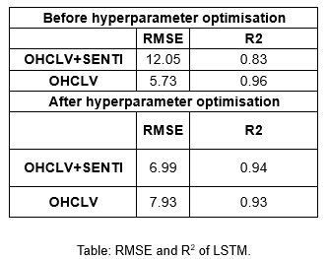

#### GRU Performance

While comparing the performance of the neural network models on Amazon’s stock both the models have good performance when trained with OHCLV data. And both models showed significant improvement after hyperparameter optimisation, particularly with OHCLV and sentiment data. These results highlight the importance of hyperparameter tuning, especially when dealing with complex datasets that combine traditional market indicators with sentiment analysis. The LSTM model initially handled the simpler OHLCV data better, but both models benefited from optimization, particularly when integrating sentiment data. This underscores the differences between LSTM and GRU models and the critical role of fine-tuning in enhancing their performance.

The following table gives more insights into the RMSE and R2 values before and after hyperparameter optimisation.

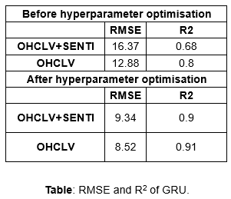

#### Combination analysis

#### Comparison of Models with Moving Averages (OHCLV)

The performance of RNN, LSTM, and GRU models was compared against traditional moving average methods, such as the 7-day, 21-day, 12-day exponential, and 26-day exponential moving averages using OHCLV data. The MSE and MAE values are used to assess the model predictions before and after hyperparameter optimization.

The following plots display data from January 1, 2015, to May 1, 2024, showing the price movements over time:

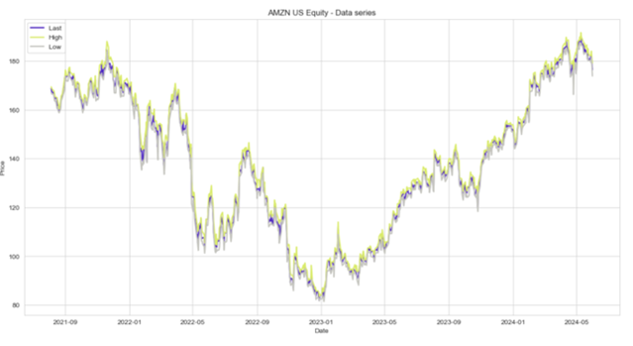

**Figure**: Plot of series of high, low and last price movements over time (OHCLV data_

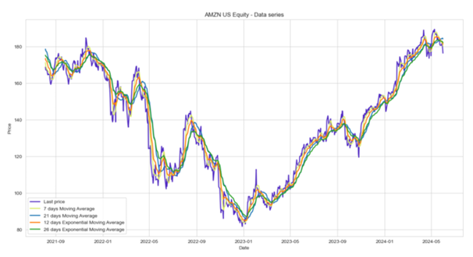

**Figure**: Plot of moving averages and last price over time.

Before hyperparameter optimization, the 7-day and 12-day exponential moving averages generally provided the lowest MSE and MAE values, indicating that these traditional methods still offer competitive forecasting accuracy. Among the machine learning models, the LSTM model outperformed both RNN and GRU, achieving the lowest MSE and MAE. The RNN had a moderate performance, while the GRU had the highest errors before optimization.

After hyperparameter optimization, the results were mixed. The GRU model saw a significant reduction in MSE and MAE, indicating an improvement. However, the RNN and LSTM models showed increased error metrics, with the RNN showing the most substantial increase in both MSE and MAE, suggesting possible overfitting or poor hyperparameter tuning. The LSTM performance also deteriorated post-optimization, but to a lesser extent compared to RNN.

The following plots displays data from January 1, 2015, to May 1, 2024, showing the prediction forecast of LSTM and GRU before and after hyperparameter optimisation.

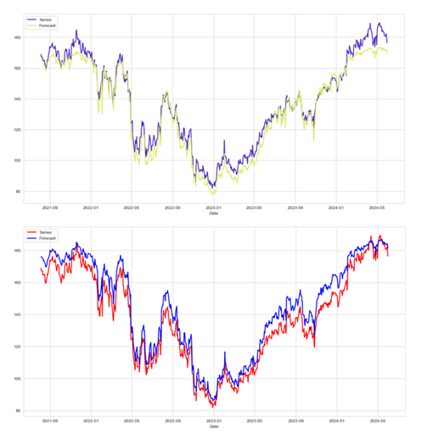

**Figure**: (Top) Predictions of stock price before hyperparameter, (bottom) Predictions of stock price after including hyperparameter for LSTM with OHCLV data.

The analysis highlights that while machine learning models such as LSTM, GRU, and RNN can be powerful tools for stock price forecasting, they require careful tuning and validation. The mixed results after hyperparameter optimization underscore the importance of using robust validation techniques to avoid overfitting and to ensure the model’s generalizability across different datasets. The report analysed seven different company stocks, but only Amazon’s stock is used here to illustrate the plots and results.

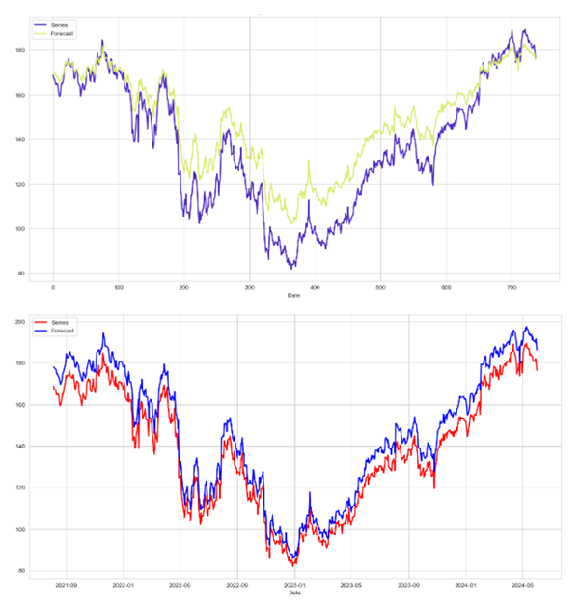

Figure: (Top) Predictions of stock price before hyperparameter, (bottom) Predictions of stocks price after including hyperparameters for GRU with OHCLV data.

The below table shows the metrics MSE and MAE values for OHCLV data.

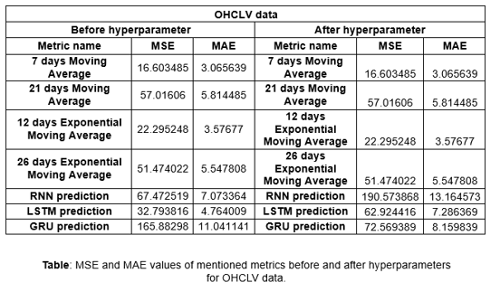

#### Comparison of Models with Moving Averages (OHCLV + Sentimental Data)

Like LSTM, the performances for models are compared using the MAE and MSE values. The moving average and OHCLV data plot for a period as shown in LSTM are the same. GRU exhibited the highest errors among the models before hyperparameter optimisation just like LSTM. After hyperparameter optimisation, RNN saw an increase in both MSE (325.756) and MAE (17.174), indicating possible overfitting or poor tuning. The LSTM improved drastically, with its MSE dropping to 48.852 and MAE to 6.666, demonstrating effective hyperparameter optimization. The GRU also improved, reducing its MSE to 87.277 and MAE to 9.051, though not as effectively as the LSTM model.

The following plots displays data from January 1, 2015, to May 1, 2024, showing the prediction forecast of LSTM and GRU before and after hyperparameter optimisation.

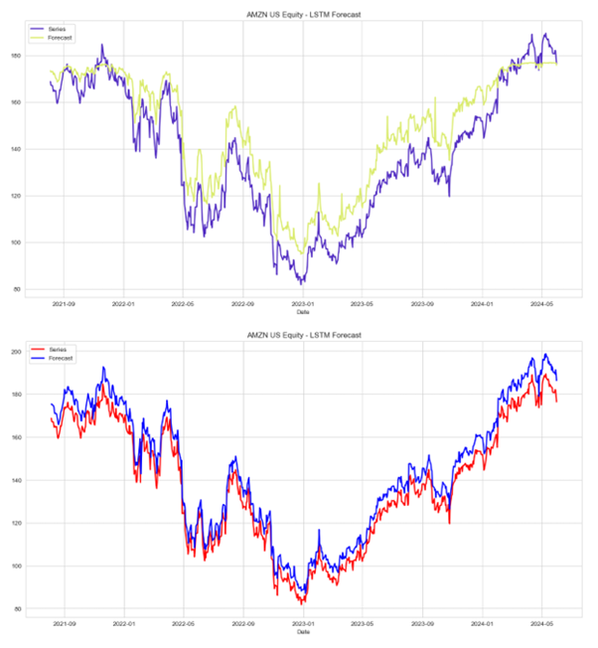

**Figure**: (Top) Predictions of stock price before hyperparameter, (bottom) Predictions of stock price after including hyperparameters for LSTM with OHCLV and sentiment data.

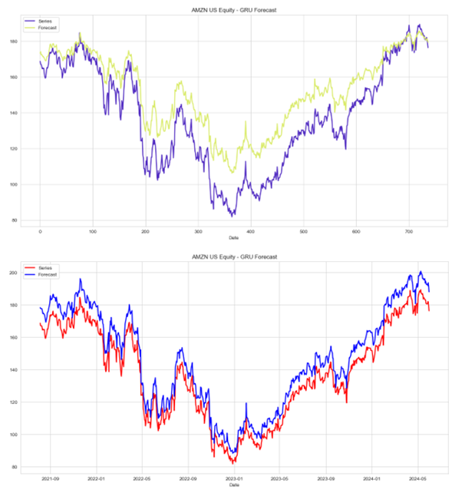

**Figure**: (Top) Predictions of stock price before hyperparameters, (bottom) Predictions of stock price after including hyperparameters for GRU with OHCLV and sentiment data.

The below table shows the metrics MSE and MAE values for OHCLV and sentiment data.

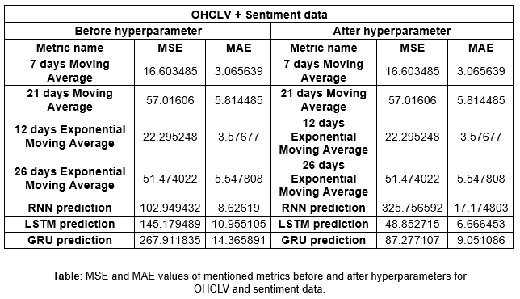

### Model comparison.

When comparing the overall performance across all models, including traditional moving averages and advanced neural networks, it was evident that while traditional metrics like the 7-day and 12-day exponential moving averages offered competitive baseline performance, neural network models, particularly GRU and LSTM, provided more nuanced and accurate forecasts, especially after fine-tuning. The RNN model, though effective in some cases, generally underperformed compared to LSTM and GRU, highlighting the greater adaptability and predictive power of these advanced models across different datasets and metrics.

The below table shows the metrics MSE and MAE values for OHCLV data plotted for daily returns.

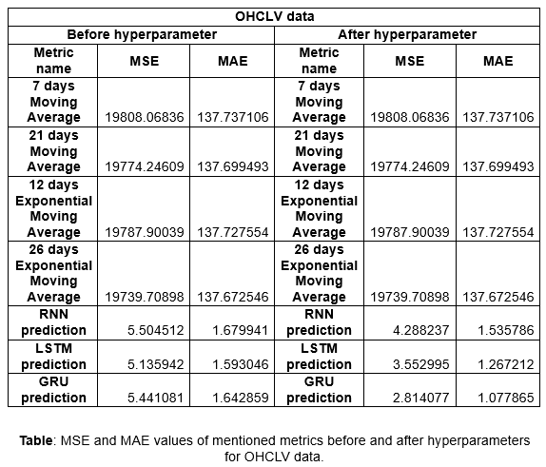

The below table shows the metrics MSE and MAE values for OHCLV and sentiment data plotted for daily returns.

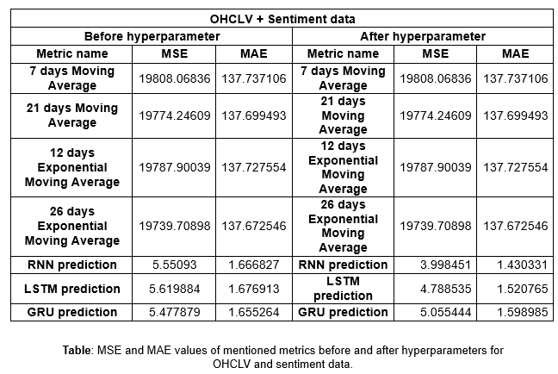

In conclusion, the GRU model demonstrated superior performance for most companies selected for stock price prediction. After hyperparameter optimization, it consistently outperformed other models. However, in several instances, particularly when predicting the PX_LAST metric using OHCLV and sentiment data, the LSTM model showed significant improvements post-optimization. Both LSTM and GRU models performed well for certain stocks, aligning with studies that suggest that combinational neural network models, blend the strengths of various architectures like LSTM and GRU, often yield more accurate and robust predictions.

By blending different models, combinational neural networks can reduce the risk of overfitting to specific patterns in the training data, leading to better generalization and more robust predictions on unseen data. This adaptability allows for fine-tuning and optimization based on the unique characteristics of the data being analysed, making the predictions more reliable. Numerous studies have shown that combinational neural networks outperform single architecture models in various applications, including stock price prediction, highlighting the improved accuracy and robustness of predictions when leveraging the complementary strengths of different neural network types.

# Trading Dashboards & Backtesting (Pon Ananth Veppalodai Senthurpandi - 230289833)

In the world of stock trading, buying and selling stocks are based on a trader’s ability to forecast the future of stocks. To predict stocks, tools like Bloomberg terminal helps traders with a lot of raw information about the stocks. Finding the important metrics and transforming raw information into those metrics are the first step while trading for any stocks. Trading Dashboard gives traders those important metrics based on market research, previous trading and the real-time news in one place. In this part of the essay, the different types of data acquired from Bloomberg terminal is explained using the candlestick plot. Then, the term backtesting in financial settings is explained along with the different trading strategies used by traders. It also talks about how backtesting is done using historical data to evaluate those trading strategies. It also includes the calculation of the basic trading indicators like annual returns, cumulative returns, annual volatility, Sharpe ratios for the stocks of various technology companies and an EV based company.

## Getting Data from Bloomberg

As mentioned in the previous part, the data acquired to create the trading dashboard was from the Bloomberg terminal. It collects the historical data of the last 3 years for stocks like Apple (AAPL), Tesla (TSLA), Amazon (AMZN), Nvidia (NVDA), Meta (META), Microsoft (MSFT), Google (GOOGL). The past values like PX_LAST, PX_HIGH, PX_VOLUME, PX_OPEN, PX_LOW is downloaded from the terminal through Bloomberg API. The Python library named ‘xbbg’ is used to import ‘blp’ object to use the API. In BLP, the ‘bdh’ function is used to get the historical data of the above values.

## Candlestick Plot

The best way to represent these basic values of stocks in most of the financial tools is via Candlestick charts (Nison, 2001). Candlestick charts were developed before the invention of the bar chart. This chart was first used by a Japanese rice trader, Munehisa Homma, in the 18th century and then it was developed into highly useful charts for stock traders to understand the stock values in this century (Nison, 2001). Candlesticks provide a better representation of price movements using a single bar throughout a particular period. Single day stock values of open, low, high, close prices are represented here using a single candlestick then these candlesticks are plotted for a particular period to understand and predict the movements of stocks over that specific period in a very detailed way. Short-term traders like day traders and momentum traders use lower time frame candlesticks, whereas long-term traders like traditional investors use higher time frame candlesticks.

### Component of Candlestick charts

In any candlestick chart as shown in fig 4.1, there are components like candlestick, wick and tail. The candlestick is differentiated by red and green colors. Red candlestick means the market has moved downwards over the candlestick period, whereas green candlestick means it has moved upwards over the period. The Wick, which is also known as Upper Shadow, shows the highest price of the market over the candlestick period. The tail, which is also known as lower shadow, shows the lowest price of the market over the candlestick period (Hu et al., 2019).  
  
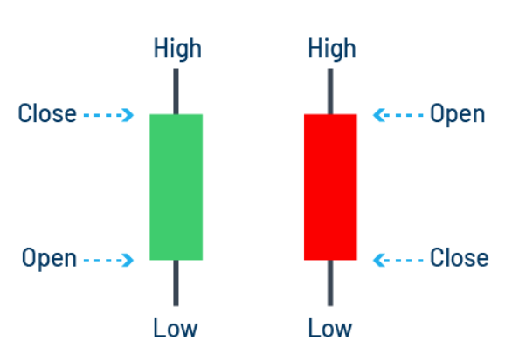

**Figure 4.1: Anatomy of Candlestick**

### Interpretating Candlestick Charts

Candlestick charts indicate the trend of the stock market during the chart's duration. It tells whether the market is linear or nonlinear. It displays the opening and closing price of the market and shows the volatility of the market using the highest and lowest price over the candlestick period. Most of the traders who trade over small periods always look at a longer-term candlestick chart to understand market sentiment (Tiong, Ngo, Lee., 2013). After conducting 56,680 test trades on 30 Jow Jones stocks, Barry D. Moore (2024) found that the most profitable candlestick patterns are inverted hammer, bearish Marubozu, gravestone doji, bearish engulfing, harami cross. The detailed result of the test trades is mentioned in Figure 4.2. Inverted hammer (as shown in figure 4.3a) is when the market is in a downward trend, thus the open price is lower. Even when the market trades higher, the close price ends up near its open price. It happens typically on the bottom of a downward trend meaning the market is ready for an upward shift. Marubozu, a Japanese word which means close-cut, is when there is no wick or tail on the candlestick. In other words, the open price or close price will be the highest or lowest price for that candlestick period. Bearish Marubozu (as shown in figure 4.3b) forms when the open price is the highest and the closing price is the lowest for that period, which signals the downward trend as the market hasn’t moved for that period. Finally, Gravestone Doji (as shown in figure 4.3c) is when the open and close prices are closer to the lowest price over the period. In other words, there is a taller wick on the top of the candlestick. It indicates that the buyers were unable to push the price up, but the sellers managed to push the price down for that period.   
  
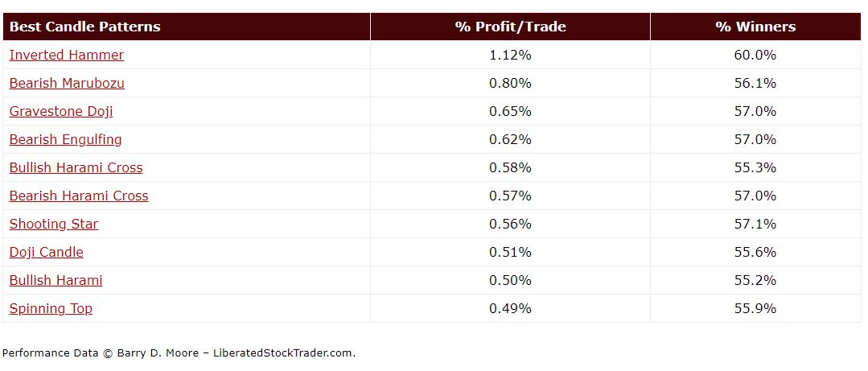

**Figure 4.2: Top 10 candlestick patterns by Barry D. Moore**

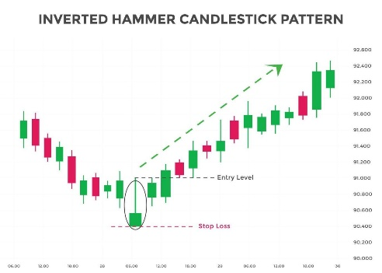 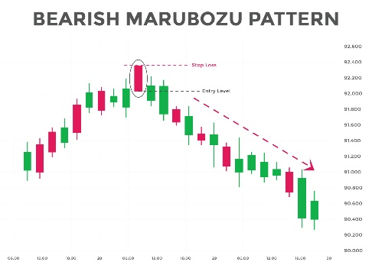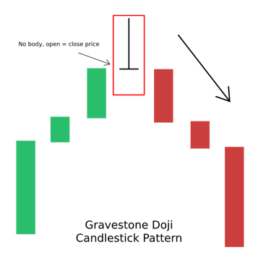

**Figure: 4.3 – a. Inverted hammer pattern. b. Bearish Marubozu pattern. c. Gravestone Doji pattern.**

### Plotting the chart using Python libraries

To plot the candlestick chart for the above stocks, the candlestick function from the library named ‘plotly’ is used. This function has variables like x, open, close, low, high to match them with those historical values of stocks. By default as shown in figure 4.4a, red colored candlestick denoted the downtrend and green colored one denoted the uptrend which can be customized using the variables ‘increasing_line_color’ and ‘decreasing_line_color’. The X axis in this chart denotes the entire time period of the chart. The slider beneath the chart helps to view candlestick for certain miniscule periods. As shown in figure 4.4b, the volume of the stocks can also be added to the candlestick chart by creating a bar chart for the same period. This is done by replacing the slider beneath the candlestick plot with help of the ‘make_subplots’ in ‘plotly’ library.   
  
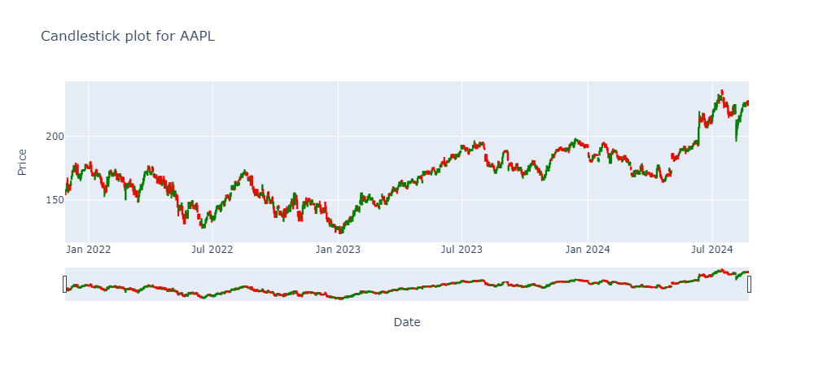

**Figure 4.4a: Candlestick chart plot for apple stock data using plotly.**

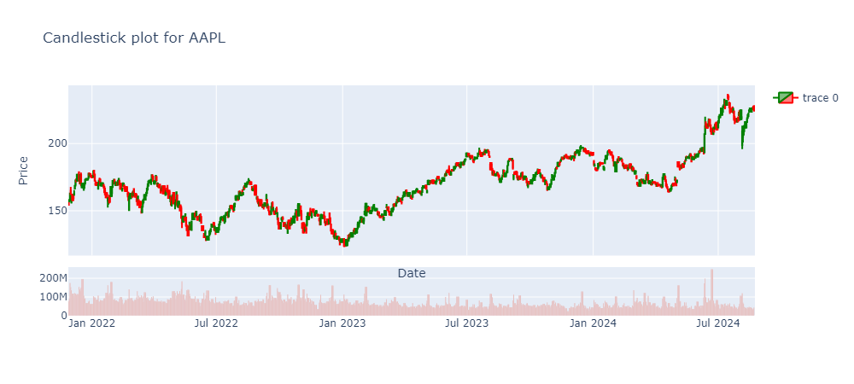

**Figure 4.4b: Candlestick chart plot for apple stock with Volume plotted using plotly.**

## Backtesting using Trading Indicators

Backtesting is a process that uses the historical data of stocks to evaluate how a certain trade strategy works. It also provides a crucial insight into the performance of the trade strategy. It holds a significant place in the financial world as it helps in shaping and refining the trade strategy. Even though the backtesting does not predict what happens in the future, it can provide confidence on how well a stock can perform into the future if it has performed well with historical data (Chen, 2021). This allows the traders to make more informed decisions to enhance the profitability of the strategies.

### Trading Strategy

A trading strategy is a systematic approach which helps the traders to make the decisions on when to buy and sell shares during a trading session. The goal of any trading strategy is to be profitable and reduce significant risks in any shares. Most of the trading strategies are created to work around the volatility of the market to find profitable returns. Trading strategies are mostly complex which considers the investment style of a trader, period of trading, fundamental indicators, technical indicators etc. Thus, making it difficult for traders to understand its effectiveness without the help of backtesting.

### Types of Trading Strategies

There are different types of trading strategies such as Day trading strategy, Swing trading strategy and Long-Term trading strategy. Day trading requires quick decision making by focusing on the intraday price movements closely. Day trading emphasizes a lot on technical analysis to predict the movement of the market. To aid this type of trading, trading strategies like Moving average crossover strategy, Breakout strategy, Scalping. Swing trading requires traders to capture the movement of the market over a few days or several weeks (Nyakundi, 2023). Swing trading identifies the trend of the stock through technical analysis to protect the capital and minimize the losses. To help with the way of trading, trading strategies like Trend reversal strategy, Breakout and Pullback strategy, Moving average crossover strategy. Long-term trading is about committing to holding capital on a particular individual stock. This type of trading requires traders to choose stocks which can have good growth in the future. In this trading, traders emphasize fundamental analysis to build a stable portfolio. To aid this trading, trading strategies like Value investing, Dividend growth investing, Index fund investing.

### Simple Moving Averages Crossover Strategy

#### Simple Moving Averages (SMA)

In this part, simple moving average trading strategy is backtested on the historical data of above-mentioned stocks. Simple moving averages are nothing but average of the close prices of a stock for the ‘n’ number of days (Hayes, 2019). It is a common technical indicator in financial markets. The weightage of the prices across the period is the same. In python, the simple moving average is calculated using the library called Stockstats (jealous, 2016). In this python library, the stock data frame is created when the data frame with columns named open, close, high, low, volume is fed into the StockDataFrame object. Now, any technical indicator can be calculated by referring to that specific indicator in that dataframe. For example, a simple moving average for 50 days is calculated by just referring to ‘sma50’ in the stock dataframe. For this strategy, sma50 and sma100 are calculated.

#### Buy/Sell Signal

Moving average crossover happens when the graphs of both the moving averages cross each other at any point. The moving averages used in this crossover strategy usually are the ones with quicker moving averages (short term) and slower moving averages (long term). Short-term moving averages can be very responsive to the daily change in prices whereas long-term moving averages can be more sluggish. Using this crossover, the trading strategy is created by identifying the buy or sell signals. When the short-term moving averages move above the long-term moving averages then the buy signal is generated. When short-term moving averages fall below the long-term moving averages then the sell signal is generated (Kardile, Ugale and Mohanty, 2021).

#### Entry Exit Position

To create an entry/exit plot, the column named buy/sell is created in the existing dataframe. The buy signal is set as 1 and the sell signal as 0. When the sma50 value of any price is higher than sma100 value then the buy/sell signal is set as 1. When the sma50 value is lower than sma100 then the signal is set as 0. Then, a column called Entry/Exit is created to calculate the day-to-day difference of buy/sell signal. This provides the exact position to buy/sell the stock. When the buy/sell signal changes from 0 to 1 after sma50 moves over sma100, the entry /exit is set to +1. When the buy/sell changes from 1 to 0 after sma50 falls below sma100, the entry/exit value is set to –1.

### Plotting Entry/Exit Plot Using Python Libraries

With the help of these indicators, it is easier to visualize the stock effective in a graph. To plot this graph, the libraries like hvplot, panel is used. These libraries allow the usage widgets and sliders in the graph to make it more interactive. Captions on every point help with the detailed interpretation of stock data. Customization options make these libraries very useful to create a trading dashboard. In this graph, the buy signal is displayed with green colored ‘^’ symbol whereas the sell signal is displayed with red colored ‘v’ symbol. In the figure 4.5, the buy/sell signal is mentioned in the close line graph when the sma50 moves above or below the sma100. By hovering around the signal, the exact date of the signal can be found and used effectively.

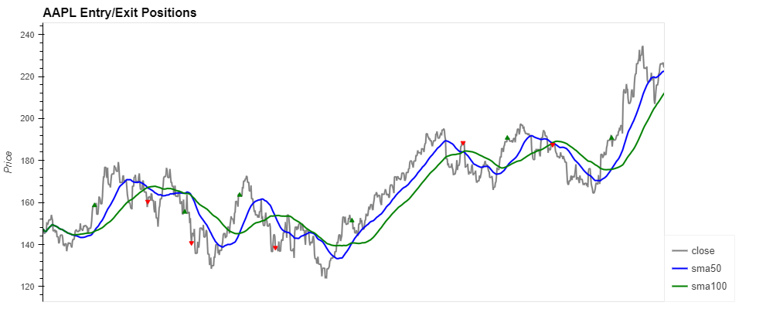

**Figure 4.5: Graph showcasing the Entry/ Exit positions of Apple data based on SMA crossover strategy.**

### Portfolio Management of Stocks

After visualizing how the strategy works with stock data, backtesting is done on this strategy. Investment capital of £1,000,000 is used to effectively invest in 500 shares of a stock based on the buy/sell signal from the SMA crossover strategy with the help of historical values of the stock. The aim of any investment strategy is to maximize the profit and minimize the losses, this can be calculated using the trade indicator called cumulative daily returns. The variables like portfolio holdings and portfolio cash are used to calculate daily returns of the portfolio. Portfolio holdings is the value of the portfolio on the invested stock, this is just a cumulative sum of multiplying close price with entry/exit position for the entire duration of backtesting. Portfolio cash represents how much liquid cash is available after buying and selling stocks. Portfolio total is also the sum of portfolio cash and portfolio holdings. Portfolio returns is the percentage change of the portfolio total which gives insight into daily performance. Portfolio cumulative returns is the overall compounded growth of the portfolio over time.

#### Visualization of Portfolio returns using Python libraries

Once the portfolio metrics are calculated, the returns are visualized for the entire investment period. Using hvplot and panel libraries, the movement of total portfolio value over the entire duration is denoted using a line chart. The buy and sell signals are denoted with green and red dots respectively. In this figure 4.6, the line starts to move when the green dot appears on the line chart which means the stocks are brought on that instance and then the portfolio value grows/falls after that instance with respect to close price. When the red dot appears, the stocks are sold then the portfolio value becomes idle till the next green dot appears in the line chart.

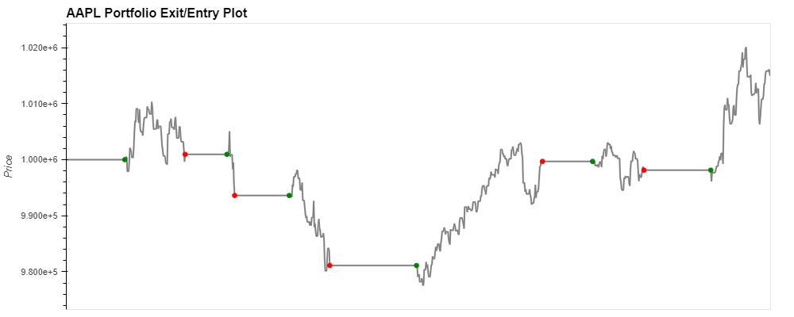

**Figure 4.6: Graph showcasing how the portfolio price moved throughout the portfolio duration for the apple stock.**

### Evaluating Stocks using Trade Indicators

The trading indicators are key to understanding the performance of any stock over a duration. In this part, the basic indicators of a stock used are annual returns, cumulative returns, annual volatility and Sharpe ratios. Annual returns are the yearly percentage change of the investment price. Cumulative returns are the percentage change of the investment value over the entire investment period. Annual volatility is the yearly variation in the investment value. Sharpe ratio gives the risk adjusted return. Mathematically, Sharpe ratio is the ratio of difference between return of portfolio and risk-free return to standard deviation of portfolio’s return. Standard deviation of returns gives the volatility of the stocks; thus, Sharpe ratio gives an insight of risks with respect to the returns. Any Sharpe ratio above 1 is considered good stock to invest in, meaning it provides excess return on the investment (Lo, 2002).

#### Calculating Trade indicators for stocks

In the following section, these indicators are calculated using mathematical functions in python and the library called numpy for all the above-mentioned stocks. Annual returns are calculated by taking an average of all returns throughout the year. Cumulative returns are calculated by finding the percentage of change over the testing period. Annual volatility is calculated by finding the standard deviation of the returns over a year. Sharpe ratio is calculated by finding the ratio of annual returns and annual volatility. After calculating the indicators, it is evident from figure 6.4b that nVidia is the best stock to invest in as it has a Sharpe ratio above 1. Even though the volatility of Tesla stocks is higher, it's a high risk downward moving stock with a Sharpe ratio of 0.19. From the figure 4.7a, it is evident that nVidia has a higher annual and cumulative return. Apple stock is a very safe and predictable stock, mostly suitable for a long-term trader. Nvidia cumulative return of 564% cumulative returns makes me most attractive stocks out of all 7 stocks. Tesla has the highest volatility and lowest returns among the stocks, which makes it a risky stock to invest for the traders.

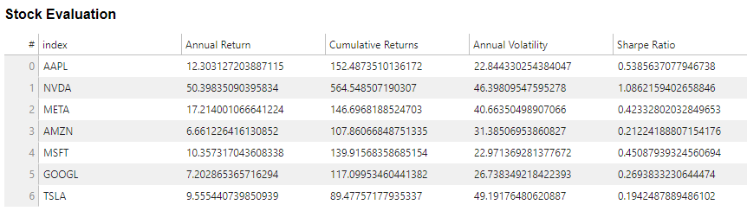

**Figure 4.7a: Evaluation of stocks based on the key indicators.**

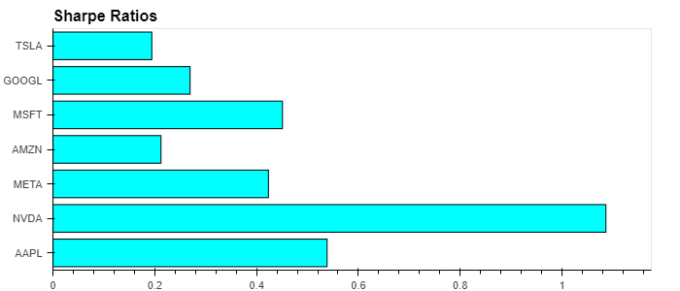

**Figure 4.7b: Graphical representation Sharpe ratio for all the stocks**

### Summary of Trade details for all stocks

In this section, the trade indicators are calculated using the buy/sell signals obtained previously for the specified portfolio. The line chart of how portfolio value changed over the entire duration was tabulated in an interactive way using the hvplot library as shown in figure 4.8. In this table, a single row represents any trade duration between the green and red points. The entry date and exit date represent the green and red points from the above line chart. Entry and Exit share price are the close price of the stock at the green and red point respectively. Entry and exit portfolio holdings are the value of stocks before entering the trade and value of stocks after exiting the trade with respect to the portfolio. Profit/loss provides the difference between entry and exit portfolio holdings. Profit/loss denotes the profit, or the loss made on that trade using SMA crossover strategy. The widgets, which were created using the panel library, are used to filter trade details for each of stocks for the investment duration.

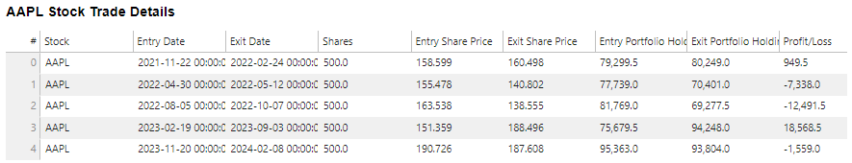

**Figure 4.8: Detailed summary of each trade performed in Apple stock with the help of SMA Crossover strategy.**

## Backtesting using Backtesting.py library

Previously, the backtesting was done using commonly available libraries in python. In this part, a library dedicated to backtesting is used to build the plots and summary of stocks and trades based on the trading strategy used. The open-source library called backtesting.py (kernc, 2024) allows users to test, optimize, research and improve their trading strategies. It offers a detailed summary of evaluation of a trading strategy along with interactive plots. Previously, the backtesting was done using commonly available libraries in python. In this part, a library dedicated to backtesting is used to build the plots and summary of stocks and trades based on the trading strategy used. After installing the library, the objects like Strategy and backtest are imported.

### Mean Reversion Strategy

In this section, the same historical data for all the seven stocks used in the above backtesting are downloaded. First up, the trading strategy called Mean Reversion is coded and then the backtest is done on all the stock data available. In this Mean reversion strategy, once the rolling mean period of 50 is initialized, the entry signal is obtained when the stock price is more than 3 standard deviations below the rolling mean. The exit signal is obtained when the stock price is more than 3 standard deviations above the rolling mean. The profit will be the same as the value of a simple moving average. Once the strategy is coded, the backesting is done with the help of a module called backtest. To use this module, variables like the stock data, strategy, the initial investment and a trade commission value need to be passed. On passing this data, the backtest is run for the historical data of the stocks with an output of graphs and statistics regarding the trading strategy.

### Plots of Backtesting

When plotting the results of backtesting, the graphs for equity shares, profit/loss, candlestick plots with trades and the market movements, volume of stocks, standard deviation are created in an interactive way. These graphs give traders visualization of market movements especially when trades happen with the help of light green candlesticks. Equity shares plots allow the traders to understand the trend of the market, thus reducing the risk and maximizing the profit while investing. From the figure 4.9, it is easy to interpret the trade positions of apple stock using mean reversion strategy and the market movements of the stock at the same time. It also provides the volume of the stock along with it.

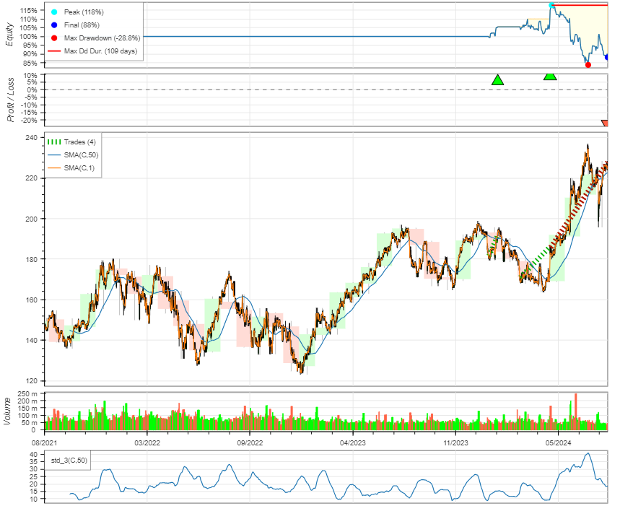

**Figure 4.9: Plotting the result of backtesting using backtesting.py library.**

### Stats of Backtesting

The backtesting also gives statistics about the entire evaluation of the trading strategy for the entire duration of the backtesting period. The statistics (Figure 4.10) contain the annual volatility, Sharpe ratio, annual return, cumulative return, Sortino ratio, percentage of maximum and average drawdown, number of trades, win rate, best and worst trade, profit factor etc. It also contains the table called trades with trade details for each of the trades using ‘_trades’ from the stats dataframe. Similarly, the ‘_equity_curve’ table with equity, drawdown percentage and the drawdown duration. From this stat table below, we can interpret that annual return of the stock for this strategy is negative and annual volatility is comparatively smaller. It also provides Equity shares table and details of the trades along with profit/loss in it. The strategy used in here is Mean Reversion with a rolling mean period of 50.

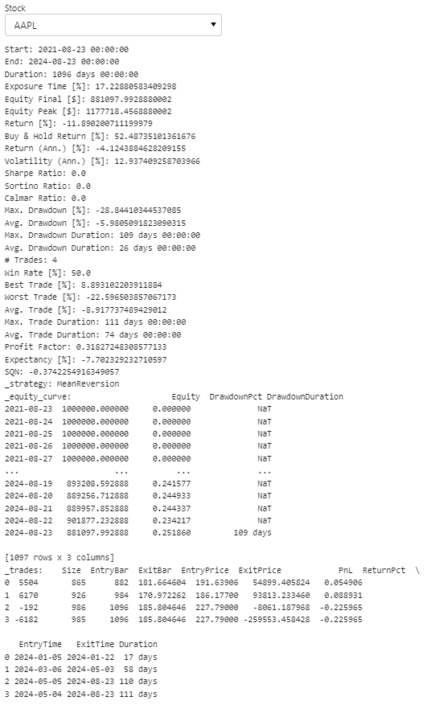

**Figure 4.10: Detailed statistics summary of the Mean reversion strategy on Apple stock**.

### Optimization of the strategy

The strategy can be optimized with the help of the function called ‘optimize’. For this Mean reversion strategy, the simple moving average rolling period is optimized to find the rolling mean period that provides maximized equity share price. The constraint can be added like the rolling period cannot be less than particular days. This strategy optimization saves a lot of time for the traders to find optimum values through this function rather than looping it over multiple times. Once the optimization is completed, the results are shown as a summary and plots for all the stocks available with different optimized strategies for each stock. With the help of the ‘_startegy’ value in stats dataframe, the optimized rolling period for that stock can be found. For example, the apple stock used above can be optimized to better give better annual returns. When the optimization is performed over the stock with different range of rolling mean period, it is found that the mean reversion strategy works at its peak when the rolling mean period was 25. From the figure 4.11, It is shown that the annual return of apple stock has become positive in this optimized strategy. The trades have increased from 4 to 5. Win rate in trades increased from 50% in non-optimised strategy to 80% in optimised strategy. This example indicates how crucial this optimize function can be for the traders to use while backtesting their strategy.

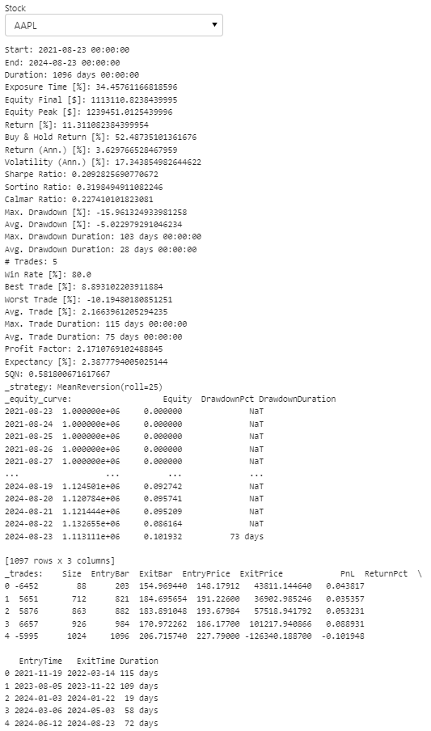

**Figure 4.11: Detailed statistics summary of the optimized Mean reversion strategy on Apple stock**

### Drawbacks of the library

This library has its drawbacks too as the strategies created are very technical indicator specific. The chart’s results after running a backtest are not customizable. It does not allow the backtesting to be implemented on multiple stocks for a single investment (Radovanovic, 2023). In real life trading, this type of investment is very frequently used. This library does not accept any other input values other than OHLCV values of a stock with specific column names. Thus, it faces serious competition with alternatives like Backtrader, QuantConnect, Zipline, Bt, VectorBt etc.

## Trading Strategy Dashboard

In the previous section, the process of backtesting was performed to evaluate various trading strategies. After analyzing the results of backtesting, it is evident from the table 4.1 that the optimized mean reversion performs well for all the seven stocks. Interactive dashboard is created to visualize the performance of optimized mean reversion by plotting the results obtained using the backtesting.py library. The dashboard includes a selection widget at the top of the screen that lists tickers of the stocks. When a particular stock is selected, the dashboard dynamically updates to display the resulting plot for that stock. The layout of the stock is organized in a column format. By serving the dashboard through a web browser, it becomes accessible for everyone to interact with the results generated. This kind of dashboard setup is particularly useful for financial traders and investors. The use of panel python library ensured that the dashboard is highly customizable and easy to interact with. In figure 4.12, trading dashboard served through web browser for the apple stock data is shown. The trading was performed using Optimized mean reversion strategy. This browser dashboard makes it easier for the traders to collaborate with other traders. From the dashboard, the movements of market and the portfolio returns provides more confidence on this trading strategy than the previous non-optimized strategies.

|  |  |  |  |
| --- | --- | --- | --- |
| **Strategy** | **Annual returns** | **Annual Volatility** | **Sharpe Ratio** |
| Mean Reversion | -4.124388 | 12.9374 | 0 |
| Optimized Mean Reversion | 3.629766 | 17.343854 | 0.209282 |

**Table 4.1: Comparison of Mean Reversion and Optimised Mean reversion Strategy**

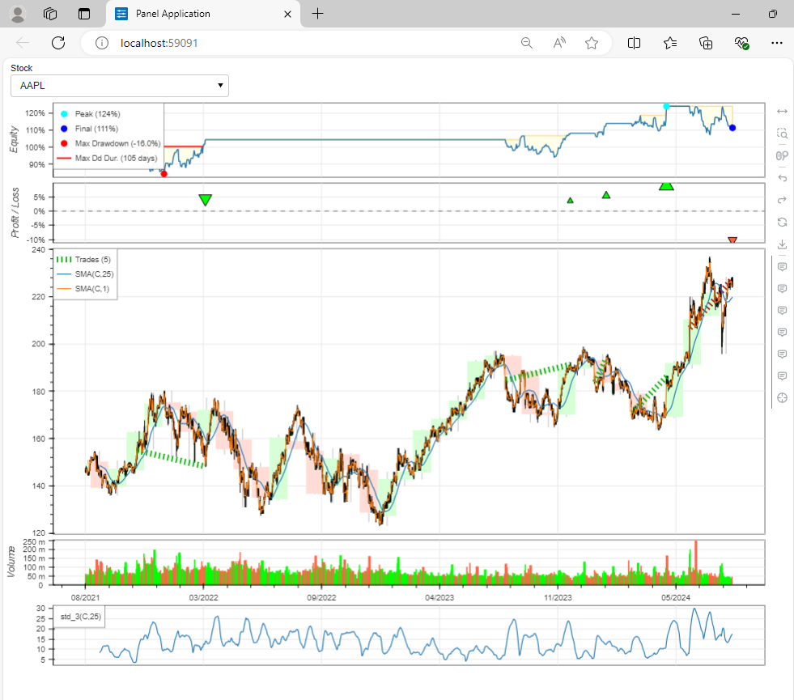

**Figure 4.12: Trading Dashboard of apple stock data for the optimised Mean reversion strategy.**

# Future Scope & Conclusion

## Future Scope

As with any project report, this report also explores the project's future scope. Optimizing the machine learning models can improve the accuracy of the models is also another aspect that can be explored in a detailed way. The explanatory variables used in the models can be further engineered to figure out new variables that impacts price prediction. Exploring advanced machine learning techniques like combinational neural network models which blend the strengths of two or more ML methods to yield more accurate and robust predictions. Incoporating advanced backtesting capablities can ensure that models and strategies are rigorously tested and can be applied in real-world scenarios. Improving backtesting capabilities helps in identifying the potential issues in the strategy beforehand and making required adjustments before deploying to improve trade performance. The next logical step with dashboarding is to create a comprehensive app or website with all the different plot mentioned in the analysis using web technologies like React.js, Angular.js etc. These technologies provide hosting platforms that is visually appealing and highly functional. After developing an app or website, the machine learning models and trading strategies can be deployed on cloud platforms like AWS, Azure etc. Integrating Bloomberg Anywhere license will provide access to real-time stock data for accurate and up-to-date analysis.

## Conclusion

This project report is just an introduction to stock market prediction with the help of fundamental and technical indicators along with some ML methods. The classification model aimed to assess sentiment scores’ impact on forecasting stock price movements and generating buy/sell signals. The analysis found that fundamental and technical indicators were crucial for predictions, while sentiment scores had minimal impact. Logistic Regression emerged as the best model for creating buy/sell indicators, consistently performing well across all seven stocks. The GRU model generally outperformed others in predicting stock prices, especially after hyperparameter optimization. However, the LSTM model excelled in specific cases, particularly with PX_LAST metrics using OHCLV and sentiment data. Traditional moving averages provided competitive baselines, but neural networks, especially GRU and LSTM, offered more accurate forecasts. Evaluate trades using SMA crossover by calculating signals and mean reversion with the backtesting.py library, optimizing for best performance. Use backtesting.py to fine-tune mean reversion strategies. Finally, create a dashboard to visualize and identify the most effective trading strategy.

# References

Agrawal, A. (2017). Logistic Regression. Simplified. [online] Medium. Available at: <https://medium.com/data-science-group-iitr/logistic-regression-simplified-9b4efe801389> [Accessed 21 Aug. 2024].

Ainsworth, M. (2023) Why is data-driven analytics of interest to companies?, Max Web Solutions. Available at: <https://maxwebsolutions.co.uk/blog/why-is-data-driven-analytics-of-interest-to-companies/#:~:text=By%20analysing%20internal%20processes%20and,base%20that%20improve%20the%20business>. (Accessed: 19 August 2024).

Akaike, H. (1974). A new look at the statistical model identification. IEEE Transactions on Automatic Control, 19, pp.716–723. doi:<https://doi.org/10.1109/TAC.1974.1100705>.

Alkhatib, K., Najadat, H., Hmeidi, I. and Shatnawi, M. (2013). Stock Price Prediction Using K-Nearest Neighbor (kNN) Algorithm. International Journal of Business, [online] 3(3). Available at: <https://www.ijbhtnet.com/journals/Vol_3_No_3_March_2013/4.pdf> [Accessed 21 Aug. 2024].

Ampomah, E.K., Qin, Z. and Nyame, G. (2020). Evaluation of Tree-Based Ensemble Machine Learning Models in Predicting Stock Price Direction of Movement. Information, 11(6), p.332. doi:<https://doi.org/10.3390/info11060332>.

Awais, M. (2023) Why exploratory data analysis is an important step in data analysis?, LinkedIn. Available at: <https://www.linkedin.com/pulse/why-exploratory-data-analysis-important-step-muhammad-awais/> (Accessed: 20 August 2024).

Ayushman Durgapal and Vrince Vimal (2021). Prediction of Stock Price Using Statistical and Ensemble learning Models: A Comparative Study. IEEE 8th Uttar Pradesh Section International Conference on Electrical, Electronics and Computer Engineering. doi:<https://doi.org/10.1109/upcon52273.2021.9667644>.

Barry D. Moore (2024). 10 Best Candle Patterns for Traders Proven Reliable. [online] Liberated Stock Trader. Available at: <https://www.liberatedstocktrader.com/candle-patterns-reliable-profitable/>.

Bhavani, A., Ramana, A.V. and Chakravarthy, A.S.N., (2022). "Comparative Analysis between LSTM and GRU in Stock Price Prediction," 2022 International Conference on Edge Computing and Applications (ICECAA), Tamilnadu, India, 2022, pp. 532-537, doi: 10.1109/ICECAA55415.2022.9936434.

Bloom, N., Liang, J., Roberts, J. and Ying, Z.J. (2015). DOES WORKING FROM HOME WORK? EVIDENCE FROM A CHINESE EXPERIMENT. The Quarterly Journal of Economics, [online] 130(1), pp.165–218. Available at: <https://www.jstor.org/stable/26372598>.

Box, G.E.P., Jenkins, G.M., Reinsel, G.C. and Ljung, G.M. (2016). Time series analysis: forecasting and control. Hoboken, New Jersey: John Wiley & Sons, Inc.

Chan, W. (2020). Time Series Data Mining: Comparative Study of ARIMA and Prophet Methods for Forecasting Closing Prices of Myanmar Stock Exchange. Journal of Computer Applications and Research, 1(1), p.2020.

Chen, J. (2021). Backtesting Definition. [online] Investopedia. Available at: <https://www.investopedia.com/terms/b/backtesting.asp>.

Demir, M., Dalgic, A. and Ergen, F. (2022). Handbook of research on the impacts and implications of COVID-19 on the tourism industry. Hershey, PA: Business Science Reference.

Deng, S., Huang, X., Zhu, Y., Su, Z., Fu, Z. and Shimada, T. (2023). Stock index direction forecasting using an explainable eXtreme Gradient Boosting and investor sentiments. The North American Journal of Economics and Finance, [online] 64, p.101848. doi:<https://doi.org/10.1016/j.najef.2022.101848>.

Desai, Dr.Jay., Joshi, N.A., Chokshi, A.H. and Dave (2011). A study of seasonality based trading strategy for indian stocks and indices. [online] Emerging Markets: Finance eJournal. Available at: <https://api.semanticscholar.org/CorpusID:126639951>.

Deveikyte, J. et al. (2022) A sentiment analysis approach to the prediction of market volatility, Frontiers. Available at: <https://www.frontiersin.org/journals/artificial-intelligence/articles/10.3389/frai.2022.836809/full> (Accessed: 19 August 2024).

Ferdinand, F.V., Santoso, T.H. and K. V. I. Saputra (2023). Performance Comparison Between Facebook Prophet and SARIMA on Indonesian Stock. IEEE International Conference on Industrial Engineering and Engineering Management. doi:<https://doi.org/10.1109/ieem58616.2023.10406940>.

Fernando, J. (2023a). Equity: What investors need to know. [online] Investopedia. Available at: <https://www.investopedia.com/terms/e/equity.asp>.

Fernando, J. (2023b). Moving Average (MA). [online] Investopedia. Available at: <https://www.investopedia.com/terms/m/movingaverage.asp>.

GeeksforGeeks (2023). Stochastic Gradient Descent Classifier. [online] GeeksforGeeks. Available at: <https://www.geeksforgeeks.org/stochastic-gradient-descent-classifier/> [Accessed 21 Aug. 2024].

Grattton, P. (2022). What Is the Stock Market and How Does It Work? [online] Investopedia. Available at: <https://www.investopedia.com/terms/s/stockmarket.asp>.

Gric, Z., Bajzík, J. and Badura, O. (2023) Does sentiment affect stock returns? A meta-analysis across survey-based measures, International Review of Financial Analysis. Available at: <https://www.sciencedirect.com/science/article/abs/pii/S1057521923002892> (Accessed: 19 August 2024).

Gupta, S. (2018) Sentiment analysis: Concept, analysis and applications, Medium. Available at: <https://towardsdatascience.com/sentiment-analysis-concept-analysis-and-applications-6c94d6f58c17> (Accessed: 19 August 2024).

Hammer, B., Virgili, E. and Bilotta, F. (2023) Evidence-based literature review: De-duplication a cornerstone for quality, World journal of methodology. Available at: <https://www.ncbi.nlm.nih.gov/pmc/articles/PMC10789108/#:~:text=Removing%20duplicate%20records%20is%20essential,data%20extraction%20and%20analysis%20efforts>. (Accessed: 20 August 2024).

Hayes, A. (2019). Simple Moving Average - SMA. [online] Investopedia. Available at: <https://www.investopedia.com/terms/s/sma.asp>.

Hayes, Adam. “Bollinger Band®.” Investopedia, 7 May 2020, [www.investopedia.com/terms/b/bollingerbands.asp](http://www.investopedia.com/terms/b/bollingerbands.asp).

Hillier, W. (2023) What is data cleaning and why does it matter? [how-to], CareerFoundry. Available at: <https://careerfoundry.com/en/blog/data-analytics/what-is-data-cleaning/> (Accessed: 20 August 2024).

Hu, W., Si, Y.-W., Fong, S. and Lau, R.Y.K. (2019). A formal approach to candlestick pattern classification in financial time series. Applied Soft Computing, 84, p.105700. doi:<https://doi.org/10.1016/j.asoc.2019.105700>.

Hyndman, R.J. and Athanasopoulos, G. (2018). Forecasting: Principles and Practice. [online] otexts.com. Available at: <https://otexts.com/fpp3/>.

jealous (2016). GitHub - jealous/stockstats: Supply a wrapper StockDataFrame based on the pandas.DataFrame with inline stock statistics/indicators support. [online] GitHub. Available at: <https://github.com/jealous/stockstats> [Accessed 22 Aug. 2024].

Kardile, R., Ugale, T. and Mohanty, S.N. (2021). Stock Price Predictions using Crossover SMA. [online] IEEE Xplore. doi:<https://doi.org/10.1109/ICRITO51393.2021.9596479>.

Kernc (2024). kernc/backtesting.py. [online] GitHub. Available at: <https://github.com/kernc/backtesting.py>.

Khan, F. (2024) What is data preprocessing: Definition, importance, and steps, Astera. Available at: <https://www.astera.com/type/blog/data-preprocessing/#:~:text=Data%20preprocessing%20influences%20the%20accuracy,accuracy%20and%20decision%2Dmaking%20prowess>. (Accessed: 20 August 2024).

Khoong, W.H. (2023) Why scaling your data is important, Medium. Available at: <https://medium.com/codex/why-scaling-your-data-is-important-1aff95ca97a2> (Accessed: 21 August 2024).

Lansing, K. and Tubbs, M. (2018). Using Sentiment and Momentum to Predict Stock Returns. [online] Available at: <https://www.frbsf.org/wp-content/uploads/el2018-29.pdf> [Accessed 22 Aug. 2024].

Lawi, A., Mesra, H. and Amir, S. (2022). Implementation of Long Short-Term Memory and Gated Recurrent Units on grouped time-series data to predict stock prices accurately. Journal of Big Data, 9(1). doi:<https://doi.org/10.1186/s40537-022-00597-0>.

Lo, A.W. (2002). The Statistics of Sharpe Ratios. Financial Analysts Journal, 58(4), pp.36–52. doi:<https://doi.org/10.2469/faj.v58.n4.2453>.

Luceño, A. and Peña, D. (2007). Autoregressive Integrated Moving Average (ARIMA) Modeling. Encyclopedia of Statistics in Quality and Reliability. doi:<https://doi.org/10.1002/9780470061572.eqr276>.

Mitchell, C. (2024). How to Use Bollinger Bands to Gauge Trends. [online] Investopedia. Available at: <https://www.investopedia.com/trading/using-bollinger-bands-to-gauge-trends/#:~:text=The%20upper%20band%20is%20calculated> [Accessed 23 Aug. 2024].

Mohamed, A. (2024) Why sentiment analysis is important: The power of emotions, Aim Technologies. Available at: <https://www.aimtechnologies.co/2023/09/05/why-sentiment-analysis-is-important-the-power-of-emotions-in-data/#:~:text=In%20the%20business%20world%2C%20understanding,and%20identify%20areas%20for%20improvement>. (Accessed: 19 August 2024).

Mohamed, A. (2024) Why sentiment analysis is important: The power of emotions, Aim Technologies. Available at: <https://www.aimtechnologies.co/2023/09/05/why-sentiment-analysis-is-important-the-power-of-emotions-in-data/#:~:text=In%20the%20business%20world%2C%20understanding,and%20identify%20areas%20for%20improvement>. (Accessed: 19 August 2024).

Murphy, C. (2019). Support and Resistance Basics. [online] Investopedia. Available at: <https://www.investopedia.com/trading/support-and-resistance-basics/>.

Nikou M, Mansourfar G, Bagherzadeh J. (2019). Stock price prediction using DEEP learning algorithm and its comparison with machine learning algorithms. Intell Sys Acc Fin Mgmt., 26: 164–174. <https://doi.org/10.1002/isaf.1459>

Nison, S. (2001). Japanese candlestick charting techniques: a contemporary guide to the ancient techniques of the Far East. Paramus, N.J.; London: Prentice Hall.

Ngui, S.W. (2023). How to use Support Vector Machine to Predict Stock Prices. [online] Medium. Available at: <https://swngui.medium.com/how-to-use-support-vector-machine-to-predict-stock-prices-f0bc137d2e19> [Accessed 20 Aug. 2024].

Nyakundi, J. (2023). Building a Trading Strategy 101: Everything You Need to Know in 2024. [online] Trading Strategy Guides. Available at: <https://tradingstrategyguides.com/trading-strategy/> [Accessed 23 Aug. 2024].

Nti, Isaac Kofi, et al. “A Systematic Review of Fundamental and Technical Analysis of Stock Market Predictions.” Artificial Intelligence Review, vol. 53, no. 1, 20 Aug. 2019, pp. 3007–3057, link.springer.com/article/10.1007/s10462-019-09754-z, <https://doi.org/10.1007/s10462-019-09754-z>.

Quantified Strategies (2024). Average daily returns definition, Medium. Available at: <https://tradingstrategy.medium.com/average-daily-returns-definition-0dd33537b185#:~:text=By%20calculating%20and%20analyzing%20average,performance%2C%20and%20forecasting%20future%20returns>. (Accessed: 21 August 2024).

Radovanovic, I. (2023). Backtesting.py - An Introductory Guide to Backtesting with Python - AlgoTrading101 Blog. [online] Quantitative Trading Ideas and Guides - AlgoTrading101 Blog. Available at: <https://algotrading101.com/learn/backtesting-py-guide/>.

Renu IR, Christie R (2018). Fundamental analysis versus technical analysis—a comparative review. Int JRecent Sci Res 9(1):23009–23013. <https://doi.org/10.24327> /IJRSR

Roy, S., Ranjan Mehera, Rajat Kumar Pal and Samir Kumar Bandyopadhyay (2023). Hyperparameter optimization for deep neural network models: a comprehensive study on methods and techniques. Innovations in Systems and Software Engineering. doi:<https://doi.org/10.1007/s11334-023-00540-3>.

Salman, M. (2023) Checking for missing values in machine learning Eda, Medium. Available at: <https://medium.com/@mahnoorsalman96/checking-for-missing-values-for-machine-learning-bb4c263a6555#:~:text=In%20machine%20learning%2C%20ensuring%20the,skewed%20predictions%20and%20compromised%20insights>. (Accessed: 20 August 2024).

Sasidharan, A. (2021). Support Vector Machine Algorithm. [online] GeeksforGeeks. Available at: <https://www.geeksforgeeks.org/support-vector-machine-algorithm/> [Accessed 21 Aug. 2024].

Scikit-Learn (2019). User guide: contents — scikit-learn 0.22.1 documentation. [online] Scikit-learn.org. Available at: <https://scikit-learn.org/stable/user_guide.html>.

Segal, Troy. “Fundamental Analysis: Principles, Types, and How to Use It.” Investopedia, 19 Dec. 2023, [www.investopedia.com/terms/f/fundamentalanalysis.asp](http://www.investopedia.com/terms/f/fundamentalanalysis.asp).

Shi, A. (2023). SGDClassifier: Untaught Lessons You Need to Know. [online] Medium. Available at: <https://code.likeagirl.io/sgdclassifier-with-scikit-learn-untaught-lessons-you-need-to-know-7bf2f56c04dc> [Accessed 19 Aug. 2024].

Shynkevich, Y. et al. (no date) Forecasting Price Movements using Technical Indicators: Investigating the Impact of Varying Input Window Length. Available at: <https://irep.ntu.ac.uk/id/eprint/32787/1/PubSub10294_702a_McGinnity.pdf> (Accessed: 20 August 2024).

Song, H. and Choi, H. (2023). Forecasting Stock Market Indices Using the Recurrent Neural Network Based Hybrid Models: CNN-LSTM, GRU-CNN, and Ensemble Models. Applied Sciences, 13(7), p.4644. doi:<https://doi.org/10.3390/app13074644>.

Sunki, A., SatyaKumar, C., Narayana, G.S., Koppera, V. and Hakeem, M. (2024). Time series forecasting of stock market using ARIMA, LSTM and FB prophet. MATEC Web of Conferences, [online] 392, p.01163. doi:<https://doi.org/10.1051/matecconf/202439201163>.

Taylor, S. and Letham, B. (2017). Forecasting at scale. PeerJ Preprints, [online] 5, p.e3190v2. doi:<https://doi.org/10.7287/peerj.preprints.3190v2>.

TensorFlow (n.d.). API Documentation | TensorFlow Core v2.4.1. [online] TensorFlow. Available at: <https://www.tensorflow.org/api_docs>.

Tiong, L.C., Ngo, D.C. and Lee, Y., (2013). Stock price prediction model using candlestick pattern feature. International Journal Of Interactive Digital Media, 1(3), pp.58-64.

Understanding Momentum Indicators and RSI.” Investopedia, 30 Apr. 2021, [www.investopedia.com/investing/momentum-and-relative-strength-index/](http://www.investopedia.com/investing/momentum-and-relative-strength-index/).

Wang, J., He, J., Feng, C., Feng, L. and Li, Y. (2021). Stock index prediction and uncertainty analysis using multi-scale nonlinear ensemble paradigm of optimal feature extraction, two-stage deep learning and Gaussian process regression. Applied Soft Computing, 113, p.107898. doi:<https://doi.org/10.1016/j.asoc.2021.107898>.

Xiao, Q. and Ihnaini, B. (2023) Stock trend prediction using sentiment analysis, PeerJ. Computer science. Available at: <https://www.ncbi.nlm.nih.gov/pmc/articles/PMC10403218/#:~:text=They%20can%20utilize%20text%20mining,to%20predict%20various%20stock%20trends>. (Accessed: 19 August 2024).

Zheng, J., Xin, D., Cheng, Q., Tian, M. and Yang, L. (2024). The Random Forest Model for Analyzing and Forecasting the US Stock Market in the Context of Smart Finance. [online] Available at: <https://arxiv.org/pdf/2402.17194#:~:text=The%20random%20forest%20model%20is> [Accessed 21 Aug. 2024].